|  |  |  |  |  |
| --- | --- | --- | --- | --- |
|  |  | | |  |
|  |  | | |  |
|  | NFC Entry and Starting  <<Feature>>  (F002070) | | |  |
|  |  | | |  |
| Document Type | **Feature Document (FD)** | | |  |
| Template Version | **6.0b / FFSD 7.1** | | |  |
| SysML Report Template Version | **O Beta (7/25/2019)** | | |  |
| Document ID | 2020-08-24 | | |  |
| Document Location |  | | |  |
| Document Owner | **Aaron Bonnell-Kangas, Aaron DeLong, Farhan Ehsan, Eugene Karpinsky** | | |  |
| Document Revision |  | | |  |
| Document Status | **Draft** | | |  |
| Date Issued | **2020-05-22** | | |  |
| Date Revised | **2020-08-24** | | |  |
| Document Classification | GIS1 Item Number: | **27.60/35** | |  |
| GIS2 Classification: | **Confidential** | |
|  | | | | |
|  | | | | |
| Document Approval | | | | |
| Person | Role | | Email Confirmation | Date |
|  |  | |  |  |
|  |  | |  |  |

**Auto-Generated by MagicDraw**

Printed Copies Are Uncontrolled

# Disclaimer

**This document contains Ford Motor Company Confidential information. Disclosure of the information contained in any portion of this document is not permitted without the expressed, written consent of a duly authorized representative of Ford Motor Company, Dearborn, Michigan, U.S.A.**

**Copyright, Ó 2020 Ford Motor Company**

This document contains information developed and accumulated by and for FORD MOTOR COMPANY. As such, it is a proprietary document, which, if disseminated to unauthorized persons, would provide others with restricted information, data, or procedures not otherwise available, exposing the FORD MOTOR COMPANY to potential harm.

Employees and suppliers having custody of this specification or authorized to use it must be cognizant of its proprietary nature and ensure that the information herein is not made available to unauthorized persons.

FORD MOTOR COMPANY reserves the right to protect this work as an unpublished copyrighted work in the event of an inadvertent or deliberate unauthorized publication. FORD MOTOR COMPANY also reserves its rights under copyright laws to protect this work as a published work.

This document or portions thereof shall not be distributed outside FORD MOTOR COMPANY without prior written consent. Refer all questions concerning disclosure to the author(s) or to any duly authorized representative of Ford Motor Company.

# Contents

Disclaimer 2

Contents 3

1 Introduction 5

1.1 Document Purpose 5

1.2 Document Scope 5

1.3 Document Audience 5

1.3.1 Stakeholder List 5

1.4 Document Organization 5

1.4.1 Document Context 5

1.4.2 Document Structure 6

1.5 Document Conventions 6

1.5.1 Requirements Templates 6

1.6 References 6

1.6.1 Ford Documents 6

1.6.2 External Documents and Publications 6

1.7 Glossary 7

1.7.1 Parameters / Values 7

2 Feature Overview 8

2.1 Purpose and Description of Feature 8

2.2 Feature Variants 8

2.2.1 Regions & Markets 8

2.3 Input Requirements 8

2.3.1 Legal Requirements 8

2.3.2 Trustmark Requirements 8

2.3.3 Industry Standards 9

2.4 Lessons Learned 9

2.5 Assumptions 9

3 Feature Context 10

3.1 Feature Context Diagram 10

3.2 List of Influences 10

4 Feature Modeling 12

4.1 Operation Modes and States 12

4.2 Use Cases 26

4.2.1 Use Case Diagram 27

4.2.2 Actors 28

4.2.3 Use Case Descriptions 28

4.3 Decision Tables 47

5 Feature Requirements 48

5.1 Functional Requirements 48

5.1.1 Error Handling 65

5.2 Non-Functional Requirements 65

5.2.1 Safety 65

5.2.2 Security 65

5.2.3 Reliability 65

5.3 HMI Requirements 66

5.4 Other Requirements 70

5.4.1 Design Requirements 70

5.4.2 Manufacturing Requirements 70

5.4.3 Service Requirements 72

5.4.4 After Sales Requirements 74

5.4.5 Process Requirements 75

5.4.6 Uncategorized Requirements 75

6 Functional Safety 76

6.1 System Behaviors for HARA 76

6.2 Safety Assumptions 76

6.3 Safety Goals 76

6.4 Functional Safety Requirements 76

6.4.1 Derivation of Functional Safety Requirements on Assumptions 76

6.5 ASIL Decomposition of Functional Safety Requirements 77

6.5.1 Decomposition of Functional Safety Requirement 77

7 Architecture 78

7.1 Functional Architecture 78

7.1.1 List of Functions 78

7.2 Logical Architecture 78

7.2.1 Logical Elements 79

7.2.2 Logical Interfaces 80

8 Open Concerns 81

9 Revision History 82

**List of Figures**

Figure 1: Feature Context 10

Figure 2: Add NFC key InnerSTM 13

Figure 3: Display System 16

Figure 4: MyKey Management Inner STM 18

Figure 5: NFC Enabled Device 20

Figure 6: NFC Feature Driver Information 21

Figure 7: Personal Profiles Linking STM 23

Figure 8: Remove NFC Key Inner STM 25

Figure 9: NFC Common 27

Figure 10: NFC Fleet Specific 27

Figure 11: NFC Retail Specific 28

Figure 12: Functional Architecture 78

Figure 13: Logical Architecture 79

**List of Tables**

Table 1: Features described in this FD 5

Table 2: Ford internal Documents *(not specified in SysML model)* 6

Table 3: External documents and publications *(not specified in SysML model)* 7

Table 4: Parameters / Values used in this document *(Not supported by MagicDraw report generation)* 7

Table 5: Feature Variants 8

Table 6: Regions & Markets 8

Table 7: List of Influences 11

Table 8: Operation Modes and States on Add NFC key InnerSTM 14

Table 9: Transitions between Operation Modes and States on Add NFC key InnerSTM 15

Table 10: Operation Modes and States on Display System 17

Table 11: Transitions between Operation Modes and States on Display System 18

Table 12: Operation Modes and States on MyKey Management Inner STM 19

Table 13: Transitions between Operation Modes and States on MyKey Management Inner STM 19

Table 14: Operation Modes and States on NFC Enabled Device 20

Table 15: Transitions between Operation Modes and States on NFC Enabled Device 20

Table 16: Operation Modes and States on NFC Feature Driver Information 21

Table 17: Transitions between Operation Modes and States on NFC Feature Driver Information 22

Table 18: Operation Modes and States on Personal Profiles Linking STM 23

Table 19: Transitions between Operation Modes and States on Personal Profiles Linking STM 24

Table 20: Operation Modes and States on Remove NFC Key Inner STM 26

Table 21: Transitions between Operation Modes and States on Remove NFC Key Inner STM 26

Table 22: List of Actors 28

Table 23: List of Functions 78

Table 24: Logical Elements 80

Table 25: Open Concerns *(Not supported by MagicDraw report generation)* 81

# Introduction

## Document Purpose

A Feature Document (FD) document specifies **what** the feature shall do and how it shall behave from customer perspective. It should also provide reasoning and background **why** we have the feature in the vehicle.

The FD also serves as an Item Definition as defined by ISO26262 for those features, which follow the Ford Functional Safety process.

To get more information about the concept of feature, function and component level abstraction refer to the [Ford RE Wiki](http://wiki.ford.com/display/RequirementsEngineering/Requirements+Engineering+for+SW+Enabled+Features). For details on the Ford Functional Safety (ISO26262) process refer to the [Ford Functional Safety Sharepoint](https://pd3.spt.ford.com/sites/GlobalFunctionalSafety/Pages/default.aspx).

## Document Scope

This Feature Document (FD) specifies the following features:

|  |  |  |  |
| --- | --- | --- | --- |
| **Feature ID** | **Feature Name** | **Owner** | **Reference** |
| F002070 | NFC  (Program(s): P708 MY23) | Aaron Bonnell-Kangas, Matthew Stockmaster, Aaron DeLong, Farhan Ehsan, Eugene Karpinsky and Juan Tejeda |  |

Table 1: Features described in this FD

## Document Audience

The FD is written by the feature owner of Aaron Bonnell-Kangas, Matthew Stockmaster, Aaron DeLong, Farhan Ehsan, Eugene Karpinsky and Juan Tejeda. All Stakeholders, i.e., all people who have a valid interest in the feature should read and, if possible, review the FD. It needs to be guaranteed, that all stakeholders have access to the currently valid version of the FD.

**#Hint:** The FD template has the IP Classification “Proprietary” by default. IP Classification “Confidential” might be required in some cases, e.g. by Ford Functional Safety.

### Stakeholder List

For the latest list of stakeholder of the feature and their influence refer to <Put VSEM Link here>.

|  |  |  |  |  |
| --- | --- | --- | --- | --- |
| **Name** | **CDSID** | **Org.** | **Title** | **Project Role** |
| John Van Wiemeersch | jvanviem | RA&E, Adv. Feat. Development | Supervisor | Design Support |
| Aaron DeLong | adelong2 | RA&E, Adv. Feat. Development | Research Engineer | Research Design Lead |
| Vivek Elangovan | velango5 | RA&E, Adv. Feat. Development | Research Engineer | Design Support |
| Rita Trupiano | mtrupia1 | PD, Sys. Eng.,  Distributed Feat. | Feature Owner Supervisor | Feature Owner Supervisor |
| Eugene Karpinsky | ekarpins | PD, Sys. Eng.,  Distributed Feat. | Core Feature Owner | Production Design Lead and Feature Owner |
| Farhan Ehsan | fehsan2 | PD, Sys. Eng.,  Distributed Feat. | Core Feature Owner | Production Design Lead and Feature Owner |
| Aaron Bonnell-kangas | Abonnel1 | PD, Sys. Eng.,  Distributed Feat. | Core Feature Owner | Production Design Lead and Feature Owner |
| Matt Swis | mswis | PD, EESE, Body & Security Elec. | Core Security & RF Supervisor | NFC System Owner Supervisor |
| Nisha Patel | npate152 | PD, EESE, Body & Security Elec. | Core NFC Engineer | NFC System Owner |
| David Hernandez | dhern138 | PD, EESE, Body & Security Elec. | Core NFC Engineer | NFC System Owner |
| Suthagaran Nagarasa | snagaras | PD, EESE, Body & Security Elec. | Core NFC Engineer | NFC System Owner |
| Kevin Hille | khille | PD, EESE, Body & DAT SW | Technical Specialist – Immob. | NFC Immobilizer Function Owner, Design Support |
| John Ricks | jricks7 | PD, EESE, Body & DAT SW | Software Supervisor | Software Supervisor |
| John Popovecz | jpopovec | PD, EESE, Body & DAT SW | Body Module SW Supervisor | Body Module SW Supervisor |
| Hosam Irsheid | hirsheid | PD, EESE, Body & DAT SW | Software Engineer | Software Design |
| Sam Mehdi | hmehdi | PD, EESE, Body & DAT SW | Product Design Engineer | Software Design |
| Vishala Pasala | vpasala | PD, EESE, Body & DAT SW | Software Engineer | Software Design |
| Maeen Mawari | mmawari | PD, EESE, Body & DAT SW | MBSE Engineer | Software Design |
| Eric Reed | ereed2 | PD, EESE, Body & DAT SW | VSC SW Engineer | Software Design |
| Ahmad Sabri | asabri3 | PD, EESE, Body & DAT SW | PD Engineer | Software Design |
| Jeff Lossing | jlossing | PD, EESE, Body & DAT SW | Software Engineer | Software Design |
| Andrew Hall | ahall185 | PD, EESE, Body & DAT SW | Design Engineer, BCM Software | Software Design |
| Sachin Magar | smagar | PD, EESE, Body & DAT SW | Design Engineer, BCM Software | Software Design |
| Akshita Kulkarni | akulka2 | PD, EESE, Body & DAT SW | Design Engineer, BCM Software | Software Design |
| Adithya Ramachandran | aramac11 | PD, EESE, Body & DAT SW | Software Engineer | Software Design |
| S Bagga | sbagga11 | PD, EESE, Body & DAT SW | Software Engineer | Software Design |
| Gail Cheng | gcheng | PD, In-Vehicle Infotainment & Connectivity | Infotainment Systems Supervisor | Infotainment System Design Supervisor |
| Matthew Borrelli | mborrel4 | PD, In-Vehicle Infotainment & Connectivity | Infotainment Systems Engineer | Infotainment System Design |
| Laura Check | lburek | PD, In-Vehicle Infotainment & Connectivity | SYNC Supervisor | SYNC System Supervisor |
| Iqbal Faheem Sayyed | isayyed | PD, In-Vehicle Infotainment & Connectivity | SYNC Technical Program Manager | SYNC Technical Program Manager |
| Scott Watkins | swatkins | PD, In-Vehicle Infotainment & Connectivity | DI Technical Expert | Driver Information Design Support |
| Stavros Dionyssopoulos | sdionyss | PD, CIED | DI HMI Engineer | Driver Information HMI Support |
| Nicholas Davio | ndavio | PD, CIED | HMI Supervisor | HMI Support Supervisor |
| Mack Dobbie | mdobbie | PD, CIED | HMI Designer | HMI Support |
| Montana Pruett | mpruett2 | PD, CIED | I&E Engineer | I&E Support |
| Patrick Brautigan | pbrautig | PD, CIED | UX Engineer | UX Support |
| Jeffrey Hamel | jhamel7 | PD, Enterprise Connectivity | Product Owner, TPM | Ford Mobile App Design |
| Michael Martinez | mmart664 | PD, Mobility | Product Manager | Ford Mobile App Design |
| Bruce Williams | bwilli28 | PD, EESE, Netcom Core | Product Design Engineer | Electrical Architecture Consult |
| Jim Lawlis | jlawlis | PD, EESE, Advanced Netcom | Technical Specialist - Netcom | Electrical Architecture Consult |
| Nhi Torres | ntorres5 | PD, EESE, Netcom Diag. | Supervisor | Electrical Architecture Consult |
| Eric Paton | epaton | PD, EESE, Netcom Diag. | Engineer | Electrical Architecture Consult |
| Ankita Vyas | avyas8 | PD, EESE, Functional Safety | Functional Safety Engineer | Functional Safety Consult |
| Juan Tejada | jtejeda6 | PD, EESE, MBSE | Modelling Expert | Modelling Support |
| Ahmet Cinar | acinar1 | PD Europe, Underbody EESE | Tech. Expert – Closure Electronics | Closure Design Consult |
| Uwe Zank | uzank | PD Europe, Underbody EESE | Supervisor, Security Electronics | Security Design Consult |
| Denney Vellaramkalayil | dvellara | PD Europe, Underbody EESE | System Engineer, Locking Application | Locking Design Support |
| Henry Popow | hpopow | Quality, EESE | Quality Engineer | Quality Coach |
| Gerard Szczepaniak | gszczepa | Quality, EESE | Quality Engineer | Quality Coach |
| Christina Bloxsom | cbloxsom | SE&SE, ASO, Adv. Policy | Subject Matter Expert | Safety & Regulations Consult |
| Mike Westra | mwestra | IT, Cybersecurity | Technical Leader – Security | Cybersecurity Consult |
| Jochen Schubert | jschub1 | IT, Cybersecurity | Cybersecurity Engineer | Cybersecurity Design Support |
| Dan Zajac | dzajac8 | IT, Cybersecurity | Cybersecurity Supervisor | Cybersecurity Supervisor |
| Jacob Nelson | jnels148 | IT, Cybersecurity | Cybersecurity Engineer | Cybersecurity Design Support |
| Xin Ye | xye7 | IT, Cybersecurity | Technical Specialist - Security | Cybersecurity Consult |
| Simon Hurr | shurr | IT, Cybersecurity | Security Application Specialist | Cybersecurity Consult |
| Mike Simons | msimon78 | IT, CVP&P, PaaK | Systems Engineer | Off Board Function Owner Lead |
| Faten Fawaz | ffawaz | IT, CVP&P, Basic Design | Basic Design Architect | Backend Infrastructure Design Lead |
| Steve Craig | scraig33 | IT, CVP&P, Integration | Technical Program Manager | Backend Infrastructure Design Support |
| Yona Shaposhnik | yshaposh | IT, MPS, Mobility Arch. | Solution Architect | Backend Infrastructure Design Support |
| Michelle Moody | mmoody1 | IT, Mobility, FCS | Director | Project Champion – Fleet |
| Robert Johnson | rjohns75 | IT, Mobility, FCS | Product Marketing Manager | Project Champion – Fleet |
| Mustapha Elkhatib | melkhat1 | IT, Mobility, FCS | Product Manager | Fleet Infrastructure Design Support |
| Geoffrey Scofield | gscofiel | IT, Mobility, FCS | Product Engineer | Fleet Infrastructure Design Support |
| Jennifer Oak | joak | MS&S, US Marketing | Connected Marketing Manager | Project Champion – Retail |
| Timothy Son Hing | tsonhin1 | MS&S, US Marketing | Marketing Manager | Project Champion – Retail |

## Document Organization

### Document Context

Refer to the [Specification Structure page](http://wiki.ford.com/display/RequirementsEngineering/Specification+templates) in the [Ford RE Wiki](http://wiki.ford.com/display/RequirementsEngineering/Requirements+Engineering+for+SW+Enabled+Features) to understand how the FD relates to other Ford Requirements Documents and Specifications.

### Document Structure

The structure of this document is explained below:

**Section 1** – Introduction how to use this document including responsibilities and requisite documents. Explains the terminology. Gives a clarification of the definitions, concepts and abbreviations used in the document.

**Section 2** – Feature Description. States briefly the background and the purpose of the feature, feature variants and corresponding regions and markets. Also includes input requirements, assumptions and constraints.

**Section 3** – Feature Context describes all external entities, which have an influence on the feature.

**Section 4** – Feature Modeling. Contains Use Case, Driving Scenarios, State Charts to describe the functional behavior of the feature.

**Section 5** – Safety. Lists System Behaviors and Safety Goals of the feature.

**Section 6** – Feature Requirements. Lists functional and non-functional requirements of the feature.

**Section 7** – Architecture. Shows the coarse architecture, which the feature requirements are deployed to. Describes the elements and the boundary of the feature as well as the decomposition and distribution of associated functions.

**Section 8** – List of Open Concerns

**Section 9** – Document Change History including a list of new or modified requirements. The requirements in this document are tagged, and this section contains different types of tables listing all, new, or changed requirements by their title and page no.

**Section 10** – Appendix

**#Hint:** All sections are mandatory, unless explicitly marked by the tag “#Classification” as “optional” or as applicable e.g. to certain domains like “Functional Safety”.

## Document Conventions

### Requirements Templates

Each requirement, use case or scenario in this specification shall follow the corresponding template given in the document template *Specification_Macros.dotm* at [RE Wiki - Specification Templates](http://wiki.ford.com/display/RequirementsEngineering/Specification+templates?src=contextnavpagetreemode).

#### Identification of requirements

#### Requirements Attributes

The templates provided by *Specification_Macros.dotm* define a list of attributes for each requirement. This helps to classify the requirement. The attributes are explained at [RE Wiki - Requirements Attributes](http://wiki.ford.com/display/RequirementsEngineering/Requirements+Attributes?src=contextnavpagetreemode).

## References

### Ford Documents

List here all Ford internal documents, which are directly related to the feature.

| **Reference** | **Title** | **Doc. ID** | **Document Location** | **Revision** |
| --- | --- | --- | --- | --- |
|  |  |  |  |  |

Table 2: Ford internal Documents *(not specified in SysML model)*

### External Documents and Publications

The list of external documents could include books, reports and online sources.

**#Hint:** You may refer to [IEEE Citation Reference](http://www.ieee.org/documents/ieeecitationref.pdf) on how to format a reference.

| **Reference** | **Document / Publication** | **Document Location** |
| --- | --- | --- |
|  |  |  |

Table 3: External documents and publications *(not specified in SysML model)*

## Glossary

**#Hint**: Terms, concepts and abbreviations used in the document shall be defined and illustrated here. Note that changes to terms and/or concepts described in this section tend to cause major updates to this document.

The tables below have feature specific definitions and abbreviations. For additional, non-feature specific terms please refer to the [RE Glossary](http://wiki.ford.com/display/RequirementsEngineering/Glossary?src=contextnavpagetreemode)

See **Error! Reference source not found.** for Definitions and Abbreviations.

### Parameters / Values

| **Name** | **Description** | **Range / Resolution** |
| --- | --- | --- |
|  |  |  |

Table 4: Parameters / Values used in this document *(Not supported by MagicDraw report generation)*

# Feature Overview

## Purpose and Description of Feature

**#Hint:** Some descriptive text to explain the purpose and functionality of the feature.

NFC Entry & Starting enables a customer to unlock and start their vehicle using an NFC-enabled device (e.g. key card or smartphone) as a vehicle key. To unlock the vehicle, the customer holds their NFC-enabled device near an exterior NFC reader of the vehicle. To authorize start and drive-away, the customer holds their NFC-enabled device near, or places it on, an interior NFC reader of the vehicle.

## Feature Variants

**#Hint:** Definitions for different variants of the feature (if applicable). Give each variant a descriptive name by which it can be referenced further on in the document. If no variant exists, state “No Feature Variants”.

The Variant Description should give a short informative text which describes the variants of the feature.

|  |  |  |
| --- | --- | --- |
| **Variant Name** | **Variant Description** | **Remarks** |
| **NFC Access Cards** | Entering and starting a vehicle using Ford-provided NFC smart cards ("NFC access cards"). |  |
| **NFC Phone / Smart Device** | Entering and starting a vehicle using a smartphone or other smart device (smartwatch, etc) that has NFC digital key capability. |  |

Table 5: Feature Variants

### Regions & Markets

**#Hint:** Description of purpose and functionality of the feature. If there is no variant, give feature name in first column.

|  |  |  |  |  |  |  |
| --- | --- | --- | --- | --- | --- | --- |
| **Market /**  **Region**  Variant Name | **North America** | **South America** | **Europe** | **Middle East/Africa** | **Asia / Pacific** | **China** |
| **NFC Access Cards** | Optional | Optional | Optional | Optional | Optional | Optional |
| **NFC Phone / Smart Device** | Optional | Optional | Optional | Optional | Optional | Optional |

Table 6: Regions & Markets

## Input Requirements

**#Hint:** List all input requirements, which are relevant for the feature. Typically, attribute requirements, legal requirements as well as national and international standards have to be considered.

### Legal Requirements

* : ECE-116 Vehicle Alarm and Immobilizer
* : Legal & Insurance Requirements
* : USA/CAN NHTSA Driver Distraction Guidelines
* : USA/CDN F/CMVSS 114 Theft Protection and Rollaway Prevention

### Trustmark Requirements

* : Controls/Features Layout & Behavior
* : Identification of Security Functions - Cyber Security
* : Key Device Programming Instructions
* : Key In Reminder Chime
* : Labeling Methods and Types
* : Logic of Operation: Feedback
* : Logic of Operation: Interpretation
* : Logic of Operation: Interruptibility
* : Logic of Operation: Not Intended For Use While Driving
* : Logic of Operation: Use of Systems with Visual Displays
* : Logic of Operation: Visual Information
* : Operational Stereotypes
* : Secure Idle Control Function
* : Symbols Usage and Legibility
* : Usability of In-Vehicle Systems / Components

### Industry Standards

* ISO / IEC 14443 : Contactless Proximity Technology
  + Standard for contactless proximity technology.
  + Subset of RFID, limited to 13.56 MHz frequency
  + Active action required
  + Short range (several cm)
* : P2P and Card Emulation Modes
* : Smartphone as a Key Technology
* : Standard for Functional Safety

## Lessons Learned

**#Hint:** Additional information and lessons learned from previous development or related features. A typical source for Lessons Learned is the FMA Quality History.

**#Functional Safety:** In context of Functional Safety Lessons Learned and similar information will be used to check the completeness of the Functional Safety Goals and assumptions in the Hazard Analysis and Risk Assessment (HARA).

**#Link:** [Ford Functional Safety Sharepoint](https://pd3.spt.ford.com/sites/GlobalFunctionalSafety/Pages/default.aspx)

1. NFC readers should be packaged close enough to an A-surface to allow for a 5-10cm read range from that A-surface.
2. NFC readers should be packaged at least 20mm away from sheet metal or other similar interfering materials.
3. NFC Logo should withstand recurring contact from NFC Device, as this will happen a lot
4. NFC Card dimensions should match the NFC Reader dimensions for best read performance.
5. NFC Logo should be on readers to indicate to the user where to scan

## Assumptions

**#Classification**: Optional

**#Hint:** A list of known assumptions concerning the effects of the feature’s behavior on other features or elements (i.e., dependencies) as well as assumptions on the behavior expected by the feature (e.g. known limitations). During the course of the feature development most of those assumptions are typically either converted into actual requirements or discarded at some point – such that this chapter remains mostly empty. For assumptions, which are relevant for the Functional Safety process refer to chapter 6.2 “Safety Assumptions”

No Assumptions specified.

# Feature Context

## Feature Context Diagram

**#Hint:** High level diagram of feature interactions with the environment, people or other feature or other external entities.

**#Link:** [RE Wiki - Context Diagram](http://wiki.ford.com/pages/viewpage.action?pageId=107676234&src=contextnavpagetreemode)

Feature Context of Near Field Communication

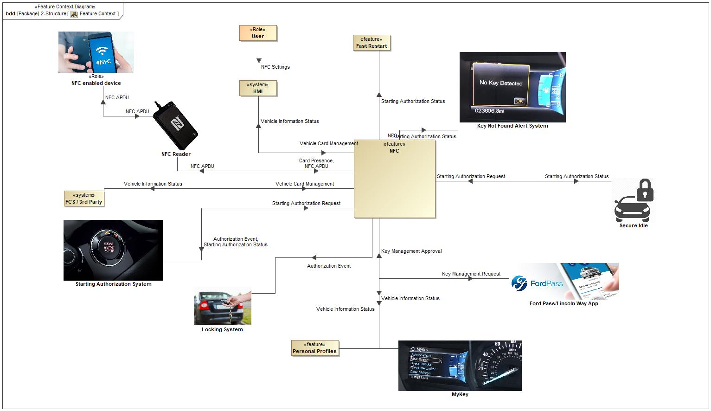

Figure 1: Feature Context

## List of Influences

|  |  |  |
| --- | --- | --- |
| **ID** | **External Entity** | **Influence Description** |
| Authorization Event | NFC To Locking System | Influence Description from Documentation field. |
| NFC To Starting Authorization System | Influence Description from Documentation field. |
| Card Presence | NFC Reader To NFC | Influence Description from Documentation field. |
| Key Management Approval | Ford Pass/Lincoln Way App To NFC | Influence Description from Documentation field. |
| Key Management Request | NFC To Ford Pass/Lincoln Way App | Influence Description from Documentation field. |
| NFC APDU | NFC Reader To NFC | Influence Description from Documentation field. |
| NFC Reader To NFC enabled device | Influence Description from Documentation field. |
| NFC To NFC Reader | Influence Description from Documentation field. |
| NFC enabled device To NFC Reader | Influence Description from Documentation field. |
| NFC Settings | User To | Influence Description from Documentation field. |
| Starting Authorization Request | Secure Idle To NFC | Influence Description from Documentation field. |
| Starting Authorization System To NFC | Influence Description from Documentation field. |
| Starting Authorization Status | NFC To Fast Restart | Influence Description from Documentation field. |
| NFC To Key Not Found Alert System | Influence Description from Documentation field. |
| NFC To Secure Idle | Influence Description from Documentation field. |
| NFC To Starting Authorization System | Influence Description from Documentation field. |
| Vehicle Card Management |  | Influence Description from Documentation field. |
| Vehicle Information Status | NFC To | Influence Description from Documentation field. |
| NFC To MyKey | Influence Description from Documentation field. |
| NFC To Personal Profiles | Influence Description from Documentation field. |

Table 7: List of Influences

# Feature Modeling

## Operation Modes and States

**#Classification:** Optional (Mandatory for Functional Safety)

**#Link:** [RE Wiki – State Charts](http://wiki.ford.com/display/RequirementsEngineering/State+Charts?src=contextnavpagetreemode)

**#Hint:** State Charts are a popular means to express feature behavior in terms of states and modes. An advantage of this state machine like approach is that consistency can be easily verified.

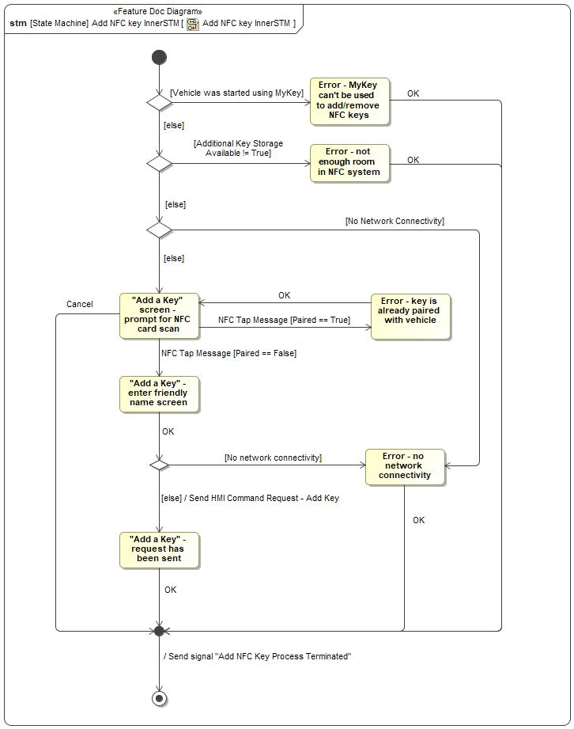

Figure 2: Add NFC key InnerSTM

|  |  |  |
| --- | --- | --- |
| **State** | **Description** | **Requirements Reference** (optional) |
| "Add a Key" - enter friendly name screen |  |  |
| "Add a Key" - request has been sent |  |  |
| "Add a Key" screen - prompt for NFC card scan |  |  |
| Error - key is already paired with vehicle |  |  |
| Error - MyKey can't be used to add/remove NFC keys |  |  |
| Error - no network connectivity |  |  |
| Error - not enough room in NFC system |  |  |

Table 8: Operation Modes and States on Add NFC key InnerSTM

|  |  |  |
| --- | --- | --- |
| **Transition ID** | **Description** | **Requirements Reference**  (optional) |
| T1 |  |  |
| T2 | Trigger signal: OK |  |
| T3 | Trigger signal: OK |  |
| T4 | Trigger signal: OK |  |
| T5 | Guard: =Paired == True  Trigger signal: NFC Tap Message |  |
| T6 | Trigger signal: OK |  |
| T7 | Guard: =Vehicle was started using MyKey |  |
| T8 | Trigger signal: Cancel |  |
| T9 | Guard: Additional Key Storage Available != True |  |
| T10 | Guard: No network connectivity |  |
| T11 | Trigger signal: OK |  |
| T12 | Guard: =Paired == False  Trigger signal: NFC Tap Message |  |
| T13 | Effect: End Add NFC Key flow |  |
| T14 | Guard: else  Effect: Send HMI Command Request - Add Key |  |
| T15 | Trigger signal: OK |  |
| T16 | Guard: =No Network Connectivity |  |
| T17 | Guard: else |  |
| T18 | Guard: else |  |
| T19 | Guard: else |  |

Table 9: Transitions between Operation Modes and States on Add NFC key InnerSTM

The screens and flows of the in-vehicle display system that are relevant to the NFC Entry and Starting feature.

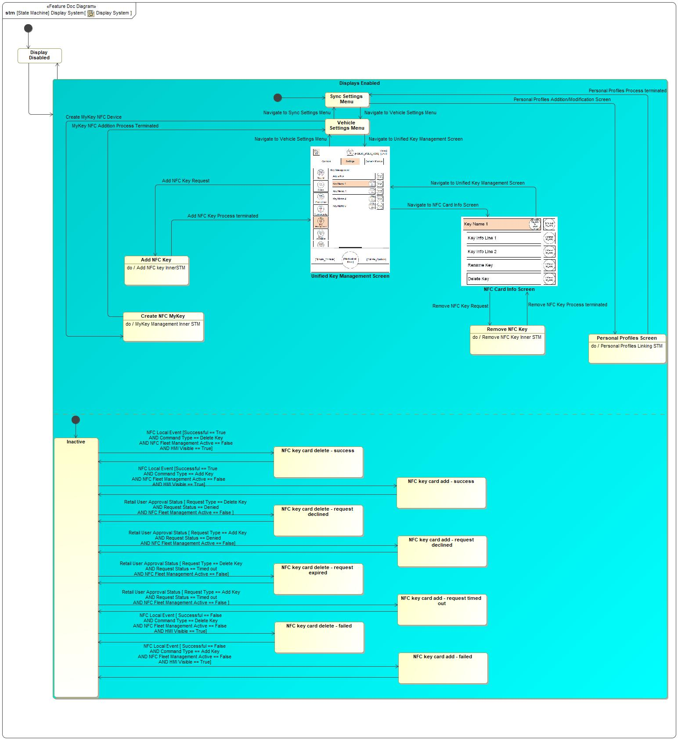

Figure 3: Display System

|  |  |  |
| --- | --- | --- |
| **State** | **Description** | **Requirements Reference** (optional) |
| Add NFC Key | Do behavior: Add NFC key InnerSTM |  |
| Create NFC MyKey | Do behavior: MyKey Management Inner STM |  |
| Display Disabled |  |  |
| Displays Enabled |  |  |
| Inactive |  |  |
| NFC Card Info Screen |  |  |
| NFC key card add - failed | The owner approved the add request, and the backend issued the add command appropriately, but some failure occurred on the vehicle that prevented the key add from being completed. |  |
| NFC key card add - request declined |  |  |
| NFC key card add - request timed out |  |  |
| NFC key card add - success |  |  |
| NFC key card delete - failed |  |  |
| NFC key card delete - request declined |  |  |
| NFC key card delete - request expired |  |  |
| NFC key card delete - success |  |  |
| Personal Profiles Screen | Do behavior: Personal Profiles Linking STM |  |
| Remove NFC Key | Do behavior: Remove NFC Key Inner STM |  |
| Sync Settings Menu |  |  |
| Unified Key Management Screen |  |  |
| Vehicle Settings Menu |  |  |

Table 10: Operation Modes and States on Display System

|  |  |  |
| --- | --- | --- |
| **Transition ID** | **Description** | **Requirements Reference**  (optional) |
| T1 | Trigger signal: Remove NFC Key Request |  |
| T2 | Trigger signal: Navigate to Unified Key Management Screen |  |
| T3 | Trigger signal: Remove NFC Key Process terminated |  |
| T4 |  |  |
| T5 |  |  |
| T6 | Trigger signal: Personal Profiles Process terminated |  |
| T7 | Trigger signal: Navigate to Unified Key Management Screen |  |
| T8 |  |  |
| T9 | Guard: =  Trigger signal: Add NFC Key Request |  |
| T10 | Trigger signal: Navigate to NFC Card Info Screen |  |
| T11 |  |  |
| T12 |  |  |
| T13 | Trigger signal: MyKey NFC Addition Process Terminated |  |
| T14 | Guard: Successful == True AND Command Type == Add Key AN...  Trigger signal: NFC Local Event |  |
| T15 | Trigger signal: Create MyKey NFC Device |  |
| T16 |  |  |
| T17 |  |  |
| T18 |  |  |
| T19 | Guard: Request Type == Delete Key AND Request Status == ...  Trigger signal: Retail User Approval Status |  |
| T20 |  |  |
| T21 | Guard: Successful == False AND Command Type == Add Key A...  Trigger signal: NFC Local Event |  |
| T22 | Guard: Successful == True AND Command Type == Delete Key ...  Trigger signal: NFC Local Event |  |
| T23 | Trigger signal: Navigate to Sync Settings Menu |  |
| T24 |  |  |
| T25 | Trigger signal: Navigate to Vehicle Settings Menu |  |
| T26 | Guard: Request Type == Add Key AND Request Status == Tim...  Trigger signal: Retail User Approval Status |  |
| T27 | Trigger signal: Navigate to Vehicle Settings Menu |  |
| T28 | Trigger signal: Personal Profiles Addition/Modification Screen |  |
| T29 |  |  |
| T30 | Guard: Successful == False AND Command Type == Delete Ke...  Trigger signal: NFC Local Event |  |
| T31 |  |  |
| T32 | Guard: Request Type == Add Key AND Request Status == Den...  Trigger signal: Retail User Approval Status |  |
| T33 | Guard: Request Type == Delete Key AND Request Status == ...  Trigger signal: Retail User Approval Status |  |
| T34 | Trigger signal: Add NFC Key Process terminated |  |
| T35 |  |  |

Table 11: Transitions between Operation Modes and States on Display System

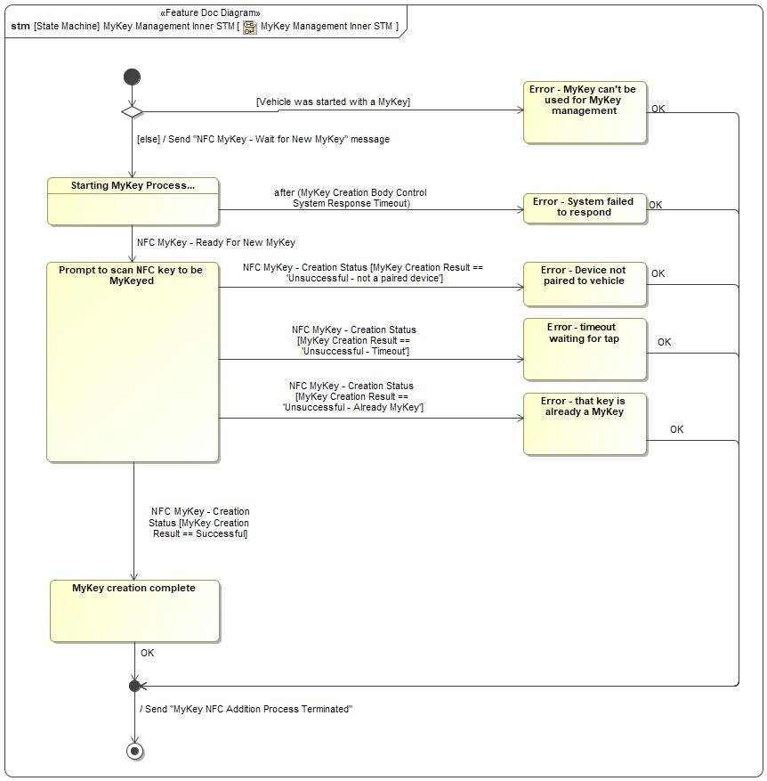

Figure 4: MyKey Management Inner STM

|  |  |  |
| --- | --- | --- |
| **State** | **Description** | **Requirements Reference** (optional) |
| Error - Device not paired to vehicle |  |  |
| Error - MyKey can't be used for MyKey management | The vehicle was started using a key with MyKey restrictions. MyKey management is not available. To create MyKeys or reset the MyKey system, turn the car off and start it again with a standard key. |  |
| Error - System failed to respond |  |  |
| Error - that key is already a MyKey |  |  |
| Error - timeout waiting for tap |  |  |
| MyKey creation complete |  |  |
| Prompt to scan NFC key to be MyKeyed |  |  |
| Starting MyKey Process... | Entry behavior: Start MyKey Process |  |

Table 12: Operation Modes and States on MyKey Management Inner STM

|  |  |  |
| --- | --- | --- |
| **Transition ID** | **Description** | **Requirements Reference**  (optional) |
| T1 | Guard: =Vehicle was started with a MyKey |  |
| T2 | Trigger signal: OK |  |
| T3 |  |  |
| T4 |  |  |
| T5 | Trigger signal: OK |  |
| T6 | Effect: End MyKey add process |  |
| T7 | Guard: =  Trigger signal: NFC MyKey - Ready For New MyKey |  |
| T8 | Guard: =else  Effect: Trigger MyKey Creation On Body Control System |  |
| T9 | Guard: MyKey Creation Result == 'Unsuccessful - Timeout'  Trigger signal: NFC MyKey - Creation Status |  |
| T10 | Guard: =MyKey Creation Result == Successful  Trigger signal: NFC MyKey - Creation Status |  |
| T11 | Trigger signal: OK |  |
| T12 | Trigger signal: OK |  |
| T13 | Guard: MyKey Creation Result == 'Unsuccessful - not a pa...  Trigger signal: NFC MyKey - Creation Status |  |
| T14 | Trigger signal: OK |  |
| T15 | Trigger signal: OK |  |
| T16 | Guard: =MyKey Creation Result == 'Unsuccessful - ...  Trigger signal: NFC MyKey - Creation Status |  |

Table 13: Transitions between Operation Modes and States on MyKey Management Inner STM

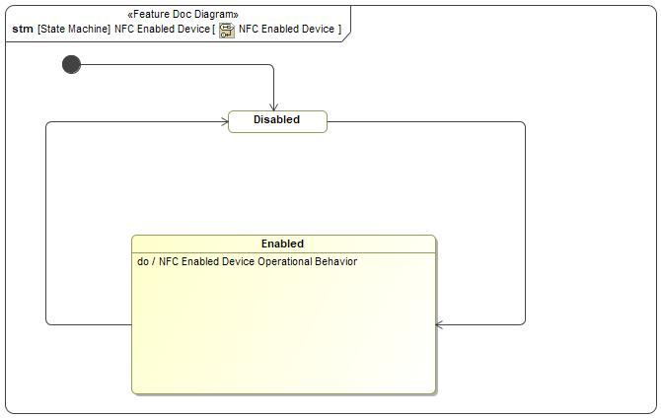

Figure 5: NFC Enabled Device

|  |  |  |
| --- | --- | --- |
| **State** | **Description** | **Requirements Reference** (optional) |
| Disabled |  |  |
| Enabled | Do behavior: NFC Enabled Device Operational Behavior |  |

Table 14: Operation Modes and States on NFC Enabled Device

|  |  |  |
| --- | --- | --- |
| **Transition ID** | **Description** | **Requirements Reference**  (optional) |
| T1 |  |  |
| T2 |  |  |
| T3 |  |  |

Table 15: Transitions between Operation Modes and States on NFC Enabled Device

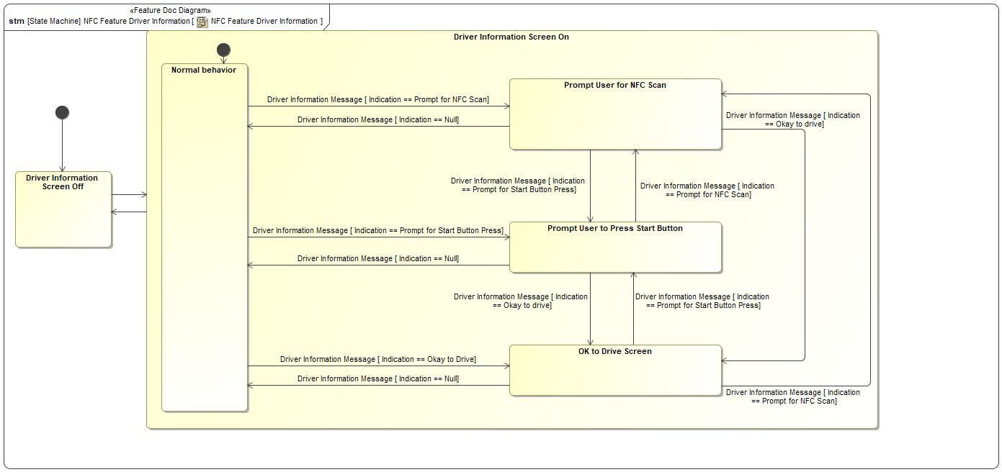

Figure 6: NFC Feature Driver Information

|  |  |  |
| --- | --- | --- |
| **State** | **Description** | **Requirements Reference** (optional) |
| Driver Information Screen Off |  |  |
| Driver Information Screen On |  |  |
| Normal behavior |  |  |
| OK to Drive Screen | This screen gives feedback to the user in the Secure Idle case - the user can exit Secure Idle by scanning an NFC device, and in this case there is no feedback indicating a successful scan except this screen. |  |
| Prompt User for NFC Scan |  |  |
| Prompt User to Press Start Button |  |  |

Table 16: Operation Modes and States on NFC Feature Driver Information

|  |  |  |
| --- | --- | --- |
| **Transition ID** | **Description** | **Requirements Reference**  (optional) |
| T1 | Guard: Indication == Okay to drive  Trigger signal: Driver Information Message |  |
| T2 | Guard: Indication == Prompt for Start Button Press  Trigger signal: Driver Information Message |  |
| T3 |  |  |
| T4 | Guard: Indication == Null  Trigger signal: Driver Information Message |  |
| T5 |  |  |
| T6 |  |  |
| T7 |  |  |
| T8 | Guard: Indication == Prompt for NFC Scan  Trigger signal: Driver Information Message |  |
| T9 | Guard: Indication == Okay to drive  Trigger signal: Driver Information Message |  |
| T10 | Name: ..Driver Information Message [ Indication == Prompt for Start Button Press]  Guard: Indication == Prompt for Start Button Press  Trigger signal: Driver Information Message |  |
| T11 | Guard: Indication == Null  Trigger signal: Driver Information Message |  |
| T12 | Guard: Indication == Okay to Drive  Trigger signal: Driver Information Message |  |
| T13 | Guard: Indication == Prompt for NFC Scan  Trigger signal: Driver Information Message |  |
| T14 | Guard: Indication == Null  Trigger signal: Driver Information Message |  |
| T15 | Guard: Indication == Prompt for Start Button Press  Trigger signal: Driver Information Message |  |
| T16 | Guard: Indication == Prompt for NFC Scan  Trigger signal: Driver Information Message |  |

Table 17: Transitions between Operation Modes and States on NFC Feature Driver Information

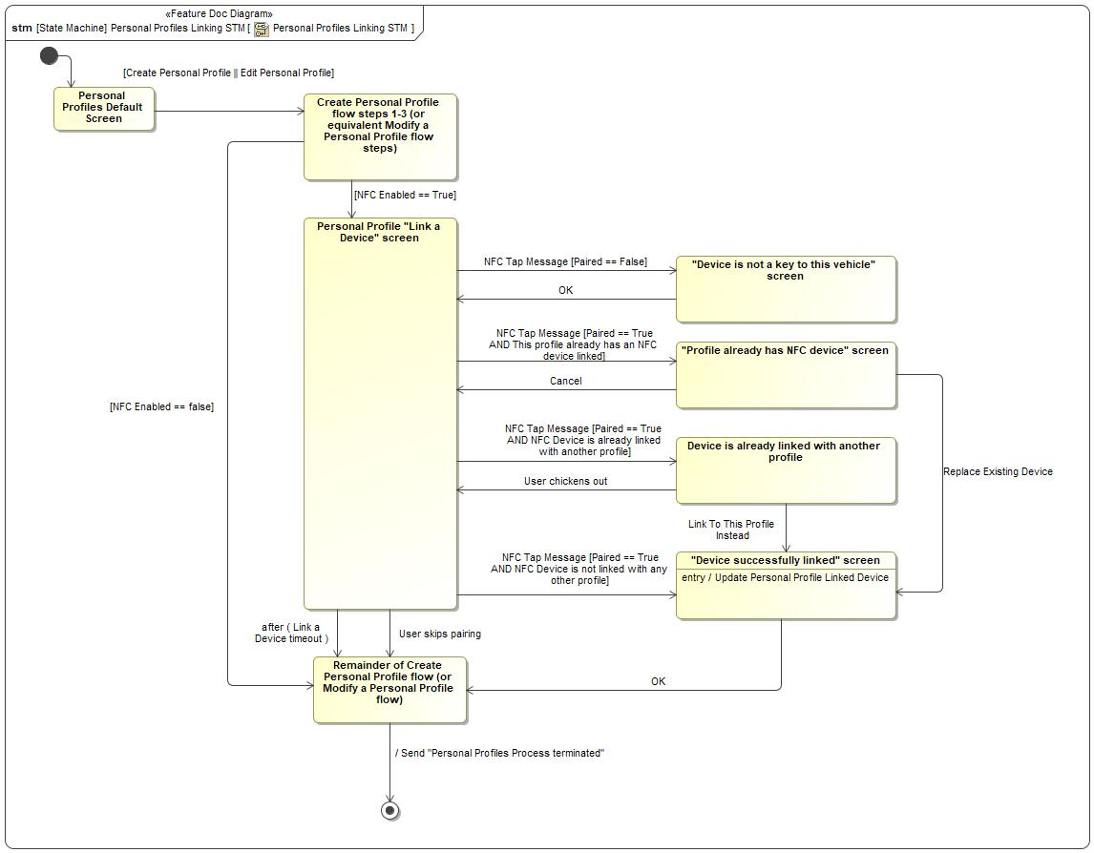

Figure 7: Personal Profiles Linking STM

|  |  |  |
| --- | --- | --- |
| **State** | **Description** | **Requirements Reference** (optional) |
| "Device is not a key to this vehicle" screen |  |  |
| "Device successfully linked" screen | Entry behavior: Update Personal Profile Linked Device |  |
| "Profile already has NFC device" screen |  |  |
| Create Personal Profile flow steps 1-3 (or equivalent Modify a Personal Profile flow steps) |  |  |
| Device is already linked with another profile |  |  |
| Personal Profile "Link a Device" screen |  |  |
| Personal Profiles Default Screen |  |  |
| Remainder of Create Personal Profile flow (or Modify a Personal Profile flow) |  |  |

Table 18: Operation Modes and States on Personal Profiles Linking STM

|  |  |  |
| --- | --- | --- |
| **Transition ID** | **Description** | **Requirements Reference**  (optional) |
| T1 | Name: User selects "Yes" - overwrite existing link  Trigger signal: Link To This Profile Instead |  |
| T2 | Trigger signal: Cancel |  |
| T3 | Guard: =Paired == False  Trigger signal: NFC Tap Message |  |
| T4 | Trigger signal: OK |  |
| T5 | Name: User selects "Yes" - replace existing device  Trigger signal: Replace Existing Device |  |
| T6 | Trigger signal: User skips pairing |  |
| T7 | Trigger signal: OK |  |
| T8 |  |  |
| T9 | Guard: =Create Personal Profile || Edit Personal ... |  |
| T10 | Effect: End Personal Profiles process |  |
| T11 |  |  |
| T12 | Guard: =NFC Enabled == false |  |
| T13 | Guard: NFC Enabled == True |  |
| T14 | Guard: =Paired == True AND NFC Device is not link...  Trigger signal: NFC Tap Message |  |
| T15 | Guard: =Paired == True AND NFC Device is already...  Trigger signal: NFC Tap Message |  |
| T16 | Trigger signal: User chickens out |  |
| T17 | Guard: =Paired == True AND This profile already h...  Trigger signal: NFC Tap Message |  |

Table 19: Transitions between Operation Modes and States on Personal Profiles Linking STM

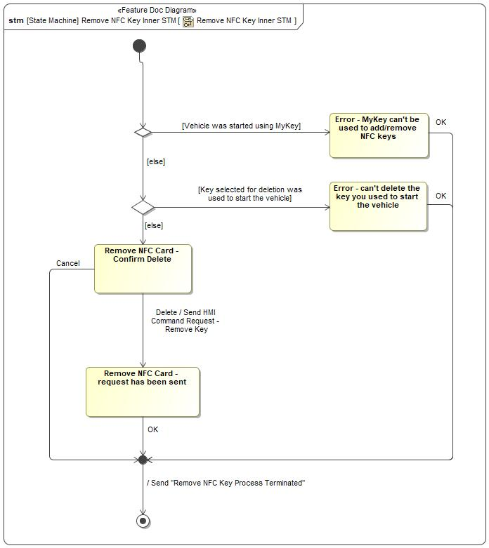

Figure 8: Remove NFC Key Inner STM

|  |  |  |
| --- | --- | --- |
| **State** | **Description** | **Requirements Reference** (optional) |
| Error - can't delete the key you used to start the vehicle | The key that the user selected for deletion is the key that was used to start the vehicle. You can't delete the key you used to start the vehicle. To delete this key, turn the car off and start it with a different key. |  |
| Error - MyKey can't be used to add/remove NFC keys |  |  |
| Remove NFC Card - Confirm Delete | Confirm that the user wants to delete the specified NFC key - it will no longer be able to open or start the vehicle. |  |
| Remove NFC Card - request has been sent |  |  |

Table 20: Operation Modes and States on Remove NFC Key Inner STM

|  |  |  |
| --- | --- | --- |
| **Transition ID** | **Description** | **Requirements Reference**  (optional) |
| T1 | Trigger signal: OK |  |
| T2 | Guard: else |  |
| T3 | Guard: Key selected for deletion was used to start the ve... |  |
| T4 | Trigger signal: OK |  |
| T5 | Trigger signal: Cancel |  |
| T6 | Guard: else |  |
| T7 | Trigger signal: OK |  |
| T8 | Effect: End MyKey Delete Process |  |
| T9 | Trigger signal: Delete  Effect: Send HMI Command Request - Remove Key |  |
| T10 | Guard: Vehicle was started using MyKey |  |
| T11 |  |  |

Table 21: Transitions between Operation Modes and States on Remove NFC Key Inner STM

## Use Cases

**#Classification:** Optional

**#Link:** [RE Wiki – Use Cases](http://wiki.ford.com/display/RequirementsEngineering/Use+Cases+Overview?src=contextnavpagetreemodehttp://wiki.ford.com/display/RequirementsEngineering/Use+Cases?src=contextnavpagetreemode)

### Use Case Diagram

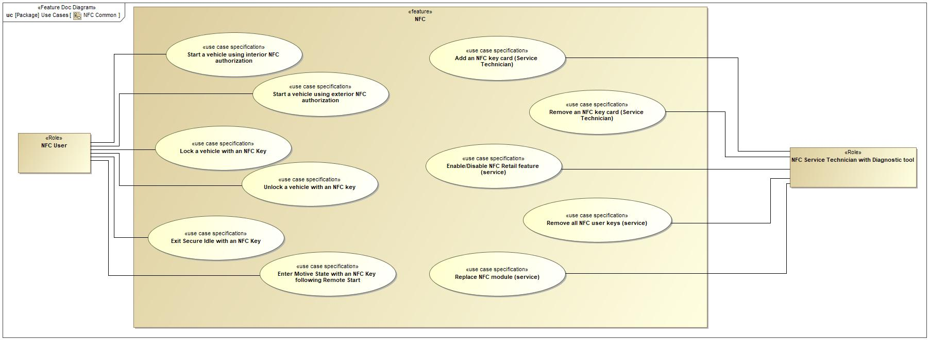

Figure 9: NFC Common

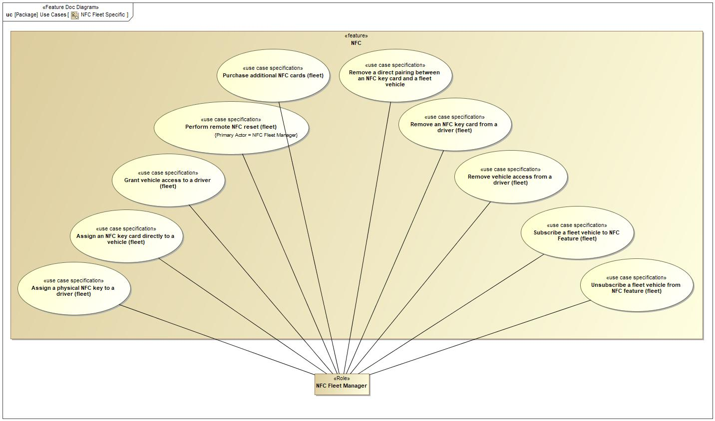

Figure 10: NFC Fleet Specific

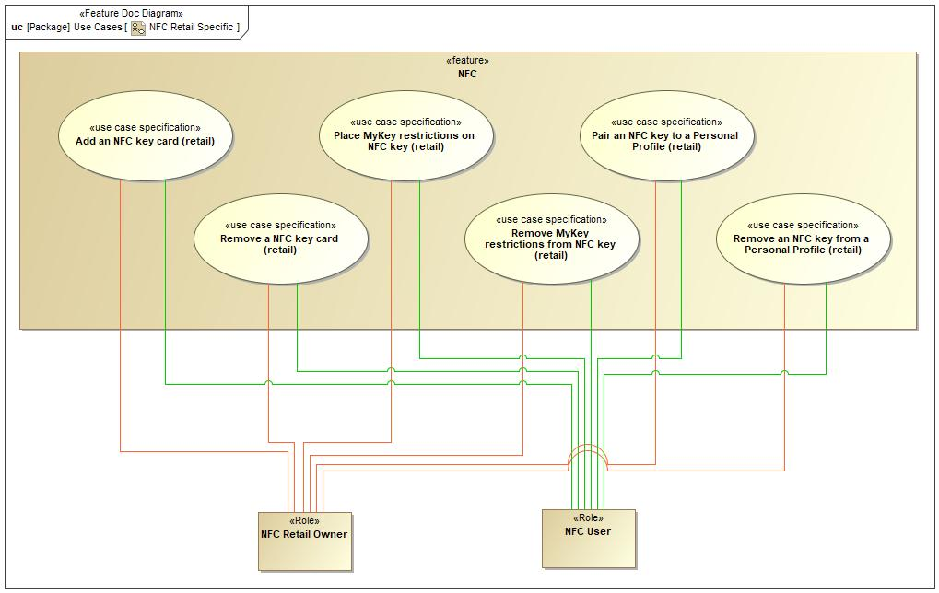

Figure 11: NFC Retail Specific

### Actors

| **Actor** | **Description** |
| --- | --- |
| NFC Fleet Manager | The manager of an FCS fleet which has NFC-capable vehicles that are subscribed to the fleet NFC management feature. |
| NFC Retail Owner | The owner of an NFC-enabled vehicle who has authorized the vehicle's modem and uses the FordPass or Lincoln Way app to interact with their vehicle. |
| NFC Service Technician with Diagnostic tool | A service technician who needs to service or replace components of NFC-capable vehicles. |
| NFC User | Any user of an NFC-capable vehicle who uses an NFC access card or NFC smart device to open and/or start the vehicle. |

Table 22: List of Actors

### Use Case Descriptions

**#Classification:** Optional

1 Enable/Disable NFC Retail feature (service)

|  |  |  |
| --- | --- | --- |
| **Actors** | Primary | NFC Service Technician with Diagnostic tool |
| **Subject** |  | NFC |
| **Description** |  |  |
| **Preconditions** | PreC1 | Service Technician has a service tool with backend connectivity and NFC service capabilities. |
| PreC2 | Service Technician has valid credentials to authorize themselves to Ford Backend. |
| PreC3 | Vehicle is equipped with NFC system. |
| **Main Flow Description** |  | To enable NFC Retail feature for a vehicle. |
| **Main Flow** | M1 | Technician queries the NFC module via diagnostic tool |
| M2 | Diagnostic tool detects NFC module. |
| M3 | Service technician selects new feature state (enabled/disabled) and provides credentials |
| M4 | Service tool compiles credentials and vehicle command requrest, transmits to backend |
| M5 | Backend authenticates credentials and transmits vehicle command package to service tool |
| M6 | Service tool transmits command package to NFCM over CAN and confirms that it has been received and executed |
| M7 | Service tool sets appropriate flags on other impacted vehicle systems to match enabled or disabled state |
| **Exceptional Flow Description** |  | No NFC module detected |
| **Exceptional Flow Description** |  | Service tool not connected to vehicle |
| **Exceptional Flow Description** |  | Configuring other modules on vehicle fails |
| **Exceptional Flow Steps** | E1 | 2 Service tool does not detect NFC module. |
| E2 | 3 Service tool indicates to technician that NFC module is not detected/lost communications. |
| E3 | 6 Service tool receives command package while not connected to vehicle, or technician credentials for service session have expired |
| E4 | 7 Service tool indicates to technician that operation cannot be completed due to timeout or disconnection from vehicle |
| E5 | - |
| E6 | 8 Service tool fails to set approprate configuration parameter bits/flags on impacted modules to match new NFC System state (enabled/disabled) |
| E7 | 9 Service tool indicates error in setting configuration parameter values on impacted modules |
| E8 | - |
| E9 | - |
| **Postconditions** | PostC1 | If new state is disabled: NFC System no longer polls for devices or communicates with rest of vehicle. Other modules ignore communication from NFC System. |
| PostC2 | If new state is enabled: NFC System is polling for devices and communicates with rest of vehicle. Impacted modules accept communications from NFC system. |
| PostC3 | NFC Retail feature is enabled/disabled, according to technician command |

9 Add an NFC key card (retail)

|  |  |  |
| --- | --- | --- |
| **Actors** | Primary | NFC Retail Owner |
|  | NFC User |
| **Subject** |  | NFC |
| **Description** |  |  |
| **Preconditions** | PreC1 | Modem has been authorized on this vehicle |
| PreC2 | Retail owner has Ford/Lincoln mobile app installed on their smart device. |
| PreC3 | Retail owner’s smart device has network connectivity. |
| PreC4 | User has a key to this vehicle that is not a MyKey. |
| PreC5 | User has a physical NFC key that has not been programmed to this vehicle. |
| PreC6 | Vehicle has network connectivity. |
| **Main Flow Description** |  | To add a physical NFC key to the vehicle as a user. |
| **Main Flow** | M1 | User starts vehicle with any key. |
| M2 | User selects to add NFC key card from in-vehicle HMI. |
| M3 | In-vehicle HMI prompts user to scan new NFC key card. |
| M4 | User places new NFC key card near interior NFC reader. |
| M5 | In-vehicle HMI prompts user to enter name for new key |
| M6 | User enters key name using in-vehicle HMI |
| M7 | In-vehicle HMI displays message indicating that key add request has been sent to vehicle owner for approval. |
| M8 | Retail owner receives request to add NFC key card in Ford/Lincoln mobile app. |
| M9 | Retail owner approves request. |
| M10 | In-vehicle HMI displays approval confirmation immediately if vehicle is running, at next start otherwise |
| **Alternative Flow Description** |  | Vehicle loses network connectivity after key add request has been sent, but regains connectivity before backend delivery timeout |
| **Alternative Flow Steps** | A1 | After retail owner approves request: Backend attempts to deliver key add command package to vehicle, and fails because vehicle is not connected |
| A2 | Vehicle regains connectivity before backend delivery timeout expires |
| A3 | Key add command package is successfully transmitted to vehicle |
| A4 | In-vehicle HMI displays approval confirmation immediately if vehicle is running, at next start otherwise |
| **Exceptional Flow Description** |  | Retail owner denies key add request |
| **Exceptional Flow Description** |  | Vehicle loses network connectivity before key add request is sent |
| **Exceptional Flow Description** |  | Vehicle loses network connectivity after key add request is sent, and never regains connectivity |
| **Exceptional Flow Description** |  | Retail owner's device does not have connectivity, is offline, is destroyed, etc |
| **Exceptional Flow Steps** | E1 | Retail user denies key add request: |
| E2 | After retail owner receives request to add NFC key card: Retail owner denies request. |
| E3 | In-vehicle HMI displays message indicating that key add request has been denied (immediately if running, at next start otherwise). |
| E4 | - |
| E5 | Vehicle loses network connectivity before key add request is sent: |
| E6 | After user places new NFC key card near interior NFC reader: In-vehicle HMI displays message indicating that network connectivity is required to add a key. |
| E7 | - |
| E8 | Vehicle loses network connectivity after key add request is sent, and never regains connectivity |
| E9 | After retail owner approves request: Backend attempts to deliver key add command until re-delivery timeout has elapsed |
| E10 | Notification is sent to retail owner's phone indicating that key add command was not delivered successfully |
| E11 | - |
| E12 | Retail owner's smartphone does not have connectivity, is offline, is destroyed, etc: |
| E13 | After in-vehicle HMI displays message indicating that key add request has been sent to vehicle owner for approval: Backend attempts to deliver approval request to retail owner's smartphone (and fails) |
| E14 | Retail owner's device does not receive key add request before delivery timeout expires |
| E15 | In-vehicle HMI displays message indicating that key add request has timed out (immediately if vehicle is running, at next start otherwise) |
| **Postconditions** | PostC1 | New physical NFC key can now be used to access and start this vehicle. |

10 Add an NFC key card (Service Technician)

|  |  |  |
| --- | --- | --- |
| **Actors** | Primary | NFC Service Technician with Diagnostic tool |
| **Subject** |  | NFC |
| **Subject** |  | Enabling/disabling the NFC Retail feature via Service tool |
| **Description** |  |  |
| **Preconditions** | PreC1 | NFC Retail Feature is enabled. |
| PreC2 | Service technician has a service tool that supports NFC key card add/delete. |
| PreC3 | Service technician has access to vehicle's OBD-II port. |
| PreC4 | Service technician has an NFC key card that has not been programmed to this vehicle. |
| PreC5 | Service technician has valid credentials to service backend system. |
| PreC6 | Service tool has connectivity. |
| **Main Flow Description** |  | To add a new physical NFC key to the vehicle as a service technician. |
| **Main Flow** | M1 | Service technician selects "add NFC key card" operation on service tool. |
| M2 | Service technician selects operation parameters (add factory key vs. add user key), then enters their credentials, vehicle VIN, key friendly name, and FESN of card to be added |
| M3 | Service tool connects to service backend and obtains command package using details entered by technician. |
| M4 | Service tool prompts for connection to vehicle. |
| M5 | Technician connects service tool to vehicle. |
| M6 | Service tool transmits command package to NFC system and verifies successful command execution. |
| M7 | Service tool displays success message. |
| M8 | Service tool sends message to Ford backend reporting that key add has been completed. |
| **Exceptional Flow Description** |  | Service technician chooses to add a factory key, but vehicle already has two factory keys programmed. |
| **Exceptional Flow Description** |  | Service tool unable to connect to Ford backend to obtain command package. |
| **Exceptional Flow Description** |  | Service tool unable to connect to vehicle or unable to communicate with NFC system on vehicle. |
| **Exceptional Flow Description** |  | Service tool loses connectivity after receiving key add command package |
| **Exceptional Flow Description** |  | Technician connects service tool to vehicle, but after a delay longer than the command package expiration time |
| **Exceptional Flow Description** |  | Malicious technician receives key add command package and extracts package from service tool, then attempts to transmit command package to vehicle using third-party tool after a delay longer than the command package timeout |
| **Exceptional Flow Steps** | E1 | Service technician chooses to add a factory key, but vehicle already has two factory keys programmed: |
| E2 | After service tool connects to service backend and obtains command package using details entered by technician: Service backend replies and provides valid command package, along with excess factory key warning |
| E3 | Service tool displays warning that vehicle already has maximum number of factory keys, with option to attempt key add anyway |
| E4 | If technician chooses to try key add anyway: Service tool prompts for connection to vehicle |
| E5 | Technician connects service tool to vehicle |
| E6 | Service tool transmits command package to NFC system |
| E7 | NFC system refuses to execute command package because two factory keys are already present |
| E8 | Service tool detects failed command package execution and displays error message |
| E9 | - |
| E10 | Service tool unable to connect to Ford backend to obtain command package: |
| E11 | After service technician selects operation parameters and enters credentials: Service tool attempts to contact Ford backend and fails |
| E12 | Service tool displays error message indicating that connection failed |
| E13 | - |
| E14 | Service tool unable to connect to vehicle or unable to communicate with NFC system on vehicle: |
| E15 | After technician connects service tool to vehicle: service tool attempts to communicate with NFC system and fails |
| E16 | Service tool displays connection error message |
| E17 | - |
| E18 | Service tool loses connectivity after receiving key add command package: |
| E19 | After service tool transmits command package to NFC system and verifies successful command execution: Service tool displays success message |
| E20 | Service tool attempts to deliver message to Ford backend reporting successful key add, but fails |
| E21 | Service tool stores key add success message indefinitely and waits for return of connectivity |
| E22 | - |
| E23 | Technician connects service tool to vehicle, but after a delay longer than the command package expiration time: |
| E24 | After service tool prompts for connection to vehicle: Some time passes (longer than command package expiration time) |
| E25 | After command package expiration time expires: Service tool deletes command package from internal memory |
| E26 | Service tool displays error message to technician indicating that command package has expired |
| E27 | - |
| E28 | Malicious technician receives key add command package, extracts it from service tool, then attempts to use third-party tool to transmit key add package to vehicle after key add package timeout |
| E29 | After service tool connects to service backend and obtains command package using details entered by technician: Technician extracts command package from service tool using some unsupported method |
| E30 | Some amount of time passes (longer than command package expiration) |
| E31 | Malicious technician connects to vehicle with third-party tool and attempts to transmit service package to NFC system |
| E32 | NFC system refuses to execute command package |
| **Postconditions** | PostC1 | Ford backend key pairing records are updated to reflect new key pairing. |
| PostC2 | If vehicle is subscribed to NFC fleet management feature: New NFC key card appears in "Keys with access to this vehicle" list of vehicle information page on FFM portal |
| PostC3 | New NFC key card can now be used to access and start this vehicle. |

11 Remove a NFC key card (retail)

|  |  |  |
| --- | --- | --- |
| **Actors** | Primary | NFC Retail Owner |
|  | NFC User |
| **Subject** |  | NFC |
| **Description** |  |  |
| **Preconditions** | PreC1 | NFC key card that the user wants to delete is not a factory key |
| PreC2 | User has a key that can start the vehicle and it is not a MyKey or the key the user wants to delete |
| PreC3 | Vehicle has connectivity |
| PreC4 | Vehicle's modem is authorized |
| PreC5 | Vehicle's retail owner has Ford/Lincoln mobile app installed on their smartphone |
| **Main Flow Description** |  | To remove an NFC key card from the vehicle |
| **Main Flow** | M1 | User starts vehicle with a key other than the one they want to delete |
| M2 | Using in-vehicle HMI, user navigates to list of paired keys and chooses the "delete" option for the key they want to delete |
| M3 | In-vehicle HMI confirms user intent ("are you sure?") |
| M4 | In-vehicle HMI builds key delete command request and sends it to Ford backend |
| M5 | Retail owner receives notification of deletion approval request on their smartphone app |
| M6 | Retail owner approves deletion request |
| M7 | Ford backend transmits deletion command to vehicle |
| M8 | Vehicle deletes pairing with specified key |
| M9 | In-vehicle HMI displays success message (immediately if vehicle is running, at next start otherwise) |
| **Exceptional Flow Description** |  | (Same exception flows as Add a Key) |
| **Postconditions** | PostC1 | The specified NFC key card can no longer be used to open or start the vehicle |

12 Remove all NFC user keys (service)

|  |  |  |
| --- | --- | --- |
| **Actors** | Primary | NFC Service Technician with Diagnostic tool |
| **Subject** |  | NFC |
| **Description** |  |  |
| **Preconditions** | PreC1 | NFC Retail Feature is enabled. |
| PreC2 | Service Technician has a key to this vehicle. |
| **Main Flow Description** |  | To remove all physical NFC keys from the vehicle as a service technician. |
| **Main Flow** | M1 | M1 Service Technician connects diagnostic tool to the vehicle. |
| M2 | M2 Service Technician obtains security credentials to unlock NFC module. |
| M3 | M3 Service Technician unlocks NFC module. |
| M4 | M4 Service Technician initiates diagnostic routine to remove all physical NFC keys. |
| M5 | M5 Diagnostic tool informs service technician of successful physical key removal. |
| **Postconditions** | PostC1 | Programmed physical NFC keys can no longer be used to access and start this vehicle. |

14 Subscribe a fleet vehicle to NFC Feature (fleet)

|  |  |  |
| --- | --- | --- |
| **Actors** | Primary | NFC Fleet Manager |
| **Subject** |  | NFC |
| **Description** |  |  |
| **Preconditions** | PreC1 | Fleet Manager has consented/taken ownership of the vehicle in FFM portal |
| PreC2 | Vehicle exists in Fleet Manager's fleet account (FFM Portal) |
| PreC3 | Vehicle has backend connectivity |
| **Main Flow Description** |  | To enable NFC feature on a fleet vehicle. |
| **Main Flow** | M1 | Fleet Manager selects desired vehicle(s) in FFM portal |
| M2 | Fleet Manager selects NFC feature and subscribes to that product |
| M3 | Fleet backend records new vehicle state (subscribed) and requests that Ford backend push new feature package to vehicle |
| M4 | Ford backend pushes new feature package to vehicle, vehicle applies new feature package |
| M5 | Vehicle deletes all NFC user keys that were created by retail users |
| M6 | Vehicle confirms application of feature package to Ford backend |
| **Postconditions** | PostC1 | All user keys, if programmed, are removed from vehicle |
| PostC2 | Factory key(s) remain paired with vehicle |
| PostC3 | Fleet Manager can use FFM portal (or third-party portal) to manage NFC keys on vehicle |
| PostC4 | NFC Fleet feature is enabled on this vehicle. |
| PostC5 | SYNC menus allowing Master Reset are disabled/inaccessible |
| PostC6 | SYNC menus/screens for in-vehicle key management are disabled/inaccessible |
| PostC7 | Vehicle appears in FFM under list of vehicles subscribed to NFC Fleet Feature |

15 Unsubscribe a fleet vehicle from NFC feature (fleet)

|  |  |  |
| --- | --- | --- |
| **Actors** | Primary | NFC Fleet Manager |
| **Subject** |  | NFC |
| **Description** |  |  |
| **Preconditions** | PreC1 | Vehicle has backend connectivity. |
| PreC2 | Vehicle is subscribed to NFC Fleet feature. |
| **Main Flow Description** |  | To disable NFC Fleet feature on a vehicle. |
| **Main Flow** | M1 | Fleet Manager selects desired vehicle(s) to be unsubscribed and issues "unsubscribe" command |
| M2 | FFM portal requests Ford backend send unenrollment package to vehicle |
| M3 | Ford backend sends unenrollment package to vehicle |
| M4 | Vehicle applies unenrollment package |
| M5 | Vehicle deletes all paired NFC user keys that were added by the NFC Fleet feature |
| M6 | Vehicle sends confirmation of unenrollment back to Ford backend |
| **Postconditions** | PostC1 | All user keys that were added by the NFC Fleet Feature are removed from vehicle |
| PostC2 | Any user keys that were added by a service technician remain on vehicle |
| PostC3 | FCS Portal/3rd party system cannot add, remove, or change NFC Keys from unsubscribed vehicle |
| PostC4 | Factory key(s) remain on vehicle |
| PostC5 | NFC Fleet feature is disabled on this vehicle. |
| PostC6 | SYNC menus allowing Master Reset are enabled/accessible |
| PostC7 | SYNC menus/screens for in-vehicle key management are enabled/accessible |
| PostC8 | Vehicle no longer appears in FFM under list of vehicles subscribed to NFC Fleet Feature |

16 Assign a physical NFC key to a driver (fleet)

|  |  |  |
| --- | --- | --- |
| **Actors** | Primary | NFC Fleet Manager |
| **Subject** |  | NFC |
| **Description** |  |  |
| **Preconditions** | PreC1 | Fleet manager has an NFC Key Card that is not assigned to any other driver in that fleet |
| PreC2 | Fleet manager has created a driver in the fleet |
| **Main Flow Description** |  | To assign an NFC Key Card to a specific driver in a fleet. |
| **Main Flow** | M1 | Fleet manager accesses fleet management web portal and selects the driver in question |
| M2 | Fleet manager selects operation: "Assign NFC Key Card" |
| M3 | Fleet manager selects the NFC Key Card to be assigned by selecting it from a list of available keys |
| M4 | Fleet manager confirms operation ("are you sure?") |
| **Exceptional Flow Description** |  | Fleet manager selects an NFC key card that is currently assigned to another driver in the same fleet |
| **Exceptional Flow Steps** | E1 | After fleet manager selects the NFC key card to be assigned: FCS portal displays error message indicating that key card has already been assigned to another driver |
| **Postconditions** | PostC1 | FCS portal creates pairings between the specified NFC key card and any vehicles that the driver has been assigned access to |
| PostC2 | Specified NFC key card appears on driver's information page in FCS portal, as key card assigned to driver |
| PostC3 | Specified NFC key card is assigned to specified driver. |
| PostC4 | The specified NFC key card appears on the vehicle information page for any vehicle the driver has access to, in the list of NFC key cards that can access the vehicle (first as pending, then as complete) |

17 Remove an NFC key card from a driver (fleet)

|  |  |  |
| --- | --- | --- |
| **Actors** | Primary | NFC Fleet Manager |
| **Subject** |  | NFC |
| **Description** |  |  |
| **Preconditions** | PreC1 | Driver already has an NFC card associated with them in FFM |
| PreC2 | Fleet manager has already created this driver in this fleet |
| **Main Flow Description** |  | To remove the association between a fleet driver and an NFC key card. |
| **Main Flow** | M1 | Fleet manager accesses FFM portal and selects driver in question |
| M2 | Fleet manager selects operation: "Unassign NFC Key Card" |
| M3 | Fleet manager confirms operation ("Are you sure?") |
| **Postconditions** | PostC1 | FFM portal initiates key deletion requests for any vehicles that the driver was granted access to, except vehicles where the just-removed NFC key card was manually associated with a vehicle directly |
| PostC2 | NFC key card continues to appear in "Keys that can access this vehicle" lists for vehicles that the driver had access to, with "deletion pending" labels |
| PostC3 | NFC key card in question is no longer associated with driver in question |
| PostC4 | NFC key card in question no longer appears on driver's information page in FFM portal |
| PostC5 | Once key deletions are successfully executed and confirmed by vehicles, NFC key card no longer appears in "Keys that can access this vehicle" lists for vehicles the driver had access to |

18 Grant vehicle access to a driver (fleet)

|  |  |  |
| --- | --- | --- |
| **Actors** | Primary | NFC Fleet Manager |
| **Subject** |  | NFC |
| **Description** |  |  |
| **Preconditions** | PreC1 | Fleet manager has already added vehicle and driver to fleet |
| PreC2 | Fleet manager has already paired an NFC key card to the driver in question |
| PreC3 | Vehicle has backend connectivity |
| PreC4 | Vehicle is subscribed to NFC fleet feature and a member of the fleet in question |
| **Main Flow Description** |  | To grant access to one or more vehicles to a specific driver, using the driver information page. |
| **Main Flow** | M1 | Fleet manager accesses FFM portal and navigates to the information page for the driver in question. |
| M2 | Fleet manager selects operation: "Grant Access" |
| M3 | Fleet manager selects the vehicle(s) from a list of all eligible vehicles in that fleet |
| M4 | Fleet manager confirms operation ("are you sure?") |
| M5 | Driver appears in the "Drivers with Access" list for selected vehicle(s), with "Pending" label |
| M6 | FFM backend requests key add commands be issued to the vehicle(s) in question for the NFC key card(s?) assigned to the driver in question |
| M7 | Vehicle(s) receive and execute key add command |
| **Alternative Flow Description** |  | To grant specific vehicle access to one or more fleet drivers, using the vehicle information page. |
| **Alternative Flow Steps** | A1 | Fleet manager accesses FFM portal and navigates to the information page for the vehicle in question. |
| A2 | Fleet manager selects operation: "Grant Access" |
| A3 | Fleet manager selects the driver(s) from a list of all eligible drivers in that fleet |
| A4 | Fleet manager confirms operation ("are you sure?") |
| A5 | Driver(s) appear in the "Drivers with access" list for selected vehicle, with "Pending" label |
| A6 | FFM backend requests key add commands be issued to the vehicle in question for the NFC card(s) associated with the selected driver(s) |
| A7 | Vehicle receives and executes key add command(s) |
| **Exceptional Flow Description** |  | Vehicle loses connectivity before key add request is received and remains offline |
| **Exceptional Flow Description** |  | Vehicle receives key add request, but fails to execute the request |
| **Exceptional Flow Description** |  | Fleet manager attempts to grant access to a vehicle which already has the maximum number of drivers assigned to it |
| **Exceptional Flow Steps** | E1 | Vehicle loses connectivity before key add request is received and remains offline: |
| E2 | After FFM backend requests key add requests be issued to the vehicle(s) in question: Driver appears in "drivers with access" list for specified vehicle with "pending" label, and vehicle appears in "vehicles this driver can access" list for specified driver with "pending" label |
| E3 | Backend continues to retry transmission of key add request until retry limit/timeout expires |
| E4 | If backend retry timeout expires: warning is added to vehicle information page ("cannot contact vehicle, key add unsuccessful") |
| E5 | If backend retry timeout expires: vehicle appears in "vehicles this driver can access" list on driver information page in FFM portal with "Error" label |
| E6 | If backend retry timeout expires: driver appears in "Drivers with access" list, and driver's NFC key card appears in "Keys with access" list on vehicle information page in FFM portal, both with "Error" label |
| E7 | - |
| E8 | Vehicle receives key add request, but fails to execute the request: |
| E9 | After vehicle(s) receive key add command: vehicle(s) attempt key add command execution, fail, and notify backend of failure |
| E10 | Warning is added to vehicle information page for vehicle(s) reporting key add failure ("error adding key to vehicle") |
| E11 | Vehicle(s) appear in "vehicles this driver can access" list on driver information page in FFM portal with "Error" label |
| E12 | Driver appears in "drivers with access" list, and driver's assigned NFC card appears in "Keys with access" list on vehicle page in FFM portal, both with "Error" label |
| E13 | - |
| E14 | Fleet manager attempts to grant access to a vehicle which already has the maximum number of drivers assigned: |
| E15 | After fleet manager selects the vehicle from a list of all eligible vehicles in the fleet: FFM portal displays error ("That vehicle has already been assigned the maximum number of drivers") |
| **Postconditions** | PostC1 | Driver(s) to which access has been granted appear in "Drivers that can access this vehicle" list on vehicle information page(s) in FFM portal (first with "Pending" label, then without) |
| PostC2 | NFC key card(s) assigned to driver(s) to whom access has been granted appear in "Key card that can access this vehicle" list(s) of the vehicle information page(s) of the vehicle(s) in question in the FFM portal |
| PostC3 | Specified driver(s) can now use their assigned NFC key card(s) to open and start the vehicle(s) in question. |
| PostC4 | Vehicle(s) to which access has been granted appear in "Vehicles this driver can access" list on the driver information page of FFM portal (first with "Pending" label, then without) |

19 Remove vehicle access from a driver (fleet)

|  |  |  |
| --- | --- | --- |
| **Actors** | Primary | NFC Fleet Manager |
| **Subject** |  | NFC |
| **Description** |  |  |
| **Preconditions** | PreC1 | Fleet Admin has added user to fleet. |
| PreC2 | Fleet Admin has enrolled vehicle in NFC Fleet feature. |
| PreC3 | Fleet Admin has granted vehicle access to user. |
| **Main Flow Description** |  | To remove a specific fleet driver's access to a specific vehicle using the driver's information page. |
| **Main Flow** | M1 | Fleet manager accesses FFM portal and navigates to driver information page for driver in question. |
| M2 | Fleet manager locates vehicle in "Vehicles this driver can access" list and selects "Remove access" operation |
| M3 | Fleet manager confirms operation ("are you sure?") |
| M4 | Driver appears in "Drivers with access" list with "Pending Removal" label |
| M5 | FFM requests key deletion command from Ford backend for the NFC card associated with the driver in question |
| M6 | Ford backend generates key deletion command and sends to vehicle |
| M7 | Vehicle receives key deletion command, executes, and confirms execution to Ford backend |
| **Alternative Flow Description** |  | To remove a specific fleet driver's access to a specific vehicle using the vehicle's information page. |
| **Alternative Flow Steps** | A1 | Fleet manager accesses FFM portal and navigates to vehicle information page for the vehicle in question. |
| A2 | Fleeet manager locates driver in "Drivers with access" list and selects "Remove access" operation. |
| A3 | Fleet manager confirms operation ("are you sure?") |
| A4 | Driver appears in "Drivers with access" list with "Pending Removal" label |
| A5 | FFM requests key deletion command from Ford backend for the NFC card associated with the driver in question |
| A6 | Ford backend generates key deletion command and sends to vehicle |
| A7 | Vehicle receives key deletion command, executes, and confirms execution to Ford backend |
| **Exceptional Flow Description** |  | Same exception flows as "Grant vehicle access to a driver", except "Fleet manager attempts to grant access to a vehicle which already has the maximum number of keys paired" |
| **Postconditions** | PostC1 | After confirmed successful key deletion, the driver and card no longer appear on the vehicle's information page in the FFM portal, and the vehicle no longer appears on the driver information page of the FFM portal |
| PostC2 | Fleet driver can no longer use their assigned NFC key card to access and drive the specified vehicle, unless a direct pairing between key card and vehicle has been created separately. |
| PostC3 | Fleet driver continues to appear in "Drivers with access" list of the vehicle in question, and driver's key card continues to appear in the "Keys with access" list of the vehicle in question, both with "Pending Removal" labels, until the key delete command is confirmed by the vehicle |
| PostC4 | Vehicle continues to appear in the "Vehicles this driver can access" list of the driver information page for the driver in question in the FFM portal, with a "Pending Removal" label, until the vehicle confirms successful key deletion |

20 Unlock a vehicle with an NFC key

|  |  |  |
| --- | --- | --- |
| **Actors** | Primary | NFC User |
| **Subject** |  | NFC |
| **Description** |  |  |
| **Preconditions** | PreC1 | All vehicle doors are locked. |
| PreC2 | NFC feature is enabled. |
| PreC3 | User has an NFC device that is paired with the vehicle. |
| PreC4 | Vehicle battery is not completely discharged. |
| **Main Flow Description** |  | To unlock the vehicle using an NFC device. |
| **Main Flow** | M1 | User places NFC device near NFC reader at driver door. |
| M2 | The driver door unlocks, or all of the vehicle doors unlock, depending on the vehicle's config. |
| **Alternative Flow Description** |  | To unlock all of the doors of a vehicle when two-stage unlocking is enabled. |
| **Alternative Flow Steps** | A1 | User places NFC device near NFC reader at driver door. |
| A2 | Driver door unlocks. |
| A3 | User continues to hold NFC device near NFC reader at driver door for a few seconds. |
| A4 | All doors unlock. |
| **Postconditions** | PostC1 | Driver door is unlocked, or all doors are unlocked, depending on vehicle config. |

21 Lock a vehicle with an NFC Key

|  |  |  |
| --- | --- | --- |
| **Actors** | Primary | NFC User |
| **Subject** |  | NFC |
| **Description** |  |  |
| **Preconditions** | PreC1 | Any vehicle door is unlocked. |
| PreC2 | NFC feature is enabled. |
| PreC3 | User has an NFC device that is paired with the vehicle. |
| PreC4 | Vehicle battery is not completely discharged. |
| PreC5 | Vehicle driver door is closed. |
| **Main Flow Description** |  | To lock the vehicle. |
| **Main Flow** | M1 | User places NFC device near NFC reader at driver door. |
| M2 | All vehicle doors lock. |
| **Alternative Flow Description** |  | To double-lock the vehicle (when the vehicle is configured to allow double-locking). |
| **Alternative Flow Steps** | A1 | User places NFC device near NFC reader at driver door. |
| A2 | All vehicle doors lock. |
| A3 | User continues to hold NFC device near NFC reader at driver door for a few seconds. |
| A4 | All vehicle doors double-lock. |
| **Postconditions** | PostC1 | Vehicle is locked (or double-locked, if configured and user performs long tap) |

22 Start a vehicle using exterior NFC authorization

|  |  |  |
| --- | --- | --- |
| **Actors** | Primary | NFC User |
| **Subject** |  | NFC |
| **Description** |  |  |
| **Preconditions** | PreC1 | All vehicle doors are locked. |
| PreC2 | Exterior NFC Starting Authorization is enabled. |
| PreC3 | NFC feature is enabled. |
| PreC4 | There is no PEPS keyfob in the vehicle. |
| PreC5 | There is no PaaK device in the vehicle, or the vehicle does not have PaaK enabled. |
| PreC6 | User has an NFC device with access to this vehicle. |
| PreC7 | Vehicle battery is not completely discharged. |
| PreC8 | Vehicle is off. |
| **Main Flow Description** |  | To start the vehicle quickly after unlocking it. |
| **Main Flow** | M1 | User places NFC device near NFC reader at driver door. |
| M2 | Vehicle unlocks. |
| M3 | User enters vehicle. |
| M4 | In-vehicle HMI displys message: "Press Start Button to Drive" (or equivalent) |
| M5 | User holds brake pedal and presses START/STOP button before exterior starting authorization timeout has expired. |
| M6 | Vehicle starts. |
| **Alternative Flow Description** |  | Exterior starting authorization timeout expires before user presses start/stop button. |
| **Alternative Flow Steps** | A1 | After user enters vehicle: in-vehicle HMI displays message: "Press Start Button to Drive" (or equivalent) |
| A2 | User does not press START/STOP button before exterior starting authorization timeout expires |
| A3 | In-vehicle HMI no longer displays "Press Start Button to Drive" message |
| A4 | User presses brake pedal and START/STOP button |
| A5 | In-vehicle HMI displays message: "No Key Found / Scan NFC Key to Drive" (or equivalent) |
| A6 | User scans NFC device at interior reader. |
| A7 | User holds brake pedal and presses START/STOP button. |
| **Postconditions** | PostC1 | Vehicle is started. |

23 Start a vehicle using interior NFC authorization

|  |  |  |
| --- | --- | --- |
| **Actors** | Primary | NFC User |
| **Subject** |  | NFC |
| **Description** |  |  |
| **Preconditions** | PreC1 | NFC Retail/Fleet feature is enabled. |
| PreC2 | User has an NFC key to this vehicle. |
| PreC3 | Vehicle is off. |
| **Main Flow Description** |  | To start the vehicle when the vehicle is already unlocked or when the user is already inside. |
| **Main Flow** | M1 | User holds NFC card near interior NFC reader. |
| M2 | In-vehicle HMI displays OK-to-start message: "Press brake + START/STOP to start" or equivalent |
| M3 | User holds brake pedal and pushes START/STOP button. |
| M4 | Vehicle starts. |
| **Alternative Flow Description** |  | User waits for longer than the interior starting authorization timeout duration before pressing START/STOP button. |
| **Alternative Flow Description** |  | User waits for longer than the interior NFC scanning timeout (~30 minutes) without triggering a bus wakeup (pressing brake pedal, opening/closing doors, etc) |
| **Alternative Flow Steps** | A1 | User waits after scanning NFC key card for longer than the interior starting authorization timeout duration before attempting to start vehicle: |
| A2 | After in-vehicle HMI displays OK-to-start message: User does not start vehicle within the NFC system starting authorization timeout duration (~20 sec) |
| A3 | After NFC system starting authorization timeout expires: in-vehicle HMI no longer displays OK-to-start message |
| A4 | User holds brake pedal and presses vehicle START/STOP button |
| A5 | Vehicle does not start. In-vehicle HMI displays message: "No Key Found / Scan NFC Key" (or equivalent) |
| A6 | Remainder of steps are main success scenario steps. |
| A7 | - |
| A8 | User waits for longer than the interior NFC scanning timeout (~30 minutes) without triggering bus wakeup: |
| A9 | After the interior NFC scanning timeout has expired: The vehicle's interior NFC reader stops actively detecting NFC key cards. |
| A10 | User holds NFC card near interior NFC reader. |
| A11 | NFC key card is not detected. Nothing happens. |
| A12 | User presses vehicle START/STOP button. |
| A13 | In-vehicle HMI displays message: "No Key Found / Scan NFC Key" or equivalent |
| A14 | Remainder of steps are main success scenario steps. |
| **Postconditions** | PostC1 | Vehicle is started. |

24 Pair an NFC key to a Personal Profile (retail)

|  |  |  |
| --- | --- | --- |
| **Actors** | Primary | NFC Retail Owner |
|  | NFC User |
| **Subject** |  | NFC |
| **Description** |  |  |
| **Preconditions** | PreC1 | User has an NFC key (NFC smart device key or NFC key card) that is paired with the vehicle. |
| **Main Flow Description** |  | To pair an NFC key to a Personal Profile. |
| **Main Flow** | M1 | User navigates to Personal Profiles menu in in-vehicle HMI. |
| M2 | User selects to edit their personal profile. |
| M3 | User selects operation: pair key to profile. |
| M4 | In-vehicle HMI displays list of keys. |
| M5 | User chooses the desired key from the HMI list of keys. |
| **Postconditions** | PostC1 | The vehicle will automatically sign into this profile when the vehicle is started with this NFC key. |
| PostC2 | User’s NFC key is paired to selected Personal Profile. |

25 Remove an NFC key from a Personal Profile (retail)

|  |  |  |
| --- | --- | --- |
| **Actors** | Primary | NFC Retail Owner |
|  | NFC User |
| **Subject** |  | NFC |
| **Description** |  |  |
| **Preconditions** | PreC1 | The NFC key must have previously been added to the Personal Profile. |
| **Main Flow Description** |  | To remove an NFC key from a Personal Profile. |
| **Main Flow** | M1 | User navigates to Personal Profiles menu in in-vehicle HMI. |
| M2 | User chooses to edit personal profile. |
| M3 | Profile edit screen displays keys that are currently paired with the profile. |
| M4 | User selects operation: "remove key" and specifies the NFC key they want to remove. |
| **Postconditions** | PostC1 | NFC key is removed from selected Personal Profile. |
| PostC2 | The vehicle will no longer sign into this profile when the vehicle is started with this NFC key. |

26 Place MyKey restrictions on NFC key (retail)

|  |  |  |
| --- | --- | --- |
| **Actors** | Primary | NFC Retail Owner |
|  | NFC User |
| **Subject** |  | NFC |
| **Description** |  |  |
| **Preconditions** | PreC1 | User has a different vehicle key (any type) that is not a MyKey. |
| PreC2 | User has an NFC key (NFC key card or NFC smart device) that they want to make a MyKey. |
| **Main Flow Description** |  | To make an NFC key a MyKey. |
| **Main Flow** | M1 | User starts the vehicle with a key other than the key they want to make a MyKey. |
| M2 | User navigates to MyKey menu in in-vehicle HMI. |
| M3 | User selects operation: "create a MyKey" |
| M4 | In-vehicle HMI prompts user to scan the key they want to make a MyKey. |
| M5 | User holds NFC key card they want to make a MyKey near the interior NFC reader. |
| M6 | In-vehicle HMI detects NFC key card and confirms MyKey creation. |
| **Postconditions** | PostC1 | The vehicle will automatically set MyKey restrictions when the vehicle is started with this physical NFC key. |
| PostC2 | User’s physical NFC key is now a MyKey. |

27 Remove MyKey restrictions from NFC key (retail)

|  |  |  |
| --- | --- | --- |
| **Actors** | Primary | NFC Retail Owner |
|  | NFC User |
| **Subject** |  | NFC |
| **Description** |  |  |
| **Preconditions** | PreC1 | User has a key to the vehicle (any type) that is not a MyKey. |
| **Main Flow Description** |  | To remove MyKey restrictions that have been placed on an NFC device (NFC key card or NFC smart device). |
| **Main Flow** | M1 | User starts vehicle with a key that is not a MyKey. |
| M2 | User navigates to MyKey menu in in-vehicle HMI. |
| M3 | User selects operation: clear MyKeys |
| M4 | User confirms operation. |
| M5 | In-vehicle HMI displays success message. |
| **Exceptional Flow Description** |  | User attempts to clear MyKey restrictions after starting the vehicle with a key that is a MyKey |
| **Exceptional Flow Steps** | E1 | User starts the vehicle with a key that is a MyKey. |
| E2 | User attempts to navigate to MyKey menu in in-vehicle HMI. |
| E3 | MyKey menu, or "clear MyKeys" operation, is inaccessible. |
| **Postconditions** | PostC1 | All MyKey restrictions are now removed from all keys. |

28 Exit Secure Idle with an NFC Key

|  |  |  |
| --- | --- | --- |
| **Actors** | Primary | NFC User |
| **Subject** |  | NFC |
| **Description** |  |  |
| **Preconditions** | PreC1 | NFC feature is enabled. |
| PreC2 | User has NFC key to this vehicle. |
| PreC3 | Vehicle is in Secure Idle state (engine running, non-motive) |
| **Main Flow Description** |  | To transition vehicle out of Secure Idle state with an NFC key . |
| **Main Flow** | M1 | User attempts to drive vehicle (e.g. pushes brake pedal). |
| M2 | In-vehicle HMI displays message: "No Key Found / Scan NFC Key To Drive" (or equivalent) |
| M3 | User places NFC key near interior NFC reader. |
| M4 | In-vehicle HMI displays message: "OK To Drive" (or equivalent) |
| **Postconditions** | PostC1 | Vehicle can now be shifted out of park and driven. |

29 Enter Motive State with an NFC Key following Remote Start

|  |  |  |
| --- | --- | --- |
| **Actors** | Primary | NFC User |
| **Subject** |  | NFC |
| **Description** |  |  |
| **Preconditions** | PreC1 | User has an NFC key (NFC key card or NFC smart device) to this vehicle. |
| PreC2 | Vehicle is locked. |
| PreC3 | Vehicle is running in non-motive state due to Remote Start |
| **Main Flow Description** |  | To transition vehicle into motive state with an NFC key following a Remote Start event |
| **Main Flow** | M1 | User holds NFC key near exterior NFC reader. |
| M2 | Vehicle unlocks. |
| M3 | User enters vehicle. |
| M4 | In-vehicle HMI displays message: "Press START/STOP to drive" (or equivalent) |
| M5 | User presses START/STOP button. |
| **Alternative Flow Description** |  | User waits for longer than exterior NFC starting authorization timeout duration before pressing START/STOP button |
| **Alternative Flow Steps** | A1 | Same as alternative flow steps for "Start a vehicle with exterior NFC authorization". |
| **Postconditions** | PostC1 | Vehicle can now be driven. |

Perform remote NFC reset (fleet)

|  |  |  |
| --- | --- | --- |
| **Actors** | Primary | NFC Fleet Manager |
| **Subject** |  | NFC |
| **Description** |  |  |
| **Preconditions** |  |  |

Purchase additional NFC cards (fleet)

|  |  |  |
| --- | --- | --- |
| **Actors** | Primary | NFC Fleet Manager |
| **Subject** |  | NFC |
| **Description** |  |  |
| **Preconditions** | PreC1 | Fleet manager has an active FCS fleet. |
| PreC2 | Fleet manager has one or more NFC-capable vehicles in their fleet subscribed to the NFC fleet management feature. |
| **Main Flow Description** |  | To allow a fleet manager to order additional NFC key card(s) through their active fleet account, |
| **Main Flow** | M1 | Fleet manager contacts dealer and requests a specific number of cards. |
| M2 | Dealer uses internal ordering system to place order for cards, and flags the order as being associated with a specific fleet |
| M3 | Purchased cards appear in fleet manager's FCS account in "keys associated with this fleet" list |
| M4 | Fleet manager physically receives purchased cards |
| **Alternative Flow Description** |  | Fleet manager orders cards and dealer fulfills order from inventory on hand. |
| **Alternative Flow Steps** | A1 | Fleet manager contacts dealer and requests a specific number of cards. |
| A2 | Dealer chooses to satisfy order from card inventory on hand. |
| A3 | Dealer uses a software tool to associate the purchased cards with the fleet manager's account. |
| A4 | Purchased cards appear in fleet manager's FCS account in "keys associated with this fleet" list. |
| A5 | Dealer physically delivers purchased cards to fleet manager. |
| **Postconditions** | PostC1 | Purchased NFC key cards appear in the fleet manager's FFM portal in the "keys associated with this fleet" list. |
| PostC2 | Purchased NFC key cards are physically in possession of fleet manager (or their designee). |
| PostC3 | Purchased NFC key cards can be assigned to fleet drivers or fleet vehicles. |

Remove a direct pairing between an NFC key card and a fleet vehicle

|  |  |  |
| --- | --- | --- |
| **Actors** | Primary | NFC Fleet Manager |
| **Subject** |  | NFC |
| **Description** |  |  |
| **Preconditions** | PreC1 | A direct pairing between an NFC key card and the vehicle in question has already been created (by fleet manager or using service tool) |
| PreC2 | Vehicle is currently subscribed to NFC fleet management feature. |
| **Main Flow Description** |  | A fleet manager is able to remove a direct pairing between an NFC key card and a fleet vehicle in their fleet. |
| **Main Flow** | M1 | Fleet manager accesses FFM portal. |
| M2 | Fleet manager navigates to vehicle information page for the vehicle in question. |
| M3 | Fleet manager locates the NFC card to be removed in the "Keys that can access this vehicle" list and selects "Remove" operation (or equivalent). |
| M4 | Fleet manager confirms operation ("are you sure?") |
| M5 | NFC key card still appears in "Keys that can access this vehicle" list, with "Pending removal" label |
| M6 | FFM backend issues request to Ford backend for key deletion command. |
| M7 | Ford backend generates key deletion command and transmits to vehicle. |
| M8 | Vehicle executes key deletion command and confirms completion to Ford backend. |
| M9 | NFC key card no longer appears in "Keys that can access this vehicle" list on vehicle information page in FFM portal. |
| **Exceptional Flow Description** |  | Fleet manager attempts to remove factory card pairing. |
| **Exceptional Flow Steps** | E1 | After fleet manager navigates to vehicle information page for vehicle in question: Fleet manager selects a factory card in the "Keys that can access this vehicle" list. |
| E2 | Fleet manager is unable to remove pairing - FFM portal does not allow operation. |
| **Postconditions** | PostC1 | Specified NFC key card can no longer be used to open or start the vehicle in question. |
| PostC2 | Specified NFC key card no longer appears in the "Keys that can access this vehicle" list of the vehicle information page in FFM portal. |

Remove an NFC key card (Service Technician)

|  |  |  |
| --- | --- | --- |
| **Actors** | Primary | NFC Service Technician with Diagnostic tool |
| **Subject** |  | NFC |
| **Description** |  |  |
| **Preconditions** | PreC1 | NFC feature is enabled. |
| PreC2 | Service technician has a service tool that supports NFC key add/delete operations. |
| PreC3 | Service technician has access to vehicle's OBD-II port. |
| PreC4 | Service technician has valid credentials to service backend. |
| PreC5 | Service tool has connectivity. |
| **Main Flow Description** |  | To remove a paired NFC key card from a vehicle. |
| **Main Flow** | M1 | Service technician connects service tool to vehicle. |
| M2 | Technician selects "view paired NFC key cards" operation on service tool. |
| M3 | Service tool retrieves list of paired NFC key cards from NFC system and displays them to service technician. |
| M4 | Technician notes the FESN of the key card they want to remove. |
| M5 | Technician selects "remove NFC key card" operation on service tool. |
| M6 | Technician selects operation parameters (VIN, FESN of card to be removed) and enters credentials. |
| M7 | Service tool connects to service backend and obtains command package using technician credentials and parameters. |
| M8 | If not still connected to vehicle: service tool prompts for connection to vehicle |
| M9 | If not still connected to vehicle: technician connects tool to vehicle |
| M10 | Service tool transmits command package to NFC system and verifies successful execution. |
| M11 | Service tool displays success message. |
| M12 | Service tool sends message to Ford backend reporting that key deletion has been completed successfully. |
| **Exceptional Flow Description** |  | See "Add an NFC key card (Service Technician)" - same exceptional flows |
| **Postconditions** | PostC1 | Ford backend key pairing records are updated to reflect key deletion. |
| PostC2 | If vehicle is subscribed to NFC fleet management feature: deleted keys no longer appear in "Keys with access to this vehicle" list in vehicle information page of FFM portal |
| PostC3 | Specified NFC access card can no longer be used to open and start the vehicle. |

Replace NFC module (service)

|  |  |  |
| --- | --- | --- |
| **Actors** | Primary | NFC Service Technician with Diagnostic tool |
| **Subject** |  | NFC |
| **Description** |  |  |
| **Preconditions** |  |  |
| **Main Flow Description** |  | Allow a service technician to replace a defective NFC module on an NFC-capable vehicle. |
| **Main Flow** | M1 | Technician physically accesses and replaces NFC module. |
| M2 | Technician connects service tool to vehicle and selects "replace NFC module" operation (or equivalent). |
| M3 | Technician enters credentials. Service tool detects VIN and FESN of new NFC module. |
| M4 | Service tool transmits "replace NFC module" command to backend. |
| M5 | Backend updates internal records, determines which keys need to be re-loaded on replacement NFC module, and transmits appropriate key add commands to service tool. |
| M6 | Service tool displays progress indicator and warning not to disconnect from vehicle during operation. |
| M7 | Service tool relays key add commands to vehicle and confirms their successful execution. |
| M8 | Service tool sends backend notification of successful key additions. |
| M9 | Service tool displys success message. |
| **Alternative Flow Description** |  | Service tool loses connection to backend during flow. |
| **Alternative Flow Description** |  | Service tool loses connection to vehicle during flow. |
| **Alternative Flow Steps** | A1 | Service tool loses connection to backend during flow: |
| A2 | After technician enters credentials and service tool detects VIN and FESN of new NFC module: Connection to backend is lost at some point during following main flow steps. |
| A3 | Service tool displays error: "Network connection lost - network connection required to complete this operation" (or equivalent) |
| A4 | Technician takes actions to restore network connectivity to device. |
| A5 | Technician restarts main flow at "connects service tool to vehicle and selects 'replace NFC module'" step. |
| A6 | Remaining flow is main flow. |
| A7 | - |
| A8 | Service tool loses connection to vehicle during flow: |
| A9 | After technician enters credentials and service tool detects VIN and FESN of new NFC module: Connection to vehicle is lost at some point during subsequent flow steps. |
| A10 | Service tool displays error: "Connection to vehicle lost - operation incomplete" (or equivalent) |
| A11 | Technician restores connection between service tool and vehicle. |
| A12 | Technician restarts main flow at "connects service tool to vehicle and selects 'replace NFC module'" step. |
| A13 | Remaining flow is main flow. |
| **Exceptional Flow Description** |  | NFC module not detected by service tool. |
| **Exceptional Flow Description** |  | NFC module fails to successfully execute "add key" commands sent by Ford backend. |
| **Exceptional Flow Steps** | E1 | NFC module not detected by service tool: |
| E2 | After technician connects service tool to vehicle and selects "replace NFC module" operation: Service tool fails to detect NFC module |
| E3 | Service tool displays error message: "NFC module not found" (or equivalent) |
| E4 | - |
| E5 | NFC module fails to successfully execute "add key" commands sent by Ford backend: |
| E6 | After service tool displays progress indicator and warning not to disconnect from vehicle during operation: |
| E7 | Service tool relays key add commands to vehicle. One or more key add commands are not successfully executed by NFC module. |
| E8 | Service tool displays error message: "key reloading unsuccessful" (or equivalent) |
| **Postconditions** | PostC1 | All NFC Key Cards that were paired with previous NFC module still work to open/start vehicle |
| PostC2 | Ford backend has recorded module swap event and new association between vehicle and module |
| PostC3 | Vehicle has replacement NFC module |

Assign an NFC key card directly to a vehicle (fleet)

|  |  |  |
| --- | --- | --- |
| **Actors** | Primary | NFC Fleet Manager |
| **Subject** |  | NFC |
| **Description** |  |  |
| **Preconditions** | PreC1 | Fleet manager has possession of an NFC key card that is not a member of another fleet. |
| PreC2 | Vehicle in question has an active subscription to the NFC fleet management feature. |
| **Main Flow Description** |  | To pair an NFC card with a fleet vehicle directly (without first associating the key card with a fleet driver) |
| **Main Flow** | M1 | Fleet manager accesses FFM portal and navigates to the vehicle information page for the vehicle in question. |
| M2 | Fleet manager selects operation: "Add Key" (or equivalent) |
| M3 | Fleet manager selects the NFC key card they want to add by typing in the card FESN directly, or by choosing it from a list of NFC key cards in their fleet |
| M4 | Fleet manager confirms operation ("are you sure?") |
| M5 | NFC key card appears on vehicle information page in FFM portal for the vehicle in question in the "Cards that can access this vehicle" list, with "Pending" label |
| M6 | FFM backend requests pairing from Ford backend |
| M7 | Ford backend generates command package and transmits it to vehicle |
| M8 | Vehicle adds pairing with specified NFC key card and confirms completion to backend |
| M9 | "Pending" label no longer appears next to NFC key card on vehicle information page |
| **Exceptional Flow Description** |  | Same exceptional flows and exceptional flow steps as "Grant access to a driver (fleet)". |
| **Postconditions** | PostC1 | NFC key card appears on the vehicle information page in FFM portal for the vehicle in question, in the "Cards that can access this vehicle" list |
| PostC2 | NFC key card can be used to enter and start the vehicle in question |

## Decision Tables

**#Classification:** Optional

**#Link:** [RE Wiki – Decision Tables](http://wiki.ford.com/display/RequirementsEngineering/Decision+Table).

**#Hint:** Use decision table, if behavior is not state based (in that case prefer state chart from ch. 4.1) and based purely on current inputs.

*Not supported by MagicDraw report generation.*

# Feature Requirements

**#Functional Safety:** In general, safety requirements are not listed here. However, it is possible that later in the development process, a non-safety requirement becomes a safety requirement. In such a case it may remain on this list.

**#Link:** [RE Wiki – How to write good requirements](http://wiki.ford.com/display/RequirementsEngineering/How+to+write+better+requirements?src=contextnavpagetreemode).

## Functional Requirements

No Fast Restart for NFC key cycles

If the vehicle was started with an NFC key, then users shall be not be able to perform a Fast Restart.

|  |  |  |  |  |  |  |  |
| --- | --- | --- | --- | --- | --- | --- | --- |
| Requirement ID: | | | | | | | |
| **Rationale** | Needed to prevent user confusion / annoyance | | | | | | |
| **Acceptance Criteria** |  | | | | | | |
| **Notes** |  | | | | | | |
| **Source** |  | | | | | **Owner** |  |
| **Source Req.** |  | | | | | **V&V Method** |  |
| **Type** |  | | | **Priority** |  | **Status** |  |
| [Req. Template](http://wiki.ford.com/display/RequirementsEngineering/Requirements+Attributes) Version | | 6.0 | End of Requirement | | | | |

3 NFC key cards - lanyard attachment

Ford-provided NFC key cards should include a means for connecting them to a badge lanyard (cutout slot, carrier sleeve, etc).

|  |  |  |  |  |  |  |  |
| --- | --- | --- | --- | --- | --- | --- | --- |
| Requirement ID: 3 | | | | | | | |
| **Rationale** | We expect fleet customers to provide these cards to their employees to be carried along with their employee ID badge - these badges are commonly carried on badge lanyards, so it should be convenient to carry the Ford NFC key card this way as well | | | | | | |
| **Acceptance Criteria** |  | | | | | | |
| **Notes** |  | | | | | | |
| **Source** |  | | | | | **Owner** |  |
| **Source Req.** |  | | | | | **V&V Method** |  |
| **Type** |  | | | **Priority** |  | **Status** |  |
| [Req. Template](http://wiki.ford.com/display/RequirementsEngineering/Requirements+Attributes) Version | | 6.0 | End of Requirement | | | | |

4 Changes to pairings - error indication

If a fleet manager creates a pairing between an NFC key card and a vehicle (directly or indirectly), and any of the following errors occur:

- Vehicle is at full key storage capacity at the time of request

- The vehicle is offline or otherwise unreachable, and cannot be contacted for 24 hours following the pairing being created

- A system failure on the vehicle causes the pairing not to be created

then the fleet manager shall receive a notification or indication that the pairing has failed in the fleet management portal (web interface).

|  |  |  |  |  |  |  |  |
| --- | --- | --- | --- | --- | --- | --- | --- |
| Requirement ID: 4 | | | | | | | |
| **Rationale** | Fleet managers should be notified if an action they expect to be complete is not completed | | | | | | |
| **Acceptance Criteria** |  | | | | | | |
| **Notes** |  | | | | | | |
| **Source** |  | | | | | **Owner** |  |
| **Source Req.** |  | | | | | **V&V Method** |  |
| **Type** |  | | | **Priority** |  | **Status** |  |
| [Req. Template](http://wiki.ford.com/display/RequirementsEngineering/Requirements+Attributes) Version | | 6.0 | End of Requirement | | | | |

5 Changes to pairings - execution time

When a fleet manager takes an action in the fleet NFC management portal that changes an on-vehicle pairing, including:

- granting or removing vehicle access from a driver who has an NFC card assigned to them

- creating or deleting a direct pairing between an NFC key card and a vehicle

- unsubscribing a fleet vehicle from the fleet NFC management feature

the required changes on the vehicle (adding or deleting NFC key card pairings) shall be executed and confirmed promptly, and shall not take longer than five minutes from the time the changes are made in the fleet NFC management interface, as long as the vehicle is functional and has cellular connectivity when the changes are made in the fleet NFC management interface.

|  |  |  |  |  |  |  |  |
| --- | --- | --- | --- | --- | --- | --- | --- |
| Requirement ID: 5 | | | | | | | |
| **Rationale** | First guess at acceptable system performance | | | | | | |
| **Acceptance Criteria** |  | | | | | | |
| **Notes** |  | | | | | | |
| **Source** |  | | | | | **Owner** |  |
| **Source Req.** |  | | | | | **V&V Method** |  |
| **Type** |  | | | **Priority** |  | **Status** |  |
| [Req. Template](http://wiki.ford.com/display/RequirementsEngineering/Requirements+Attributes) Version | | 6.0 | End of Requirement | | | | |

6 Direct pairings between NFC cards and vehicles - creating

A fleet manager shall be able to pair an NFC key card to a fleet vehicle when the following conditions are true:

- The target vehicle is enrolled in that fleet manager's fleet and subscribed to the fleet NFC management product

- The NFC key card is already associated with that fleet

- The vehicle has fewer than the maximum number of keys paired

When a fleet manager assigns an NFC key card directly to a vehicle in the fleet management interface, the fleet system shall cause the pairing to be created and transmitted to the vehicle.

This functionality shall be available whether or not the NFC card in question has been associated with a fleet driver.

|  |  |  |  |  |  |  |  |
| --- | --- | --- | --- | --- | --- | --- | --- |
| Requirement ID: 6 | | | | | | | |
| **Rationale** | Core feature behavior. Fleets may have use cases where they want to have a dedicated vehicle key that is not associated with a specific driver (pool vehicle, etc) | | | | | | |
| **Acceptance Criteria** |  | | | | | | |
| **Notes** |  | | | | | | |
| **Source** |  | | | | | **Owner** |  |
| **Source Req.** |  | | | | | **V&V Method** |  |
| **Type** |  | | | **Priority** |  | **Status** |  |
| [Req. Template](http://wiki.ford.com/display/RequirementsEngineering/Requirements+Attributes) Version | | 6.0 | End of Requirement | | | | |

7 Direct pairings between NFC cards and vehicles - deleting

A fleet manager shall be able to remove a direct pairing between an NFC key card and a fleet vehicle using the fleet NFC management interface, if all of the following are true:

- The vehicle in question is subscribed to the fleet NFC management feature;

- A direct pairing between the vehicle and the NFC key card has previously been created;

- The NFC key card in question is not a factory card

|  |  |  |  |  |  |  |  |
| --- | --- | --- | --- | --- | --- | --- | --- |
| Requirement ID: 7 | | | | | | | |
| **Rationale** | If the fleet manager can make direct pairings, they should also be able to remove direct pairings.  If a driver has been granted access separately, the fleet manager may not intend to remove that driver's access. | | | | | | |
| **Acceptance Criteria** |  | | | | | | |
| **Notes** |  | | | | | | |
| **Source** |  | | | | | **Owner** |  |
| **Source Req.** |  | | | | | **V&V Method** |  |
| **Type** |  | | | **Priority** |  | **Status** |  |
| [Req. Template](http://wiki.ford.com/display/RequirementsEngineering/Requirements+Attributes) Version | | 6.0 | End of Requirement | | | | |

8 Fleet drivers - un-assigning NFC card removes indirect pairings

When a fleet manager removes the association between a fleet driver and an NFC key card, the pairing(s) between that driver's NFC key card and any vehicles the driver can access shall be deleted, unless a separate, direct pairing has been created between that vehicle and that NFC key card.

|  |  |  |  |  |  |  |  |
| --- | --- | --- | --- | --- | --- | --- | --- |
| Requirement ID: 8 | | | | | | | |
| **Rationale** | Vehicle state should reflect the intended state from the fleet management interface | | | | | | |
| **Acceptance Criteria** |  | | | | | | |
| **Notes** |  | | | | | | |
| **Source** |  | | | | | **Owner** |  |
| **Source Req.** |  | | | | | **V&V Method** |  |
| **Type** |  | | | **Priority** |  | **Status** |  |
| [Req. Template](http://wiki.ford.com/display/RequirementsEngineering/Requirements+Attributes) Version | | 6.0 | End of Requirement | | | | |

9 1 Fleet NFC management interface - view associated NFC devices

A fleet manager shall be able to use the fleet NFC management interface to view a list of the NFC key cards that are associated with their fleet. An NFC key card is associated with a fleet if any of the following is true:

- The NFC key card is paired with one or more vehicles in the fleet

- The NFC key card was paired with one or more vehicles in the fleet, and the pairing was deleted by the fleet manager, but the on-vehicle pairing has not yet been deleted

- The NFC key card is associated with a driver in the fleet

- The NFC key card was purchased on an order associated with that fleet, and it has not been manually removed from that fleet

- The NFC key card was manually associated with the fleet, and it has not been manually removed from the fleet

|  |  |  |  |  |  |  |  |
| --- | --- | --- | --- | --- | --- | --- | --- |
| Requirement ID: 9 | | | | | | | |
| **Rationale** | Customer want (fleet) - should be able to view and manage the NFC cards in their fleet | | | | | | |
| **Acceptance Criteria** |  | | | | | | |
| **Notes** |  | | | | | | |
| **Source** |  | | | | | **Owner** |  |
| **Source Req.** |  | | | | | **V&V Method** |  |
| **Type** |  | | | **Priority** |  | **Status** |  |
| [Req. Template](http://wiki.ford.com/display/RequirementsEngineering/Requirements+Attributes) Version | | 6.0 | End of Requirement | | | | |

14 Fleet NFC management interface

Fleet managers shall have access to a web-based management interface that allows them to perform NFC management functions as defined in the fleet-related NFC functional requirements.

|  |  |  |  |  |  |  |  |
| --- | --- | --- | --- | --- | --- | --- | --- |
| Requirement ID: 14 | | | | | | | |
| **Rationale** |  | | | | | | |
| **Acceptance Criteria** |  | | | | | | |
| **Notes** |  | | | | | | |
| **Source** |  | | | | | **Owner** |  |
| **Source Req.** |  | | | | | **V&V Method** |  |
| **Type** |  | | | **Priority** |  | **Status** |  |
| [Req. Template](http://wiki.ford.com/display/RequirementsEngineering/Requirements+Attributes) Version | | 6.0 | End of Requirement | | | | |

15 Fleet NFC management interface - assign NFC device directly to vehicle

The fleet NFC management interface shall provide a method for fleet managers to create pairings directly between NFC cards and vehicles in the fleet.

This functionality shall be available whether or not the NFC card in question has been associated with a fleet driver.

|  |  |  |  |  |  |  |  |
| --- | --- | --- | --- | --- | --- | --- | --- |
| Requirement ID: 15 | | | | | | | |
| **Rationale** | Fleet customer want - fleet managers should be able to manage device pairings remotely, with or without a driver association | | | | | | |
| **Acceptance Criteria** |  | | | | | | |
| **Notes** |  | | | | | | |
| **Source** |  | | | | | **Owner** |  |
| **Source Req.** |  | | | | | **V&V Method** |  |
| **Type** |  | | | **Priority** |  | **Status** |  |
| [Req. Template](http://wiki.ford.com/display/RequirementsEngineering/Requirements+Attributes) Version | | 6.0 | End of Requirement | | | | |

16 Fleet NFC management interface - provide status of previously-created pairings

The fleet NFC management interface shall provide fleet managers with the status of pairings that have previously been created using the management interface - whether directly (by associating an NFC device with a vehicle) or indirectly (by associating an NFC device with a driver, then associating the driver with a vehicle).

The status provided shall be one of the following:

- Pending (pairing created in management interface, but not yet successfully created on vehicle)

- Successful (pairing has been created on vehicle)

- Failed (vehicle was offline for longer than pairing creation timeout, pairing not created due to internal vehicle error, etc)

|  |  |  |  |  |  |  |  |
| --- | --- | --- | --- | --- | --- | --- | --- |
| Requirement ID: 16 | | | | | | | |
| **Rationale** | Fleet customer want - managers should be able to confirm that pairings have been created | | | | | | |
| **Acceptance Criteria** |  | | | | | | |
| **Notes** |  | | | | | | |
| **Source** |  | | | | | **Owner** |  |
| **Source Req.** |  | | | | | **V&V Method** |  |
| **Type** |  | | | **Priority** |  | **Status** |  |
| [Req. Template](http://wiki.ford.com/display/RequirementsEngineering/Requirements+Attributes) Version | | 6.0 | End of Requirement | | | | |

17 Fleet NFC management subscription - subscribing deletes all retail-added keys

When a fleet manager subscribes an NFC-capable fleet vehicle to the fleet NFC management feature:

- all NFC user keys shall be deleted from the vehicle (including user NFC key cards and other types of NFC devices)

- all retail modem authorizations shall be removed (i.e., the vehicle is removed from the FordPass/Lincoln Way garages of any users who have added it)

|  |  |  |  |  |  |  |  |
| --- | --- | --- | --- | --- | --- | --- | --- |
| Requirement ID: 17 | | | | | | | |
| **Rationale** | Clear vehicle state when transitioning between retail mode and fleet mode - prevents unintentional pairings sticking around | | | | | | |
| **Acceptance Criteria** |  | | | | | | |
| **Notes** |  | | | | | | |
| **Source** |  | | | | | **Owner** |  |
| **Source Req.** |  | | | | | **V&V Method** |  |
| **Type** |  | | | **Priority** |  | **Status** |  |
| [Req. Template](http://wiki.ford.com/display/RequirementsEngineering/Requirements+Attributes) Version | | 6.0 | End of Requirement | | | | |

18 Fleet NFC management subscription - unsubscribing deletes all fleet-added keys

When a fleet manager unsubscribes an NFC-capable fleet vehicle from the fleet NFC management feature:

- All NFC user keys shall be deleted from the vehicle

|  |  |  |  |  |  |  |  |
| --- | --- | --- | --- | --- | --- | --- | --- |
| Requirement ID: 18 | | | | | | | |
| **Rationale** | Clear vehicle state when transitioning between retail and fleet modes - prevents fleet vehicles from being released/sold with fleet pairings still active | | | | | | |
| **Acceptance Criteria** |  | | | | | | |
| **Notes** |  | | | | | | |
| **Source** |  | | | | | **Owner** |  |
| **Source Req.** |  | | | | | **V&V Method** |  |
| **Type** |  | | | **Priority** |  | **Status** |  |
| [Req. Template](http://wiki.ford.com/display/RequirementsEngineering/Requirements+Attributes) Version | | 6.0 | End of Requirement | | | | |

19 Indirect pairings - conditions for creation

A fleet manager shall be able to use the fleet NFC management interface to grant a fleet driver access to an NFC-enabled vehicle if:

- The target vehicle is enrolled in that fleet manager's fleet and subscribed to the fleet NFC management feature

- The target vehicle has not reached the maximum number of NFC device pairings

|  |  |  |  |  |  |  |  |
| --- | --- | --- | --- | --- | --- | --- | --- |
| Requirement ID: 19 | | | | | | | |
| **Rationale** |  | | | | | | |
| **Acceptance Criteria** |  | | | | | | |
| **Notes** |  | | | | | | |
| **Source** |  | | | | | **Owner** |  |
| **Source Req.** |  | | | | | **V&V Method** |  |
| **Type** |  | | | **Priority** |  | **Status** |  |
| [Req. Template](http://wiki.ford.com/display/RequirementsEngineering/Requirements+Attributes) Version | | 6.0 | End of Requirement | | | | |

20 Indirect pairings - granting access causes pairing to be created

If a fleet driver has an NFC key card associated with them, granting vehicle access to the driver shall create a pairing ("indirect pairing") between the target vehicle and that driver's assigned NFC key card.

|  |  |  |  |  |  |  |  |
| --- | --- | --- | --- | --- | --- | --- | --- |
| Requirement ID: 20 | | | | | | | |
| **Rationale** | Fleet customer want: shall be able to manage drivers remotely | | | | | | |
| **Acceptance Criteria** |  | | | | | | |
| **Notes** |  | | | | | | |
| **Source** |  | | | | | **Owner** |  |
| **Source Req.** |  | | | | | **V&V Method** |  |
| **Type** |  | | | **Priority** |  | **Status** |  |
| [Req. Template](http://wiki.ford.com/display/RequirementsEngineering/Requirements+Attributes) Version | | 6.0 | End of Requirement | | | | |

21 Indirect pairings - removing access causes pairing to be deleted

When a fleet manager removes vehicle access from a driver using the fleet manager's web portal, and that fleet driver has an NFC key card associated with them, the pairing between that driver's NFC key card and that vehicle shall be deleted, unless a separate direct pairing has been created between the NFC key card and the vehicle.

|  |  |  |  |  |  |  |  |
| --- | --- | --- | --- | --- | --- | --- | --- |
| Requirement ID: 21 | | | | | | | |
| **Rationale** | Feature behavior - NFC card pairings update automatically to reflect driver access grants | | | | | | |
| **Acceptance Criteria** |  | | | | | | |
| **Notes** |  | | | | | | |
| **Source** |  | | | | | **Owner** |  |
| **Source Req.** |  | | | | | **V&V Method** |  |
| **Type** |  | | | **Priority** |  | **Status** |  |
| [Req. Template](http://wiki.ford.com/display/RequirementsEngineering/Requirements+Attributes) Version | | 6.0 | End of Requirement | | | | |

22 Master Reset - fleet pairings not deleted

When a Master Reset is triggered on a vehicle, whether through the in-vehicle HMI or remotely, and that vehicle is subscribed to the fleet NFC management feature, NFC pairings that were created through the fleet NFC management interface shall not be deleted.

|  |  |  |  |  |  |  |  |
| --- | --- | --- | --- | --- | --- | --- | --- |
| Requirement ID: 22 | | | | | | | |
| **Rationale** | Users of fleet vehicles should not be able to override pairings created by fleet managers; users of fleet vehicles should not be able to strand themselves by deleting their cards | | | | | | |
| **Acceptance Criteria** |  | | | | | | |
| **Notes** |  | | | | | | |
| **Source** |  | | | | | **Owner** |  |
| **Source Req.** | * -385324004.jpg REQ-NFC-ES-73 Call Handle Master Reset on Master Reset event | | | | | **V&V Method** |  |
| **Type** |  | | | **Priority** |  | **Status** |  |
| [Req. Template](http://wiki.ford.com/display/RequirementsEngineering/Requirements+Attributes) Version | | 6.0 | End of Requirement | | | | |

23 NFC key cards - can manually add to fleet

The fleet NFC management interface shall provide a method for fleet managers to manually associate any NFC key card with their fleet by typing in the unique identifier printed on the card.

|  |  |  |  |  |  |  |  |
| --- | --- | --- | --- | --- | --- | --- | --- |
| Requirement ID: 23 | | | | | | | |
| **Rationale** | Fleet managers may acquire Ford NFC key cards through a channel that does not automatically associate them with the fleet | | | | | | |
| **Acceptance Criteria** |  | | | | | | |
| **Notes** |  | | | | | | |
| **Source** |  | | | | | **Owner** |  |
| **Source Req.** |  | | | | | **V&V Method** |  |
| **Type** |  | | | **Priority** |  | **Status** |  |
| [Req. Template](http://wiki.ford.com/display/RequirementsEngineering/Requirements+Attributes) Version | | 6.0 | End of Requirement | | | | |

24 NFC key cards - can manually remove from fleet

The fleet NFC management interface shall provide a method for fleet managers to manually disassociate any NFC key card from their fleet, if all of the following are true:

- The key card was previously added to their fleet (from a fleet-associated vehicle purchase, a fleet-associated key card order, manual association, or some other method)

- The key card is not associated with any drivers in the fleet

- The key card is not paired with any vehicles in the fleet

- If the key card was paired with one or more fleet vehicles, and those pairing(s) have been removed using the fleet NFC management interface, those deletions have been completed and confirmed on-vehicle

|  |  |  |  |  |  |  |  |
| --- | --- | --- | --- | --- | --- | --- | --- |
| Requirement ID: 24 | | | | | | | |
| **Rationale** | If we have a way to add them, should have a way to remove them | | | | | | |
| **Acceptance Criteria** |  | | | | | | |
| **Notes** |  | | | | | | |
| **Source** |  | | | | | **Owner** |  |
| **Source Req.** |  | | | | | **V&V Method** |  |
| **Type** |  | | | **Priority** |  | **Status** |  |
| [Req. Template](http://wiki.ford.com/display/RequirementsEngineering/Requirements+Attributes) Version | | 6.0 | End of Requirement | | | | |

25 Number of key pairings

Vehicles with the NFC Entry and Starting feature shall support the simultaneous pairing of at least 100 NFC devices.

|  |  |  |  |  |  |  |  |
| --- | --- | --- | --- | --- | --- | --- | --- |
| Requirement ID: 25 | | | | | | | |
| **Rationale** | Ask from fleet customers | | | | | | |
| **Acceptance Criteria** |  | | | | | | |
| **Notes** |  | | | | | | |
| **Source** |  | | | | | **Owner** |  |
| **Source Req.** |  | | | | | **V&V Method** |  |
| **Type** |  | | | **Priority** |  | **Status** |  |
| [Req. Template](http://wiki.ford.com/display/RequirementsEngineering/Requirements+Attributes) Version | | 6.0 | End of Requirement | | | | |

27 Overlapping pairings

An overlapping pairing exists when the same NFC device is paired to a vehicle through two or more paths simultaneously: for example, when an NFC device is assigned to a driver who has been granted access to a vehicle, and also assigned directly to that same vehicle.

When an overlapping pairing exists, the fleet NFC management system shall transmit only the first pairing to the vehicle (subsequent pairings are redundant).

When one of the paths of an overlapping pairing is deleted, the fleet NFC management system shall not delete the pairing from the vehicle unless no other paths exist (for example, if the direct pairing in the example is deleted, the fleet NFC management system shall not remove the pairing from the vehicle until the device-driver relationship or the driver-vehicle relationship is deleted)

|  |  |  |  |  |  |  |  |
| --- | --- | --- | --- | --- | --- | --- | --- |
| Requirement ID: 27 | | | | | | | |
| **Rationale** | Design decision - we need to either prevent overlapping pairings from ever being created, or we need to determine how to handle them when they do exist | | | | | | |
| **Acceptance Criteria** |  | | | | | | |
| **Notes** |  | | | | | | |
| **Source** |  | | | | | **Owner** |  |
| **Source Req.** |  | | | | | **V&V Method** |  |
| **Type** |  | | | **Priority** |  | **Status** |  |
| [Req. Template](http://wiki.ford.com/display/RequirementsEngineering/Requirements+Attributes) Version | | 6.0 | End of Requirement | | | | |

28 Purchasing additional cards for fleet - view order status

A fleet manager shall be able to use the fleet NFC management interface to view the status of a previously-placed order for additional NFC key cards. The order status shall include:

- Number of cards ordered

- Delivery address

- Expected delivery date, or expected delivery date/time if available

|  |  |  |  |  |  |  |  |
| --- | --- | --- | --- | --- | --- | --- | --- |
| Requirement ID: 28 | | | | | | | |
| **Rationale** | Domino's does it, why can't we | | | | | | |
| **Acceptance Criteria** |  | | | | | | |
| **Notes** |  | | | | | | |
| **Source** |  | | | | | **Owner** |  |
| **Source Req.** |  | | | | | **V&V Method** |  |
| **Type** |  | | | **Priority** |  | **Status** |  |
| [Req. Template](http://wiki.ford.com/display/RequirementsEngineering/Requirements+Attributes) Version | | 6.0 | End of Requirement | | | | |

29 Purchasing additional NFC cards for a fleet - new cards appear in list of associated cards

When a fleet manager orders additional NFC cards, through the fleet NFC management interface or through their Ford dealer, the individual NFC cards that are delivered to the fleet manager shall appear in that fleet's list of fleet-associated NFC key cards before the physical cards are delivered to the fleet manager.

|  |  |  |  |  |  |  |  |
| --- | --- | --- | --- | --- | --- | --- | --- |
| Requirement ID: 29 | | | | | | | |
| **Rationale** | FCS want: fleet managers shouldn't have to type in the individual card numbers | | | | | | |
| **Acceptance Criteria** |  | | | | | | |
| **Notes** |  | | | | | | |
| **Source** |  | | | | | **Owner** |  |
| **Source Req.** |  | | | | | **V&V Method** |  |
| **Type** |  | | | **Priority** |  | **Status** |  |
| [Req. Template](http://wiki.ford.com/display/RequirementsEngineering/Requirements+Attributes) Version | | 6.0 | End of Requirement | | | | |

30 Purchasing additional NFC cards for a fleet - through dealer

A fleet manager shall be able to order additional NFC cards by contacting their existing Ford dealer and requesting that an order be created, if:

- The fleet manager has an existing fleet account (FIN code)

- The fleet manager has at least one vehicle that is subscribed to the fleet NFC management feature

|  |  |  |  |  |  |  |  |
| --- | --- | --- | --- | --- | --- | --- | --- |
| Requirement ID: 30 | | | | | | | |
| **Rationale** | To allow a fleet manager to order additional NFC key card(s) through their active fleet account | | | | | | |
| **Acceptance Criteria** |  | | | | | | |
| **Notes** |  | | | | | | |
| **Source** |  | | | | | **Owner** |  |
| **Source Req.** |  | | | | | **V&V Method** |  |
| **Type** |  | | | **Priority** |  | **Status** |  |
| [Req. Template](http://wiki.ford.com/display/RequirementsEngineering/Requirements+Attributes) Version | | 6.0 | End of Requirement | | | | |

31 Purchasing additional NFC cards for a fleet - with NFC management interface

A Fleet Manager shall be able to order additional NFC Card(s) using the fleet NFC management interface, if:

- The fleet manager has an existing fleet account (FIN code)

- The fleet manager has at least one vehicle that is subscribed to the fleet NFC management feature

|  |  |  |  |  |  |  |  |
| --- | --- | --- | --- | --- | --- | --- | --- |
| Requirement ID: 31 | | | | | | | |
| **Rationale** | To allow a fleet manager to order additional NFC key card(s) through their active fleet account | | | | | | |
| **Acceptance Criteria** |  | | | | | | |
| **Notes** |  | | | | | | |
| **Source** |  | | | | | **Owner** |  |
| **Source Req.** |  | | | | | **V&V Method** |  |
| **Type** |  | | | **Priority** |  | **Status** |  |
| [Req. Template](http://wiki.ford.com/display/RequirementsEngineering/Requirements+Attributes) Version | | 6.0 | End of Requirement | | | | |

32 Fleet NFC management subscription - subscribing

Fleet managers shall be able to use the fleet management web interface to subscribe individual vehicles in their fleet to the fleet NFC management feature, if all of the following are true:

- The vehicle to be subscribed is a member of that fleet manager's fleet

- The fleet manager has accepted/consented (verb?) that vehicle

|  |  |  |  |  |  |  |  |
| --- | --- | --- | --- | --- | --- | --- | --- |
| Requirement ID: 32 | | | | | | | |
| **Rationale** | Makes it convenient for fleet managers to start using the product | | | | | | |
| **Acceptance Criteria** |  | | | | | | |
| **Notes** |  | | | | | | |
| **Source** |  | | | | | **Owner** |  |
| **Source Req.** |  | | | | | **V&V Method** |  |
| **Type** |  | | | **Priority** |  | **Status** |  |
| [Req. Template](http://wiki.ford.com/display/RequirementsEngineering/Requirements+Attributes) Version | | 6.0 | End of Requirement | | | | |

33 Fleet NFC management subscription - unsubscribing

Fleet managers shall be able to use the fleet management web interface to unsubscribe individual vehicles in their fleet from the fleet NFC management feature.

|  |  |  |  |  |  |  |  |
| --- | --- | --- | --- | --- | --- | --- | --- |
| Requirement ID: 33 | | | | | | | |
| **Rationale** | If you can subscribe, you should be able to unsubscribe | | | | | | |
| **Acceptance Criteria** |  | | | | | | |
| **Notes** |  | | | | | | |
| **Source** |  | | | | | **Owner** |  |
| **Source Req.** |  | | | | | **V&V Method** |  |
| **Type** |  | | | **Priority** |  | **Status** |  |
| [Req. Template](http://wiki.ford.com/display/RequirementsEngineering/Requirements+Attributes) Version | | 6.0 | End of Requirement | | | | |

34 Fleet drivers - assigning NFC key cards

Fleet managers shall be able to use the fleet NFC management interface to associate an NFC key card to a driver in their fleet if:

- The NFC key card is already associated with the fleet

- The NFC key card is not already associated with another driver in that fleet

If the NFC key card is already associated with another driver in the fleet, the fleet NFC management interface shall not allow the association to occur.

|  |  |  |  |  |  |  |  |
| --- | --- | --- | --- | --- | --- | --- | --- |
| Requirement ID: 34 | | | | | | | |
| **Rationale** | Fleet customer want: fleet managers should be able to manage driver associations | | | | | | |
| **Acceptance Criteria** |  | | | | | | |
| **Notes** |  | | | | | | |
| **Source** |  | | | | | **Owner** |  |
| **Source Req.** |  | | | | | **V&V Method** |  |
| **Type** |  | | | **Priority** |  | **Status** |  |
| [Req. Template](http://wiki.ford.com/display/RequirementsEngineering/Requirements+Attributes) Version | | 6.0 | End of Requirement | | | | |

35 Fleet drivers - un-assigning NFC key cards

Fleet managers shall be able to use the fleet NFC management interface to disassociate an NFC card from a driver in their fleet, if the NFC card was previously assigned to that driver.

|  |  |  |  |  |  |  |  |
| --- | --- | --- | --- | --- | --- | --- | --- |
| Requirement ID: 35 | | | | | | | |
| **Rationale** | If you can assign, you should be able to un-assign | | | | | | |
| **Acceptance Criteria** |  | | | | | | |
| **Notes** |  | | | | | | |
| **Source** |  | | | | | **Owner** |  |
| **Source Req.** |  | | | | | **V&V Method** |  |
| **Type** |  | | | **Priority** |  | **Status** |  |
| [Req. Template](http://wiki.ford.com/display/RequirementsEngineering/Requirements+Attributes) Version | | 6.0 | End of Requirement | | | | |

36 Indirect pairings

Fleet managers shall be able to use the fleet NFC management interface to add or remove specific fleet drivers' access to specific vehicles in their fleet.

|  |  |  |  |  |  |  |  |
| --- | --- | --- | --- | --- | --- | --- | --- |
| Requirement ID: 36 | | | | | | | |
| **Rationale** |  | | | | | | |
| **Acceptance Criteria** |  | | | | | | |
| **Notes** |  | | | | | | |
| **Source** |  | | | | | **Owner** |  |
| **Source Req.** |  | | | | | **V&V Method** |  |
| **Type** |  | | | **Priority** |  | **Status** |  |
| [Req. Template](http://wiki.ford.com/display/RequirementsEngineering/Requirements+Attributes) Version | | 6.0 | End of Requirement | | | | |

37 Retail HMI elements disabled when fleet management feature active

When a vehicle is subscribed to the fleet NFC management feature, the NFC key management features of the in-vehicle HMI (add key, delete key) shall be inaccessible or disabled.

|  |  |  |  |  |  |  |  |
| --- | --- | --- | --- | --- | --- | --- | --- |
| Requirement ID: 37 | | | | | | | |
| **Rationale** |  | | | | | | |
| **Acceptance Criteria** |  | | | | | | |
| **Notes** |  | | | | | | |
| **Source** |  | | | | | **Owner** |  |
| **Source Req.** |  | | | | | **V&V Method** |  |
| **Type** |  | | | **Priority** |  | **Status** |  |
| [Req. Template](http://wiki.ford.com/display/RequirementsEngineering/Requirements+Attributes) Version | | 6.0 | End of Requirement | | | | |

38 Long tap at exterior reader is equivalent to double fob button press

A long tap of an authorized NFC device at an exterior reader shall cause the same effects as a double press of the "unlock" or "lock" button on a keyfob, depending on the vehicle's locking state.

If all of the vehicle's doors are locked, the long tap shall have the same effects as a double press of the "unlock" button. Otherwise, the long tap shall have the same effects as a single press of the "lock" button.

For the purposes of this requirement, "double press" means pressing the same button on a keyfob two times within a two-second interval.

A long tap may cause additional effects beyond what would occur with a keyfob button press (for example, authorizing vehicle start for a short time).

|  |  |  |  |  |  |  |  |
| --- | --- | --- | --- | --- | --- | --- | --- |
| Requirement ID: 38 | | | | | | | |
| **Rationale** | We want to mirror behaviors that the user already understands whenever possible. Making a short tap equal to a single button press allows us to re-use the existing locking system behavior design. | | | | | | |
| **Acceptance Criteria** |  | | | | | | |
| **Notes** |  | | | | | | |
| **Source** |  | | | | | **Owner** |  |
| **Source Req.** | * -385324004.jpg REQ-NFC-ES-13 Authenticate Device: Long Tap * -385324004.jpg REQ-NFC-ES-54 Authenticate Device: Second NFC Transaction * -385324004.jpg REQ-NFC-ES-110 Body Control System Operational Behavior: Handle NFC Tap | | | | | **V&V Method** |  |
| **Type** |  | | | **Priority** |  | **Status** |  |
| [Req. Template](http://wiki.ford.com/display/RequirementsEngineering/Requirements+Attributes) Version | | 6.0 | End of Requirement | | | | |

39 NFC devices can be paired to multiple vehicles

Users shall be able to pair a single supported NFC device to multiple NFC-equipped Ford vehicles simultaneously.

|  |  |  |  |  |  |  |  |
| --- | --- | --- | --- | --- | --- | --- | --- |
| Requirement ID: 39 | | | | | | | |
| **Rationale** | Core feature behavior | | | | | | |
| **Acceptance Criteria** |  | | | | | | |
| **Notes** |  | | | | | | |
| **Source** |  | | | | | **Owner** |  |
| **Source Req.** |  | | | | | **V&V Method** |  |
| **Type** |  | | | **Priority** |  | **Status** |  |
| [Req. Template](http://wiki.ford.com/display/RequirementsEngineering/Requirements+Attributes) Version | | 6.0 | End of Requirement | | | | |

40 Unlocking a vehicle with an NFC key

The NFC system shall provide a method for unlocking the vehicle's doors using an NFC device.

|  |  |  |  |  |  |  |  |
| --- | --- | --- | --- | --- | --- | --- | --- |
| Requirement ID: 40 | | | | | | | |
| **Rationale** | Core feature behavior | | | | | | |
| **Acceptance Criteria** |  | | | | | | |
| **Notes** |  | | | | | | |
| **Source** |  | | | | | **Owner** |  |
| **Source Req.** |  | | | | | **V&V Method** |  |
| **Type** |  | | | **Priority** |  | **Status** |  |
| [Req. Template](http://wiki.ford.com/display/RequirementsEngineering/Requirements+Attributes) Version | | 6.0 | End of Requirement | | | | |

41 Starting a vehicle using exterior NFC authorization

When a user unlocks a locked vehicle using an authorized NFC device at an exterior reader, the vehicle shall be able to be started once for a short period of time. During this time, the vehicle shall start without noticeable delay when the user presses the start/stop button.

|  |  |  |  |  |  |  |  |
| --- | --- | --- | --- | --- | --- | --- | --- |
| Requirement ID: 41 | | | | | | | |
| **Rationale** | Makes vehicle entry and starting convenient for NFC card users (eliminates second card scan at interior reader) | | | | | | |
| **Acceptance Criteria** |  | | | | | | |
| **Notes** |  | | | | | | |
| **Source** |  | | | | | **Owner** |  |
| **Source Req.** | * -385324004.jpg REQ-NFC-ES-105 Call Authorize Starting on key search request reception * -385324004.jpg REQ-NFC-ES-132 Body Control System Operational Behavior: Handle Start Button Press * -385324004.jpg REQ-NFC-ES-136 Authenticate Device: Setting Starting Authorized Property for Exterior Taps | | | | | **V&V Method** |  |
| **Type** |  | | | **Priority** |  | **Status** |  |
| [Req. Template](http://wiki.ford.com/display/RequirementsEngineering/Requirements+Attributes) Version | | 6.0 | End of Requirement | | | | |

42 Starting a vehicle using interior NFC authorization

When the user places an authorized NFC device near the interior NFC reader of the vehicle, the vehicle shall be able to be started once for a short period of time. During this time, the vehicle shall start without noticeable delay when the user presses the start/stop button.

|  |  |  |  |  |  |  |  |
| --- | --- | --- | --- | --- | --- | --- | --- |
| Requirement ID: 42 | | | | | | | |
| **Rationale** | Needed to allow vehicle operation using NFC cards | | | | | | |
| **Acceptance Criteria** |  | | | | | | |
| **Notes** |  | | | | | | |
| **Source** |  | | | | | **Owner** |  |
| **Source Req.** | * -385324004.jpg REQ-NFC-ES-56 Authorize Starting: "Authorized" output * -385324004.jpg REQ-NFC-ES-105 Call Authorize Starting on key search request reception * -385324004.jpg REQ-NFC-ES-132 Body Control System Operational Behavior: Handle Start Button Press * -385324004.jpg REQ-NFC-ES-137 Authenticate Device: Setting Starting Authorized Property for Interior Taps | | | | | **V&V Method** |  |
| **Type** |  | | | **Priority** |  | **Status** |  |
| [Req. Template](http://wiki.ford.com/display/RequirementsEngineering/Requirements+Attributes) Version | | 6.0 | End of Requirement | | | | |

43 Pairing an NFC device to a Personal Profile

Users shall be able to pair an NFC key to a Personal Profile from the in-vehicle HMI.

When an NFC device is paired to a Personal Profile, that Personal Profile shall be activated when the paired NFC device is used to start the vehicle.

|  |  |  |  |  |  |  |  |
| --- | --- | --- | --- | --- | --- | --- | --- |
| Requirement ID: 43 | | | | | | | |
| **Rationale** | NFC devices should work with the Personal Profiles feature just like any other key type. | | | | | | |
| **Acceptance Criteria** |  | | | | | | |
| **Notes** |  | | | | | | |
| **Source** |  | | | | | **Owner** |  |
| **Source Req.** | * -385324004.jpg REQ-NFC-ES-152 Activating personal profile with NFC Device | | | | | **V&V Method** |  |
| **Type** |  | | | **Priority** |  | **Status** |  |
| [Req. Template](http://wiki.ford.com/display/RequirementsEngineering/Requirements+Attributes) Version | | 6.0 | End of Requirement | | | | |

44 Removing an NFC key from a Personal Profile

Users shall be able to remove an NFC key from a Personal Profile from the in-vehicle HMI.

|  |  |  |  |  |  |  |  |
| --- | --- | --- | --- | --- | --- | --- | --- |
| Requirement ID: 44 | | | | | | | |
| **Rationale** | Needed to support Personal Profiles feature | | | | | | |
| **Acceptance Criteria** |  | | | | | | |
| **Notes** |  | | | | | | |
| **Source** |  | | | | | **Owner** |  |
| **Source Req.** |  | | | | | **V&V Method** |  |
| **Type** |  | | | **Priority** |  | **Status** |  |
| [Req. Template](http://wiki.ford.com/display/RequirementsEngineering/Requirements+Attributes) Version | | 6.0 | End of Requirement | | | | |

45 NFC devices with MyKey restrictions - creation

Users shall be able to use the in-vehicle HMI to apply MyKey restrictions to an NFC key card.

|  |  |  |  |  |  |  |  |
| --- | --- | --- | --- | --- | --- | --- | --- |
| Requirement ID: 45 | | | | | | | |
| **Rationale** | Needed to support MyKey feature | | | | | | |
| **Acceptance Criteria** |  | | | | | | |
| **Notes** |  | | | | | | |
| **Source** |  | | | | | **Owner** |  |
| **Source Req.** | * -385324004.jpg REQ-NFC-ES-131 Body Control System Operational Behavior: Call Monitor MyKey Creation Status function * -385324004.jpg REQ-NFC-ES-246 Monitor MyKey Creation Status: Set Waiting for New MyKey to False after timer expiration | | | | | **V&V Method** |  |
| **Type** |  | | | **Priority** |  | **Status** |  |
| [Req. Template](http://wiki.ford.com/display/RequirementsEngineering/Requirements+Attributes) Version | | 6.0 | End of Requirement | | | | |

46 NFC devices with MyKey restrictions - removing restrictions

Retail users shall be able to remove MyKey restrictions from an NFC device using the in-vehicle HMI.

|  |  |  |  |  |  |  |  |
| --- | --- | --- | --- | --- | --- | --- | --- |
| Requirement ID: 46 | | | | | | | |
| **Rationale** | Needed to support MyKey feature | | | | | | |
| **Acceptance Criteria** |  | | | | | | |
| **Notes** |  | | | | | | |
| **Source** |  | | | | | **Owner** |  |
| **Source Req.** | * -385324004.jpg REQ-NFC-ES-131 Body Control System Operational Behavior: Call Monitor MyKey Creation Status function * -385324004.jpg REQ-NFC-ES-246 Monitor MyKey Creation Status: Set Waiting for New MyKey to False after timer expiration | | | | | **V&V Method** |  |
| **Type** |  | | | **Priority** |  | **Status** |  |
| [Req. Template](http://wiki.ford.com/display/RequirementsEngineering/Requirements+Attributes) Version | | 6.0 | End of Requirement | | | | |

47 Moving a vehicle out of Secure Idle state with an NFC key

Users shall be able transition vehicle out of Secure Idle state by placing an authorized NFC device near the interior NFC reader.

|  |  |  |  |  |  |  |  |
| --- | --- | --- | --- | --- | --- | --- | --- |
| Requirement ID: 47 | | | | | | | |
| **Rationale** | Needed to allow vehicle operation using NFC cards | | | | | | |
| **Acceptance Criteria** |  | | | | | | |
| **Notes** |  | | | | | | |
| **Source** |  | | | | | **Owner** |  |
| **Source Req.** | * -385324004.jpg REQ-NFC-ES-105 Call Authorize Starting on key search request reception * -385324004.jpg REQ-NFC-ES-110 Body Control System Operational Behavior: Handle NFC Tap | | | | | **V&V Method** |  |
| **Type** |  | | | **Priority** |  | **Status** |  |
| [Req. Template](http://wiki.ford.com/display/RequirementsEngineering/Requirements+Attributes) Version | | 6.0 | End of Requirement | | | | |

48 Moving a vehicle into motive state with an NFC key following Remote Start event

Users shall be able transition vehicle into motive state by placing an authorized NFC device near the interior NFC reader following a Remote Start event.

|  |  |  |  |  |  |  |  |
| --- | --- | --- | --- | --- | --- | --- | --- |
| Requirement ID: 48 | | | | | | | |
| **Rationale** | Needed to allow vehicle operation using NFC cards | | | | | | |
| **Acceptance Criteria** |  | | | | | | |
| **Notes** |  | | | | | | |
| **Source** |  | | | | | **Owner** |  |
| **Source Req.** | * -385324004.jpg REQ-NFC-ES-105 Call Authorize Starting on key search request reception | | | | | **V&V Method** |  |
| **Type** |  | | | **Priority** |  | **Status** |  |
| [Req. Template](http://wiki.ford.com/display/RequirementsEngineering/Requirements+Attributes) Version | | 6.0 | End of Requirement | | | | |

49 Polling for NFC keys

When the vehicle has been parked and off for 14 days, the exterior NFC reader shall stop polling for NFC keys. When the user activates the door switch or door keypad, the vehicle shall re-enable polling for NFC keys.

|  |  |  |  |  |  |  |  |
| --- | --- | --- | --- | --- | --- | --- | --- |
| Requirement ID: 49 | | | | | | | |
| **Rationale** |  | | | | | | |
| **Acceptance Criteria** |  | | | | | | |
| **Notes** |  | | | | | | |
| **Source** |  | | | | | **Owner** |  |
| **Source Req.** |  | | | | | **V&V Method** |  |
| **Type** |  | | | **Priority** |  | **Status** |  |
| [Req. Template](http://wiki.ford.com/display/RequirementsEngineering/Requirements+Attributes) Version | | 6.0 | End of Requirement | | | | |

50 Short tap at exterior reader is equivalent to single fob button press

A short tap of an NFC device at an exterior reader shall cause the same effects as a single press of the "unlock" or "lock" button on a keyfob, depending on the vehicle's locking state.

If all of the vehicle's doors are locked, the short tap shall have the same effects as a single press of the "unlock" button. Otherwise, the short tap shall have the same effects as a single press of the "lock" button.

A short tap may cause additional effects beyond what would occur with a keyfob button press (for example, authorizing vehicle start for a short time).

|  |  |  |  |  |  |  |  |
| --- | --- | --- | --- | --- | --- | --- | --- |
| Requirement ID: 50 | | | | | | | |
| **Rationale** | We want to mirror behaviors that the user already understands whenever possible. Making a short tap equal to a single button press allows us to re-use the existing locking system behavior design. | | | | | | |
| **Acceptance Criteria** |  | | | | | | |
| **Notes** |  | | | | | | |
| **Source** |  | | | | | **Owner** |  |
| **Source Req.** | * -385324004.jpg REQ-NFC-ES-14 Authenticate Device: Short Tap * -385324004.jpg REQ-NFC-ES-110 Body Control System Operational Behavior: Handle NFC Tap | | | | | **V&V Method** |  |
| **Type** |  | | | **Priority** |  | **Status** |  |
| [Req. Template](http://wiki.ford.com/display/RequirementsEngineering/Requirements+Attributes) Version | | 6.0 | End of Requirement | | | | |

51 Support CCC-compliant NFC devices

The NFC Entry and Starting feature shall support the use of CCC-compliant NFC smart devices (phones, smart watches, other wearables, etc) for accessing and starting vehicles.

|  |  |  |  |  |  |  |  |
| --- | --- | --- | --- | --- | --- | --- | --- |
| Requirement ID: 51 | | | | | | | |
| **Rationale** |  | | | | | | |
| **Acceptance Criteria** |  | | | | | | |
| **Notes** |  | | | | | | |
| **Source** |  | | | | | **Owner** |  |
| **Source Req.** |  | | | | | **V&V Method** |  |
| **Type** |  | | | **Priority** |  | **Status** |  |
| [Req. Template](http://wiki.ford.com/display/RequirementsEngineering/Requirements+Attributes) Version | | 6.0 | End of Requirement | | | | |

52 Support NFC cards

The NFC Entry and Starting feature shall support the use of NFC key cards for accessing and starting vehicles.

|  |  |  |  |  |  |  |  |
| --- | --- | --- | --- | --- | --- | --- | --- |
| Requirement ID: 52 | | | | | | | |
| **Rationale** |  | | | | | | |
| **Acceptance Criteria** |  | | | | | | |
| **Notes** |  | | | | | | |
| **Source** |  | | | | | **Owner** |  |
| **Source Req.** |  | | | | | **V&V Method** |  |
| **Type** |  | | | **Priority** |  | **Status** |  |
| [Req. Template](http://wiki.ford.com/display/RequirementsEngineering/Requirements+Attributes) Version | | 6.0 | End of Requirement | | | | |

53 Adding NFC key cards

Retail users shall be able to add new NFC key cards to their vehicle using the in-vehicle HMI.

|  |  |  |  |  |  |  |  |
| --- | --- | --- | --- | --- | --- | --- | --- |
| Requirement ID: 53 | | | | | | | |
| **Rationale** |  | | | | | | |
| **Acceptance Criteria** |  | | | | | | |
| **Notes** |  | | | | | | |
| **Source** |  | | | | | **Owner** |  |
| **Source Req.** | * -385324004.jpg REQ-NFC-ES-98 Call Execute Command on NFC Command Message reception * -385324004.jpg REQ-NFC-ES-133 Body Control System Operational Behavior: Handle NFC Command Complete | | | | | **V&V Method** |  |
| **Type** |  | | | **Priority** |  | **Status** |  |
| [Req. Template](http://wiki.ford.com/display/RequirementsEngineering/Requirements+Attributes) Version | | 6.0 | End of Requirement | | | | |

54 Adding NFC key cards - information presented to owner for approval

When a user adds a new NFC key card using the in-vehicle HMI and the approval request for that pairing is sent to the retail owner of the vehicle, the approval request prompt shall display:

- The serial number of the card being added;

- The card name assigned by the user during the in-vehicle pairing process;

- Details about the vehicle that the card is to be paired with (name, VIN, etc).

|  |  |  |  |  |  |  |  |
| --- | --- | --- | --- | --- | --- | --- | --- |
| Requirement ID: 54 | | | | | | | |
| **Rationale** | Providing the card name is a convenient way for users to identify the request being made. Showing the card serial number allows the approving user to confirm that the card request corresponds to the card they think it does. Showing the vehicle details allows the approving user to distinguish between requests if they have multiple NFC-enabled vehicles in their garage. | | | | | | |
| **Acceptance Criteria** |  | | | | | | |
| **Notes** |  | | | | | | |
| **Source** |  | | | | | **Owner** |  |
| **Source Req.** |  | | | | | **V&V Method** |  |
| **Type** |  | | | **Priority** |  | **Status** |  |
| [Req. Template](http://wiki.ford.com/display/RequirementsEngineering/Requirements+Attributes) Version | | 6.0 | End of Requirement | | | | |

55 Adding NFC key cards - not possible if user is restricted

When the vehicle has been started with a key that has MyKey restrictions applied to it, the HMI actions for adding and removing NFC key cards shall be inaccessible or disabled.

|  |  |  |  |  |  |  |  |
| --- | --- | --- | --- | --- | --- | --- | --- |
| Requirement ID: 55 | | | | | | | |
| **Rationale** | We define MyKey users as lacking privileges to add or remove new NFC keys. | | | | | | |
| **Acceptance Criteria** |  | | | | | | |
| **Notes** |  | | | | | | |
| **Source** |  | | | | | **Owner** |  |
| **Source Req.** | * -385324004.jpg REQ-NFC-ES-24 A MyKey cannot create a MyKey * -385324004.jpg REQ-NFC-ES-131 Body Control System Operational Behavior: Call Monitor MyKey Creation Status function | | | | | **V&V Method** |  |
| **Type** |  | | | **Priority** |  | **Status** |  |
| [Req. Template](http://wiki.ford.com/display/RequirementsEngineering/Requirements+Attributes) Version | | 6.0 | End of Requirement | | | | |

56 Adding NFC key cards - requires scanning key card to be added

The process for adding a new NFC key card to the vehicle (pairing) shall require the user to present the new key card at the in-vehicle NFC reader before the approval request is sent to the retail owner.

|  |  |  |  |  |  |  |  |
| --- | --- | --- | --- | --- | --- | --- | --- |
| Requirement ID: 56 | | | | | | | |
| **Rationale** | Scanning the card at the reader positively identifies the key card to be added, avoids possible errors from manually typing the identifying number on the card, and verifies that the new card is functional. | | | | | | |
| **Acceptance Criteria** |  | | | | | | |
| **Notes** |  | | | | | | |
| **Source** |  | | | | | **Owner** |  |
| **Source Req.** |  | | | | | **V&V Method** |  |
| **Type** |  | | | **Priority** |  | **Status** |  |
| [Req. Template](http://wiki.ford.com/display/RequirementsEngineering/Requirements+Attributes) Version | | 6.0 | End of Requirement | | | | |

57 Adding NFC key cards - user can assign card name

In the process for adding a new NFC key card to the vehicle, the user shall be able to enter a custom name for the card, which will be used to identify it in the user interface later on.

The name entry for the card shall occur before the pairing approval request is sent to the retail owner.

|  |  |  |  |  |  |  |  |
| --- | --- | --- | --- | --- | --- | --- | --- |
| Requirement ID: 57 | | | | | | | |
| **Rationale** | Users that have several NFC key cards may have difficulty distinguishing them by the card serial numbers alone. | | | | | | |
| **Acceptance Criteria** |  | | | | | | |
| **Notes** |  | | | | | | |
| **Source** |  | | | | | **Owner** |  |
| **Source Req.** |  | | | | | **V&V Method** |  |
| **Type** |  | | | **Priority** |  | **Status** |  |
| [Req. Template](http://wiki.ford.com/display/RequirementsEngineering/Requirements+Attributes) Version | | 6.0 | End of Requirement | | | | |

58 Adding/removing NFC key cards - in-vehicle notification of success/failure

When a retail user requests an NFC card pairing/deletion through the in-vehicle HMI, and the retail owner approves or denies that request, a textual notification shall appear on the in-vehicle HMI including:

- The request type (pair, delete)

- The user-defined name and/or serial number of the NFC key card to be paired/deleted

- The status of the request (approved/completed, denied, timed out/failed)

If the vehicle is running when this notification is received, it shall be displayed immediately.

If the vehicle is not running when the notification is received, it shall be displayed at the next vehicle start.

|  |  |  |  |  |  |  |  |
| --- | --- | --- | --- | --- | --- | --- | --- |
| Requirement ID: 58 | | | | | | | |
| **Rationale** | Give confirmation to the retail user that their request has been acted upon | | | | | | |
| **Acceptance Criteria** |  | | | | | | |
| **Notes** |  | | | | | | |
| **Source** |  | | | | | **Owner** |  |
| **Source Req.** | * -385324004.jpg REQ-NFC-ES-98 Call Execute Command on NFC Command Message reception | | | | | **V&V Method** |  |
| **Type** |  | | | **Priority** |  | **Status** |  |
| [Req. Template](http://wiki.ford.com/display/RequirementsEngineering/Requirements+Attributes) Version | | 6.0 | End of Requirement | | | | |

59 Adding/removing NFC key cards - owner approval timeout

Approval requests (for pairings or deletions) shall expire after <some delay>. If after this time, the retail owner has not acted on the approval request, or if the approval request could not be delivered to the retail owner's smartphone, the request shall be invalidated, with the same side effects as a denied request.

|  |  |  |  |  |  |  |  |
| --- | --- | --- | --- | --- | --- | --- | --- |
| Requirement ID: 59 | | | | | | | |
| **Rationale** | Lack of response to an approval prompt needs to mean approval is denied - establish a fixed timeout to prevent requests from accumulating over time | | | | | | |
| **Acceptance Criteria** |  | | | | | | |
| **Notes** |  | | | | | | |
| **Source** |  | | | | | **Owner** |  |
| **Source Req.** |  | | | | | **V&V Method** |  |
| **Type** |  | | | **Priority** |  | **Status** |  |
| [Req. Template](http://wiki.ford.com/display/RequirementsEngineering/Requirements+Attributes) Version | | 6.0 | End of Requirement | | | | |

60 Adding/removing NFC key cards - requires owner approval

When a user adds or removes a key pairing using the in-vehicle HMI, the pairing shall not be created until a retail admin of the vehicle approves the add/delete request.

|  |  |  |  |  |  |  |  |
| --- | --- | --- | --- | --- | --- | --- | --- |
| Requirement ID: 60 | | | | | | | |
| **Rationale** | Provides security against untrusted users who have vehicle access adding another key that they control | | | | | | |
| **Acceptance Criteria** |  | | | | | | |
| **Notes** |  | | | | | | |
| **Source** |  | | | | | **Owner** |  |
| **Source Req.** |  | | | | | **V&V Method** |  |
| **Type** |  | | | **Priority** |  | **Status** |  |
| [Req. Template](http://wiki.ford.com/display/RequirementsEngineering/Requirements+Attributes) Version | | 6.0 | End of Requirement | | | | |

61 Master Reset - inaccessible when vehicle was started with NFC user key

If the key that authorized the starting of a vehicle was an NFC user key (not a factory key), the option to trigger a Master Reset in the in-vehicle HMI shall be inaccessible or disabled until the vehicle is started with a different key type.

|  |  |  |  |  |  |  |  |
| --- | --- | --- | --- | --- | --- | --- | --- |
| Requirement ID: 61 | | | | | | | |
| **Rationale** | Prevents users from stranding themselves (Master Reset deletes all NFC user keys) | | | | | | |
| **Acceptance Criteria** |  | | | | | | |
| **Notes** |  | | | | | | |
| **Source** |  | | | | | **Owner** |  |
| **Source Req.** | * -385324004.jpg REQ-NFC-ES-73 Call Handle Master Reset on Master Reset event | | | | | **V&V Method** |  |
| **Type** |  | | | **Priority** |  | **Status** |  |
| [Req. Template](http://wiki.ford.com/display/RequirementsEngineering/Requirements+Attributes) Version | | 6.0 | End of Requirement | | | | |

62 Mobile app - method for approving or denying NFC requests

The Ford/Lincoln mobile app shall provide a means for vehicle owners to approve or deny requests to add or remove NFC key cards from a vehicle that they control.

|  |  |  |  |  |  |  |  |
| --- | --- | --- | --- | --- | --- | --- | --- |
| Requirement ID: 62 | | | | | | | |
| **Rationale** | Needed for NFC key card management. | | | | | | |
| **Acceptance Criteria** |  | | | | | | |
| **Notes** |  | | | | | | |
| **Source** |  | | | | | **Owner** |  |
| **Source Req.** |  | | | | | **V&V Method** |  |
| **Type** |  | | | **Priority** |  | **Status** |  |
| [Req. Template](http://wiki.ford.com/display/RequirementsEngineering/Requirements+Attributes) Version | | 6.0 | End of Requirement | | | | |

63 Removing NFC key cards

Retail users who have starting access to a vehicle shall be able to delete (unpair) previously-added NFC key cards, with approval from the vehicle's owner, using the in-vehicle HMI screen. The vehicle owner shall receive a notification of the key card deletion request, and be able to approve or deny the request, on their FordPass/Lincoln Way smartphone app.

Factory NFC cards are excepted from this requirement. It shall not be possible to add or remove NFC factory key cards using the in-vehicle HMI.

|  |  |  |  |  |  |  |  |
| --- | --- | --- | --- | --- | --- | --- | --- |
| Requirement ID: 63 | | | | | | | |
| **Rationale** |  | | | | | | |
| **Acceptance Criteria** |  | | | | | | |
| **Notes** |  | | | | | | |
| **Source** |  | | | | | **Owner** |  |
| **Source Req.** |  | | | | | **V&V Method** |  |
| **Type** |  | | | **Priority** |  | **Status** |  |
| [Req. Template](http://wiki.ford.com/display/RequirementsEngineering/Requirements+Attributes) Version | | 6.0 | End of Requirement | | | | |

64 Master Reset - NFC system behavior

When a retail user performs a Master Reset using the in-vehicle HMI, and the vehicle is not subscribed to the fleet NFC management feature, the NFC system shall delete all NFC user key pairings.

|  |  |  |  |  |  |  |  |
| --- | --- | --- | --- | --- | --- | --- | --- |
| Requirement ID: 64 | | | | | | | |
| **Rationale** | Provides a convenient way to remove a large number of keys at once (for example, before a vehicle is sold).  Master Reset also resets vehicle modem authorization, which prevents key add/delete requests from occurring - so if keys were not deleted, there would be no way for retail users to remove them until the modem was re-authorized | | | | | | |
| **Acceptance Criteria** |  | | | | | | |
| **Notes** |  | | | | | | |
| **Source** |  | | | | | **Owner** |  |
| **Source Req.** | * -385324004.jpg REQ-NFC-ES-73 Call Handle Master Reset on Master Reset event | | | | | **V&V Method** |  |
| **Type** |  | | | **Priority** |  | **Status** |  |
| [Req. Template](http://wiki.ford.com/display/RequirementsEngineering/Requirements+Attributes) Version | | 6.0 | End of Requirement | | | | |

95 Locking a vehicle with an NFC key

The NFC system shall provide a method for locking the vehicle's doors using an NFC device.

|  |  |  |  |  |  |  |  |
| --- | --- | --- | --- | --- | --- | --- | --- |
| Requirement ID: 95 | | | | | | | |
| **Rationale** | Core feature behavior | | | | | | |
| **Acceptance Criteria** |  | | | | | | |
| **Notes** |  | | | | | | |
| **Source** |  | | | | | **Owner** |  |
| **Source Req.** |  | | | | | **V&V Method** |  |
| **Type** |  | | | **Priority** |  | **Status** |  |
| [Req. Template](http://wiki.ford.com/display/RequirementsEngineering/Requirements+Attributes) Version | | 6.0 | End of Requirement | | | | |

### Error Handling

No Error Handling Requirements specified.

## Non-Functional Requirements

***#Hint:*** *Non-functional requirements specify some performance criteria in addition to the functional behavior given defined by the functional requirements. Timing (if not already included in the functional requirements), security details (e.g. how secure does an algorithm have to be) reliability (e.g. mean time between failure) or maintainability could be specified in this section.*

### Safety

**#Hint:** Only those safety requirements, which are not related to Functional Safety (ISO26262) should go here. For Functional Safety refer to chapter 6 “Functional Safety”.

*Not supported by MagicDraw report generation.*

### Security

2 NFC key cards - globally unique

NFC key cards shall be globally unique (there shall be no method of cloning NFC cards, and no duplicate cards shall ever be manufactured)

|  |  |  |  |  |  |  |  |
| --- | --- | --- | --- | --- | --- | --- | --- |
| Requirement ID: 2 | | | | | | | |
| **Rationale** |  | | | | | | |
| **Acceptance Criteria** |  | | | | | | |
| **Notes** |  | | | | | | |
| **Source** |  | | | | | **Owner** |  |
| **Source Req.** |  | | | | | **V&V Method** |  |
| **Type** |  | | | **Priority** |  | **Status** |  |
| [Req. Template](http://wiki.ford.com/display/RequirementsEngineering/Requirements+Attributes) Version | | 6.0 | End of Requirement | | | | |

### Reliability

96 Feature Reliability

NFC keys should be reliably read when placed near vehicle NFC readers in various parallel or near-parallel orientations.

|  |  |  |  |  |  |  |  |
| --- | --- | --- | --- | --- | --- | --- | --- |
| Requirement ID: 96 | | | | | | | |
| **Rationale** |  | | | | | | |
| **Acceptance Criteria** |  | | | | | | |
| **Notes** |  | | | | | | |
| **Source** |  | | | | | **Owner** |  |
| **Source Req.** |  | | | | | **V&V Method** |  |
| **Type** |  | | | **Priority** |  | **Status** |  |
| [Req. Template](http://wiki.ford.com/display/RequirementsEngineering/Requirements+Attributes) Version | | 6.0 | End of Requirement | | | | |

## HMI Requirements

**#Hint:** Requirements in this section could specify details of e.g. the icons, the GUI or the sounds.

1 NFC key cards - cards can be identified without electronic reader

NFC key cards shall include some printed feature that allows a user to identify a specific NFC key card by examination alone, without using any electronic interface.

|  |  |  |  |  |  |  |  |
| --- | --- | --- | --- | --- | --- | --- | --- |
| Requirement ID: 1 | | | | | | | |
| **Rationale** | Users should be able to differentiate between cards which otherwise look identical. | | | | | | |
| **Acceptance Criteria** |  | | | | | | |
| **Notes** |  | | | | | | |
| **Source** |  | | | | | **Owner** |  |
| **Source Req.** |  | | | | | **V&V Method** |  |
| **Type** |  | | | **Priority** |  | **Status** |  |
| [Req. Template](http://wiki.ford.com/display/RequirementsEngineering/Requirements+Attributes) Version | | 6.0 | End of Requirement | | | | |

10 Fleet NFC management interface - HMI - assigning an NFC device to a driver

The fleet NFC management interface should allow fleet managers to assign an NFC device to a driver in either of the following ways:

- Selecting a driver from the Fleet Drivers list, then selecting the NFC device to be assigned from the Fleet NFC Devices list

- Selecting an NFC device from the Fleet NFC Devices list, then selecting the driver from the Fleet Drivers list

|  |  |  |  |  |  |  |  |
| --- | --- | --- | --- | --- | --- | --- | --- |
| Requirement ID: 10 | | | | | | | |
| **Rationale** | FO understanding of current interface layout from FCS | | | | | | |
| **Acceptance Criteria** |  | | | | | | |
| **Notes** |  | | | | | | |
| **Source** |  | | | | | **Owner** |  |
| **Source Req.** |  | | | | | **V&V Method** |  |
| **Type** |  | | | **Priority** |  | **Status** |  |
| [Req. Template](http://wiki.ford.com/display/RequirementsEngineering/Requirements+Attributes) Version | | 6.0 | End of Requirement | | | | |

11 Fleet NFC management interface - HMI - creating a direct pairing

The fleet NFC management interface should allow fleet managers to create direct pairings between vehicles and NFC devices in either of the following ways:

- Selecting an NFC device from the Fleet NFC Devices list, then selecting a target vehicle from the Fleet NFC Vehicles list

- Selecting a vehicle from the Fleet NFC Vehicles list, then selecting a target NFC device from the Fleet NFC Devices list

|  |  |  |  |  |  |  |  |
| --- | --- | --- | --- | --- | --- | --- | --- |
| Requirement ID: 11 | | | | | | | |
| **Rationale** | FO understanding of current interface layout from FCS | | | | | | |
| **Acceptance Criteria** |  | | | | | | |
| **Notes** |  | | | | | | |
| **Source** |  | | | | | **Owner** |  |
| **Source Req.** |  | | | | | **V&V Method** |  |
| **Type** |  | | | **Priority** |  | **Status** |  |
| [Req. Template](http://wiki.ford.com/display/RequirementsEngineering/Requirements+Attributes) Version | | 6.0 | End of Requirement | | | | |

12 Fleet NFC management interface - HMI - granting a driver access to a vehicle

The fleet NFC management interface should allow fleet managers to grant drivers access to vehicles in either of the following ways:

- Selecting a vehicle from the Fleet NFC Vehicles list, then selecting a driver or drivers from the Fleet Drivers list

- Selecting a driver or drivers from the Fleet Drivers list, then selecting a vehicle from the Fleet NFC Vehicles list

|  |  |  |  |  |  |  |  |
| --- | --- | --- | --- | --- | --- | --- | --- |
| Requirement ID: 12 | | | | | | | |
| **Rationale** | FO understanding of current interface layout from FCS | | | | | | |
| **Acceptance Criteria** |  | | | | | | |
| **Notes** |  | | | | | | |
| **Source** |  | | | | | **Owner** |  |
| **Source Req.** |  | | | | | **V&V Method** |  |
| **Type** |  | | | **Priority** |  | **Status** |  |
| [Req. Template](http://wiki.ford.com/display/RequirementsEngineering/Requirements+Attributes) Version | | 6.0 | End of Requirement | | | | |

13 Fleet NFC management interface - HMI - views provided

The fleet NFC management interface shall provide the following user-facing views:

- List of all NFC devices associated with the fleet ("Fleet NFC Devices list")

- List of all fleet vehicles subscribed to the fleet NFC management feature ("Fleet NFC Vehicles list")

- List of all drivers in the fleet ("Fleet Drivers list")

|  |  |  |  |  |  |  |  |
| --- | --- | --- | --- | --- | --- | --- | --- |
| Requirement ID: 13 | | | | | | | |
| **Rationale** | FO understanding of current interface layout from FCS | | | | | | |
| **Acceptance Criteria** |  | | | | | | |
| **Notes** |  | | | | | | |
| **Source** |  | | | | | **Owner** |  |
| **Source Req.** |  | | | | | **V&V Method** |  |
| **Type** |  | | | **Priority** |  | **Status** |  |
| [Req. Template](http://wiki.ford.com/display/RequirementsEngineering/Requirements+Attributes) Version | | 6.0 | End of Requirement | | | | |

65 Exterior NFC target

The vehicle exterior shall have a visual target indicating where users must place their NFC key for locking and unlocking.

|  |  |  |  |  |  |  |  |
| --- | --- | --- | --- | --- | --- | --- | --- |
| Requirement ID: 65 | | | | | | | |
| **Rationale** |  | | | | | | |
| **Acceptance Criteria** |  | | | | | | |
| **Notes** |  | | | | | | |
| **Source** |  | | | | | **Owner** |  |
| **Source Req.** |  | | | | | **V&V Method** |  |
| **Type** |  | | | **Priority** |  | **Status** |  |
| [Req. Template](http://wiki.ford.com/display/RequirementsEngineering/Requirements+Attributes) Version | | 6.0 | End of Requirement | | | | |

66 Interior NFC instruction

The in-vehicle HMI shall instruct the user how to use interior NFC reader when the user attempts to start the vehicle and the start authorization has recently expired and no valid key is detected.

|  |  |  |  |  |  |  |  |
| --- | --- | --- | --- | --- | --- | --- | --- |
| Requirement ID: 66 | | | | | | | |
| **Rationale** |  | | | | | | |
| **Acceptance Criteria** |  | | | | | | |
| **Notes** |  | | | | | | |
| **Source** |  | | | | | **Owner** |  |
| **Source Req.** |  | | | | | **V&V Method** |  |
| **Type** |  | | | **Priority** |  | **Status** |  |
| [Req. Template](http://wiki.ford.com/display/RequirementsEngineering/Requirements+Attributes) Version | | 6.0 | End of Requirement | | | | |

67 Start authorization indication

While the start authorization period is active, the in-vehicle HMI shall inform the user that the vehicle may be started.

|  |  |  |  |  |  |  |  |
| --- | --- | --- | --- | --- | --- | --- | --- |
| Requirement ID: 67 | | | | | | | |
| **Rationale** |  | | | | | | |
| **Acceptance Criteria** |  | | | | | | |
| **Notes** |  | | | | | | |
| **Source** |  | | | | | **Owner** |  |
| **Source Req.** | * -385324004.jpg REQ-NFC-ES-136 Authenticate Device: Setting Starting Authorized Property for Exterior Taps | | | | | **V&V Method** |  |
| **Type** |  | | | **Priority** |  | **Status** |  |
| [Req. Template](http://wiki.ford.com/display/RequirementsEngineering/Requirements+Attributes) Version | | 6.0 | End of Requirement | | | | |

68 In-vehicle HMI for active key list

The in-vehicle HMI shall provide a means for the user to view a list of all active keys on a vehicle. The HMI shall show which key authorized the start of the vehicle.

|  |  |  |  |  |  |  |  |
| --- | --- | --- | --- | --- | --- | --- | --- |
| Requirement ID: 68 | | | | | | | |
| **Rationale** |  | | | | | | |
| **Acceptance Criteria** |  | | | | | | |
| **Notes** |  | | | | | | |
| **Source** |  | | | | | **Owner** |  |
| **Source Req.** |  | | | | | **V&V Method** |  |
| **Type** |  | | | **Priority** |  | **Status** |  |
| [Req. Template](http://wiki.ford.com/display/RequirementsEngineering/Requirements+Attributes) Version | | 6.0 | End of Requirement | | | | |

69 In-vehicle HMI for adding NFC key cards

The in-vehicle HMI shall provide a means for the user to add a physical NFC key to the vehicle. The HMI shall guide the user through the process of adding a physical NFC key.

|  |  |  |  |  |  |  |  |
| --- | --- | --- | --- | --- | --- | --- | --- |
| Requirement ID: 69 | | | | | | | |
| **Rationale** |  | | | | | | |
| **Acceptance Criteria** |  | | | | | | |
| **Notes** |  | | | | | | |
| **Source** |  | | | | | **Owner** |  |
| **Source Req.** | * -385324004.jpg REQ-NFC-ES-98 Call Execute Command on NFC Command Message reception | | | | | **V&V Method** |  |
| **Type** |  | | | **Priority** |  | **Status** |  |
| [Req. Template](http://wiki.ford.com/display/RequirementsEngineering/Requirements+Attributes) Version | | 6.0 | End of Requirement | | | | |

70 In-vehicle HMI for removing keys

The in-vehicle HMI shall provide a means for the user to delete any non-factory NFC keys.

|  |  |  |  |  |  |  |  |
| --- | --- | --- | --- | --- | --- | --- | --- |
| Requirement ID: 70 | | | | | | | |
| **Rationale** |  | | | | | | |
| **Acceptance Criteria** |  | | | | | | |
| **Notes** |  | | | | | | |
| **Source** |  | | | | | **Owner** |  |
| **Source Req.** | * -385324004.jpg REQ-NFC-ES-98 Call Execute Command on NFC Command Message reception * -385324004.jpg REQ-NFC-ES-133 Body Control System Operational Behavior: Handle NFC Command Complete | | | | | **V&V Method** |  |
| **Type** |  | | | **Priority** |  | **Status** |  |
| [Req. Template](http://wiki.ford.com/display/RequirementsEngineering/Requirements+Attributes) Version | | 6.0 | End of Requirement | | | | |

71 In-vehicle HMI for Master Reset

The in-vehicle HMI shall make it clear that a Master Reset will deactivate the Digital Key feature and delete all digital keys.

|  |  |  |  |  |  |  |  |
| --- | --- | --- | --- | --- | --- | --- | --- |
| Requirement ID: 71 | | | | | | | |
| **Rationale** |  | | | | | | |
| **Acceptance Criteria** |  | | | | | | |
| **Notes** |  | | | | | | |
| **Source** |  | | | | | **Owner** |  |
| **Source Req.** | * -385324004.jpg REQ-NFC-ES-73 Call Handle Master Reset on Master Reset event | | | | | **V&V Method** |  |
| **Type** |  | | | **Priority** |  | **Status** |  |
| [Req. Template](http://wiki.ford.com/display/RequirementsEngineering/Requirements+Attributes) Version | | 6.0 | End of Requirement | | | | |

72 In-vehicle HMI for MyKey

The in-vehicle HMI shall provide a means for the user to make a physical NFC key a MyKey.

|  |  |  |  |  |  |  |  |
| --- | --- | --- | --- | --- | --- | --- | --- |
| Requirement ID: 72 | | | | | | | |
| **Rationale** |  | | | | | | |
| **Acceptance Criteria** |  | | | | | | |
| **Notes** |  | | | | | | |
| **Source** |  | | | | | **Owner** |  |
| **Source Req.** | * -385324004.jpg REQ-NFC-ES-131 Body Control System Operational Behavior: Call Monitor MyKey Creation Status function * -385324004.jpg REQ-NFC-ES-246 Monitor MyKey Creation Status: Set Waiting for New MyKey to False after timer expiration | | | | | **V&V Method** |  |
| **Type** |  | | | **Priority** |  | **Status** |  |
| [Req. Template](http://wiki.ford.com/display/RequirementsEngineering/Requirements+Attributes) Version | | 6.0 | End of Requirement | | | | |

73 In-vehicle HMI for Personal Profiles

The in-vehicle HMI shall provide a means for the user to pair a physical NFC key or digital key to a Personal Profile.

|  |  |  |  |  |  |  |  |
| --- | --- | --- | --- | --- | --- | --- | --- |
| Requirement ID: 73 | | | | | | | |
| **Rationale** |  | | | | | | |
| **Acceptance Criteria** |  | | | | | | |
| **Notes** |  | | | | | | |
| **Source** |  | | | | | **Owner** |  |
| **Source Req.** |  | | | | | **V&V Method** |  |
| **Type** |  | | | **Priority** |  | **Status** |  |
| [Req. Template](http://wiki.ford.com/display/RequirementsEngineering/Requirements+Attributes) Version | | 6.0 | End of Requirement | | | | |

74 In-vehicle HMI for Secure Idle

The in-vehicle HMI shall provide an indication to the user to scan an NFC key when the vehicle is in Secure Idle and the user attempts to drive the vehicle.

|  |  |  |  |  |  |  |  |
| --- | --- | --- | --- | --- | --- | --- | --- |
| Requirement ID: 74 | | | | | | | |
| **Rationale** |  | | | | | | |
| **Acceptance Criteria** |  | | | | | | |
| **Notes** |  | | | | | | |
| **Source** |  | | | | | **Owner** |  |
| **Source Req.** | * -385324004.jpg REQ-NFC-ES-110 Body Control System Operational Behavior: Handle NFC Tap | | | | | **V&V Method** |  |
| **Type** |  | | | **Priority** |  | **Status** |  |
| [Req. Template](http://wiki.ford.com/display/RequirementsEngineering/Requirements+Attributes) Version | | 6.0 | End of Requirement | | | | |

75 In-vehicle HMI for Remote Start

The in-vehicle HMI shall provide an indication to the user to scan an NFC key when the vehicle is in a non-motive, Remote Start state and the user attempts to drive the vehicle.

|  |  |  |  |  |  |  |  |
| --- | --- | --- | --- | --- | --- | --- | --- |
| Requirement ID: 75 | | | | | | | |
| **Rationale** |  | | | | | | |
| **Acceptance Criteria** |  | | | | | | |
| **Notes** |  | | | | | | |
| **Source** |  | | | | | **Owner** |  |
| **Source Req.** | * -385324004.jpg REQ-NFC-ES-110 Body Control System Operational Behavior: Handle NFC Tap | | | | | **V&V Method** |  |
| **Type** |  | | | **Priority** |  | **Status** |  |
| [Req. Template](http://wiki.ford.com/display/RequirementsEngineering/Requirements+Attributes) Version | | 6.0 | End of Requirement | | | | |

## Other Requirements

### Design Requirements

***#Hint:*** *Requirements of a Logical Function should be typically agnostic of their SW/HW implementation*. If for specific reasons the function owner needs to define explicitly design constraints on the solution, it can be done in this chapter.

*Not supported by MagicDraw report generation.*

### Manufacturing Requirements

78 Pairing during manufacturing

The system shall provide a method for previously-unassociated NFC key cards to be paired with a vehicle during vehicle manufacturing.

|  |  |  |  |  |  |  |  |
| --- | --- | --- | --- | --- | --- | --- | --- |
| Requirement ID: 78 | | | | | | | |
| **Rationale** | Because the NFC cards and NFC modules may be sourced from different suppliers and/or manufactured in different locations, we want to avoid requiring that the module and its cards are pre-paired (which would require keeping the module and the cards together until they get to the vehicle). | | | | | | |
| **Acceptance Criteria** |  | | | | | | |
| **Notes** |  | | | | | | |
| **Source** |  | | | | | **Owner** |  |
| **Source Req.** | * -385324004.jpg REQ-NFC-ES-133 Body Control System Operational Behavior: Handle NFC Command Complete | | | | | **V&V Method** |  |
| **Type** |  | | | **Priority** |  | **Status** |  |
| [Req. Template](http://wiki.ford.com/display/RequirementsEngineering/Requirements+Attributes) Version | | 6.0 | End of Requirement | | | | |

79 Pairing during manufacturing - no connectivity required

The method for programming the NFC key cards during manufacturing shall not require cloud or offsite server connectivity.

|  |  |  |  |  |  |  |  |
| --- | --- | --- | --- | --- | --- | --- | --- |
| Requirement ID: 79 | | | | | | | |
| **Rationale** | We can't count on connectivity being available at plants during manufacturing. | | | | | | |
| **Acceptance Criteria** |  | | | | | | |
| **Notes** |  | | | | | | |
| **Source** |  | | | | | **Owner** |  |
| **Source Req.** |  | | | | | **V&V Method** |  |
| **Type** |  | | | **Priority** |  | **Status** |  |
| [Req. Template](http://wiki.ford.com/display/RequirementsEngineering/Requirements+Attributes) Version | | 6.0 | End of Requirement | | | | |

80 Pairing during manufacturing - possible to pair one or two keys

The method for programming the NFC key cards during manufacturing shall allow either one or two cards to be programmed as factory cards.

|  |  |  |  |  |  |  |  |
| --- | --- | --- | --- | --- | --- | --- | --- |
| Requirement ID: 80 | | | | | | | |
| **Rationale** | Some vehicles ship with two factory cards, some will ship with one | | | | | | |
| **Acceptance Criteria** |  | | | | | | |
| **Notes** |  | | | | | | |
| **Source** |  | | | | | **Owner** |  |
| **Source Req.** |  | | | | | **V&V Method** |  |
| **Type** |  | | | **Priority** |  | **Status** |  |
| [Req. Template](http://wiki.ford.com/display/RequirementsEngineering/Requirements+Attributes) Version | | 6.0 | End of Requirement | | | | |

81 Enabling/disabling the NFC Retail feature via EOL tool

The vehicle shall have a configuration parameter to selectively enable or disable the NFC Retail feature.

When the NFC Retail feature is disabled, no programmed NFC key devices shall function.

|  |  |  |  |  |  |  |  |
| --- | --- | --- | --- | --- | --- | --- | --- |
| Requirement ID: 81 | | | | | | | |
| **Rationale** |  | | | | | | |
| **Acceptance Criteria** |  | | | | | | |
| **Notes** |  | | | | | | |
| **Source** |  | | | | | **Owner** |  |
| **Source Req.** | * -385324004.jpg REQ-NFC-ES-142 Body Control System Operational Behavior: Enable/Disable NFC Feature On System | | | | | **V&V Method** |  |
| **Type** |  | | | **Priority** |  | **Status** |  |
| [Req. Template](http://wiki.ford.com/display/RequirementsEngineering/Requirements+Attributes) Version | | 6.0 | End of Requirement | | | | |

82 Assembly plant testing

|  |  |  |  |  |  |  |  |
| --- | --- | --- | --- | --- | --- | --- | --- |
| Requirement ID: 82 | | | | | | | |
| **Rationale** |  | | | | | | |
| **Acceptance Criteria** |  | | | | | | |
| **Notes** |  | | | | | | |
| **Source** |  | | | | | **Owner** |  |
| **Source Req.** |  | | | | | **V&V Method** |  |
| **Type** |  | | | **Priority** |  | **Status** |  |
| [Req. Template](http://wiki.ford.com/display/RequirementsEngineering/Requirements+Attributes) Version | | 6.0 | End of Requirement | | | | |

83 Usable to drive vehicle during manufacturing

Manufacturing employees shall be able to use the NFC system to start and drive the car during vehicle assembly.

|  |  |  |  |  |  |  |  |
| --- | --- | --- | --- | --- | --- | --- | --- |
| Requirement ID: 83 | | | | | | | |
| **Rationale** | Needed for plant operations if vehicles can be configured with only NFC keys | | | | | | |
| **Acceptance Criteria** |  | | | | | | |
| **Notes** |  | | | | | | |
| **Source** |  | | | | | **Owner** |  |
| **Source Req.** |  | | | | | **V&V Method** |  |
| **Type** |  | | | **Priority** |  | **Status** |  |
| [Req. Template](http://wiki.ford.com/display/RequirementsEngineering/Requirements+Attributes) Version | | 6.0 | End of Requirement | | | | |

### Service Requirements

**#Hint:** Requirements in this section could specify, e.g. what needs to be considered, if individual ECUs are replaced or new SW is flashed to ECUs (parameter set in non-volatile memory might get inconsistent and needs also to be updated).

84 Add/remove NFC keys with service tool has timeout

If the service tool allows technicians to request a privileged vehicle command (add/remove key, enable/disable feature) while the tool is not connected to the vehicle, the authorization provided by the Ford backend shall expire after some time period less than 48 hours from the time of the request.

|  |  |  |  |  |  |  |  |
| --- | --- | --- | --- | --- | --- | --- | --- |
| Requirement ID: 84 | | | | | | | |
| **Rationale** | Prevents malicious actors from pre-emptively requesting commands for a vehicle and storing them for later use, possibly after their credentials have expired | | | | | | |
| **Acceptance Criteria** |  | | | | | | |
| **Notes** |  | | | | | | |
| **Source** |  | | | | | **Owner** |  |
| **Source Req.** | * -385324004.jpg REQ-NFC-ES-98 Call Execute Command on NFC Command Message reception * -385324004.jpg REQ-NFC-ES-133 Body Control System Operational Behavior: Handle NFC Command Complete | | | | | **V&V Method** |  |
| **Type** |  | | | **Priority** |  | **Status** |  |
| [Req. Template](http://wiki.ford.com/display/RequirementsEngineering/Requirements+Attributes) Version | | 6.0 | End of Requirement | | | | |

85 Enabling/disabling NFC system with service tool - roll back changes on error

If the service tool does not meet the required preconditions or cannot complete the required operations at the time of attempting to configure the vehicle to enable the NFC Feature, the service tool tool shall display an error message indicating it wasn’t able to complete the request. The service tool should then undo any changes that had occurred part way through the request and revert the feature to its previous setting.

|  |  |  |  |  |  |  |  |
| --- | --- | --- | --- | --- | --- | --- | --- |
| Requirement ID: 85 | | | | | | | |
| **Rationale** |  | | | | | | |
| **Acceptance Criteria** |  | | | | | | |
| **Notes** |  | | | | | | |
| **Source** |  | | | | | **Owner** |  |
| **Source Req.** |  | | | | | **V&V Method** |  |
| **Type** |  | | | **Priority** |  | **Status** |  |
| [Req. Template](http://wiki.ford.com/display/RequirementsEngineering/Requirements+Attributes) Version | | 6.0 | End of Requirement | | | | |

86 Enabling/disabling the NFC Retail feature via Service tool

The Service tool shall be capable of configuring a vehicle and all of its impacted systems to either enable or disable the NFC Feature when the following conditions are true:

- Service tool is connected to the vehicle

- Service tool detects all impacted modules are present and communicating on the vehicle

- The service technician and service tool have authorized themselves to Ford IT/Backend

- The Ford IT/Backend approves the request to enable/disable the feature and has pushed the relevant data to the service tool

If the feature is set to enabled, then the vehicle will enable NFC Device detection (polling), Authentication, the ability to request vehicle locking control and starting authorization, and enable the in-vehicle HMI to view/display NFC feature specific menus and pop-ups"

|  |  |  |  |  |  |  |  |
| --- | --- | --- | --- | --- | --- | --- | --- |
| Requirement ID: 86 | | | | | | | |
| **Rationale** |  | | | | | | |
| **Acceptance Criteria** |  | | | | | | |
| **Notes** |  | | | | | | |
| **Source** |  | | | | | **Owner** |  |
| **Source Req.** | * -385324004.jpg REQ-NFC-ES-142 Body Control System Operational Behavior: Enable/Disable NFC Feature On System | | | | | **V&V Method** |  |
| **Type** |  | | | **Priority** |  | **Status** |  |
| [Req. Template](http://wiki.ford.com/display/RequirementsEngineering/Requirements+Attributes) Version | | 6.0 | End of Requirement | | | | |

87 Method for adding/removing NFC keys locally

Service technicians shall be able to add and remove NFC key card pairings from a vehicle using a Ford-provided service tool that is physically connected to the vehicle.

|  |  |  |  |  |  |  |  |
| --- | --- | --- | --- | --- | --- | --- | --- |
| Requirement ID: 87 | | | | | | | |
| **Rationale** | Needed for servicing NFC system. | | | | | | |
| **Acceptance Criteria** |  | | | | | | |
| **Notes** |  | | | | | | |
| **Source** |  | | | | | **Owner** |  |
| **Source Req.** | * -385324004.jpg REQ-NFC-ES-98 Call Execute Command on NFC Command Message reception | | | | | **V&V Method** |  |
| **Type** |  | | | **Priority** |  | **Status** |  |
| [Req. Template](http://wiki.ford.com/display/RequirementsEngineering/Requirements+Attributes) Version | | 6.0 | End of Requirement | | | | |

88 Method for adding/removing NFC keys locally - service tool can create factory cards

The service tool shall allow an authorized service technician to create both NFC user key pairings and NFC factory card pairings. The service technician shall select the type of pairing to be created as an input to the service tool pairing process.

|  |  |  |  |  |  |  |  |
| --- | --- | --- | --- | --- | --- | --- | --- |
| Requirement ID: 88 | | | | | | | |
| **Rationale** | Needed for lost, damaged, or stolen factory card replacement | | | | | | |
| **Acceptance Criteria** |  | | | | | | |
| **Notes** |  | | | | | | |
| **Source** |  | | | | | **Owner** |  |
| **Source Req.** | * -385324004.jpg REQ-NFC-ES-98 Call Execute Command on NFC Command Message reception | | | | | **V&V Method** |  |
| **Type** |  | | | **Priority** |  | **Status** |  |
| [Req. Template](http://wiki.ford.com/display/RequirementsEngineering/Requirements+Attributes) Version | | 6.0 | End of Requirement | | | | |

90 Service tool - module replacement

There shall be a method for a service technician to replace a defective NFC control module in a vehicle. The installed NFC system shall satisfy all of the feature behavior requirements after the module swap is performed.

|  |  |  |  |  |  |  |  |
| --- | --- | --- | --- | --- | --- | --- | --- |
| Requirement ID: 90 | | | | | | | |
| **Rationale** | Need to be able to replace modules if they fail. | | | | | | |
| **Acceptance Criteria** |  | | | | | | |
| **Notes** |  | | | | | | |
| **Source** |  | | | | | **Owner** |  |
| **Source Req.** |  | | | | | **V&V Method** |  |
| **Type** |  | | | **Priority** |  | **Status** |  |
| [Req. Template](http://wiki.ford.com/display/RequirementsEngineering/Requirements+Attributes) Version | | 6.0 | End of Requirement | | | | |

91 Service tool - module replacement - possible if existing NFC module is completely broken

Replacing the NFC module using the service technician tool/procedure shall be possible even if the NFC module installed in the vehicle is completely nonfunctional, destroyed, or missing.

|  |  |  |  |  |  |  |  |
| --- | --- | --- | --- | --- | --- | --- | --- |
| Requirement ID: 91 | | | | | | | |
| **Rationale** | The service procedure needs to be able to address all field failures - we can't assume anything about a defective module. | | | | | | |
| **Acceptance Criteria** |  | | | | | | |
| **Notes** |  | | | | | | |
| **Source** |  | | | | | **Owner** |  |
| **Source Req.** |  | | | | | **V&V Method** |  |
| **Type** |  | | | **Priority** |  | **Status** |  |
| [Req. Template](http://wiki.ford.com/display/RequirementsEngineering/Requirements+Attributes) Version | | 6.0 | End of Requirement | | | | |

92 Service tool - module replacement - restore NFC card pairings

When the NFC system control module is replaced using the appropriate service procedure, all of the NFC card pairings that were present on the vehicle before the module swap shall exist after the module swap. This includes pairings created using the fleet management interface, NFC card pairings created using the retail interface, and factory NFC card pairings. It does not include pairings with NFC phones/smart devices.

|  |  |  |  |  |  |  |  |
| --- | --- | --- | --- | --- | --- | --- | --- |
| Requirement ID: 92 | | | | | | | |
| **Rationale** | The vehicle should come out of the module swap with all the same keys paired that were paired before the module swap. NB: It may not be possible to do this for CCC mobile devices, so they are exempted. | | | | | | |
| **Acceptance Criteria** |  | | | | | | |
| **Notes** |  | | | | | | |
| **Source** |  | | | | | **Owner** |  |
| **Source Req.** |  | | | | | **V&V Method** |  |
| **Type** |  | | | **Priority** |  | **Status** |  |
| [Req. Template](http://wiki.ford.com/display/RequirementsEngineering/Requirements+Attributes) Version | | 6.0 | End of Requirement | | | | |

93 Service tool operations only work locally

The service tool used by technicians shall not permit performing privileged operations (add card, remove card, enable/disable feature) remotely (without being physically connected to the vehicle).

|  |  |  |  |  |  |  |  |
| --- | --- | --- | --- | --- | --- | --- | --- |
| Requirement ID: 93 | | | | | | | |
| **Rationale** |  | | | | | | |
| **Acceptance Criteria** |  | | | | | | |
| **Notes** |  | | | | | | |
| **Source** |  | | | | | **Owner** |  |
| **Source Req.** | * -385324004.jpg REQ-NFC-ES-98 Call Execute Command on NFC Command Message reception | | | | | **V&V Method** |  |
| **Type** |  | | | **Priority** |  | **Status** |  |
| [Req. Template](http://wiki.ford.com/display/RequirementsEngineering/Requirements+Attributes) Version | | 6.0 | End of Requirement | | | | |

94 Service tool restrictions secure against local tampering

The restrictions placed on service tool operations (request expiry, requirement for local connection to vehicle) shall be implemented in a way that is secure against tampering with the service tool (for example, tampering with the service tool's real-time clock).

|  |  |  |  |  |  |  |  |
| --- | --- | --- | --- | --- | --- | --- | --- |
| Requirement ID: 94 | | | | | | | |
| **Rationale** |  | | | | | | |
| **Acceptance Criteria** |  | | | | | | |
| **Notes** |  | | | | | | |
| **Source** |  | | | | | **Owner** |  |
| **Source Req.** |  | | | | | **V&V Method** |  |
| **Type** |  | | | **Priority** |  | **Status** |  |
| [Req. Template](http://wiki.ford.com/display/RequirementsEngineering/Requirements+Attributes) Version | | 6.0 | End of Requirement | | | | |

### After Sales Requirements

**#Hint:** Requirements in this section could specify, e.g. input for the Owner’s Manual could be gathered.

No After Sales Requirements specified.

### Process Requirements

**#Hint**: Requirements in this section are relevant for the development process of the feature, e.g. ISO26262 compliance.

No Process Requirements specified.

### Uncategorized Requirements

***#Hint:*** *Requirements* in this section are in scope of this Feature Document but do not fit in any of the previous categories.

76 Location of interior and exterior NFC readers

The location of the interior and exterior NFC readers shall meet the applicable logical findability, reachability, and visibility requirements.

|  |  |  |  |  |  |  |  |
| --- | --- | --- | --- | --- | --- | --- | --- |
| Requirement ID: 76 | | | | | | | |
| **Rationale** |  | | | | | | |
| **Acceptance Criteria** |  | | | | | | |
| **Notes** |  | | | | | | |
| **Source** |  | | | | | **Owner** |  |
| **Source Req.** |  | | | | | **V&V Method** |  |
| **Type** |  | | | **Priority** |  | **Status** |  |
| [Req. Template](http://wiki.ford.com/display/RequirementsEngineering/Requirements+Attributes) Version | | 6.0 | End of Requirement | | | | |

77 Vehicle NFC Readers

Vehicles with NFC Entry & Starting shall have at least one exterior NFC reader enable unlocking and locking and one interior NFC reader near the start/stop button to enable start and drive-away.

|  |  |  |  |  |  |  |  |
| --- | --- | --- | --- | --- | --- | --- | --- |
| Requirement ID: 77 | | | | | | | |
| **Rationale** |  | | | | | | |
| **Acceptance Criteria** |  | | | | | | |
| **Notes** |  | | | | | | |
| **Source** |  | | | | | **Owner** |  |
| **Source Req.** |  | | | | | **V&V Method** |  |
| **Type** |  | | | **Priority** |  | **Status** |  |
| [Req. Template](http://wiki.ford.com/display/RequirementsEngineering/Requirements+Attributes) Version | | 6.0 | End of Requirement | | | | |

# Functional Safety

**#Classification**: Functional Safety only

**#Hint:** This section is dedicated to the Ford Functional Safety (ISO26262) process. For details of this process refer **#Link:** [Ford Functional Safety Sharepoint](https://pd3.spt.ford.com/sites/GlobalFunctionalSafety/Pages/default.aspx)

**#Contact:** [*RE Wiki Roles & Responsibilites page – Role: Application Functional Safety Engineer*](http://wiki.ford.com/display/RequirementsEngineering/Default+Contacts+for+Stakeholder+Roles#ApplicationFunctionalSafetyEngineer)

## System Behaviors for HARA

**#Classification**: Functional Safety only

**#Hint:** List of selected system behaviors is an input to the Hazard Analysis and Risk Assessment (HARA). There needs to be a rationale why other system behaviors / functions are not considered.

No System Behaviors specified.

## Safety Assumptions

**#Hint:** Copy the assumptions from the document "FFSD 02 Hazard Analysis and Risk Assessment”, Tab. “2 - Assumptions” with “Ref/ID”, “Name”, “Category”, “Description”, “Purpose”. In this document, additionally a reference to the requirement ID is inserted.

**#Link:** [Functional Safety Sharepoint](https://pd3.spt.ford.com/sites/GlobalFunctionalSafety/Pages/default.aspx) – HARA

No Safety Assumptions specified

## Safety Goals

**#Classification**: Functional Safety only

**#Hint:** The list of Functional Safety Goals is an output of the Hazard Analysis and Risk Assessment (HARA) and therefore not required during the initial creation of the Feature Document.

**#Link:** [Functional Safety Sharepoint](https://pd3.spt.ford.com/sites/GlobalFunctionalSafety/Pages/default.aspx) – HARA

No Safety Goal specified.

## Functional Safety Requirements

**#Classification**: Functional Safety only

**#Hint:** The section lists the Functional Safety Requirements (FSRs) derived from

* a Safety Goal (list in subsections **Error! Reference source not found.** and following)

in this case each FSR should trace back to a safety goal in ch. 6.3

* and Assumptions (list in subsection **Error! Reference source not found.**).

in this case each FSR should trace back to an assumption in ch. 6.2.

In section **Error! Reference source not found.** “**Error! Reference source not found.**” the initial FSRs from chapters **Error! Reference source not found.** to **Error! Reference source not found.** may be decomposed, if required.

**#Link:** [Functional Safety Sharepoint](https://pd3.spt.ford.com/sites/GlobalFunctionalSafety/Pages/default.aspx) – Functional Safety Concept

[RE Wiki - Requirements Attributes](http://wiki.ford.com/display/RequirementsEngineering/Requirements+Attributes)

**#Classification**: Functional Safety only

**#Hint:** The section lists the Functional Safety Requirements (FSRs) derived from a Safety Goal and Assumptions.

The following should be noted for the use of the attribute fields for FSRs

- The “Source Req” trace link field in each FSR should have a reference to

- a safety goal in ch. 6.3 “Safety Goals” or

- an assumption in ch. 6.2 “Safety Assumptions”

**#Link:** [Functional Safety Sharepoint](https://pd3.spt.ford.com/sites/GlobalFunctionalSafety/Pages/default.aspx) – Functional Safety Concept

[RE Wiki - Requirements Attributes](http://wiki.ford.com/display/RequirementsEngineering/Requirements+Attributes)

No Safety Goal specified.

### Derivation of Functional Safety Requirements on Assumptions

**#Classification**: Functional Safety only

**#Hint:** Derive requirements from the Assumptions (refer to section “Safety Assumptions”

No Functional Safety Requirements tracing to Assumptions specified.

## ASIL Decomposition of Functional Safety Requirements

***#Classification:*** *Functional Safety Only*

***#Hint:*** *For ASIL D features additional measures like a requirements decomposition might be required. Fill out the following table for each ASIL D decomposition applied in the feature. The decomposition rationale is the reason why the decomposition was performed, whereas the rationale for each requirement expresses the reason and thought behind that particular requirement and should include how the requirement is able to independently fulfill the needs of the parent requirement.*

***#Link:***[*Functional Safety Sharepoint*](https://pd3.spt.ford.com/sites/GlobalFunctionalSafety/Pages/default.aspx) *- Functional Safety Concept*

### Decomposition of Functional Safety Requirement

| Initial Safety Requirement | First FSR | |
| --- | --- | --- |
| Decomposition Rationale |  | |
| Method for Decomposition | A -> A(A) + QM(A) | |
| Functional Safety Requirement 1 after Decomposition | F-S-Req-ID |  |
| F-S-Req. Title | Main Function FSR |
| ASIL | QM(A) |
| Rationale |  |
| Satisfied by |  |
| Functional Safety Requirement 2 after Decomposition | F-S-Req-ID |  |
| F-S-Req. Title | A(A) |
| ASIL | Monitor Function FSR |
| Rationale |  |
| Satisfied by |  |
| Functional Safety Requirement for Independence | F-S-Req.-ID |  |
| F-S-Req. Title | Main and Monitor Independence |
| ASIL |  |
| Rationale |  |

# Architecture

## Functional Architecture

**#Classification:** Mandatory for Functional Safety – otherwise optional

**#Hint**: This section depicts the coarse Functional Architecture. This architectural step is needed to find the right functional partitioning for the function level. The function shown here are those, which are specified on function level. Either SysML activity diagrams or Data Flow Diagrams could be used to depict such a Functional Architecture. For bigger features, which are decomposed in a hierarchical manner down to atomic functions (and which do not follow the Functional Safety process), a function tree could be given here.

**#Links:**

* Functional Decomposition: [RE Wiki – Functional Decomposition](http://wiki.ford.com/display/RequirementsEngineering/Functional+Decomposition)
* SysML - Activity Diagrams or [RE Wiki - Data Flow Diagrams](http://wiki.ford.com/display/RequirementsEngineering/Data+Flow+Diagram?src=contextnavpagetreemodehttp://wiki.ford.com/display/RequirementsEngineering/Data+Flow+Diagram?src=contextnavpagetreemode)
* Data Flow Diagram: [RE Wiki – Data Flow Diagram](http://wiki.ford.com/display/RequirementsEngineering/Functional+Decomposition)

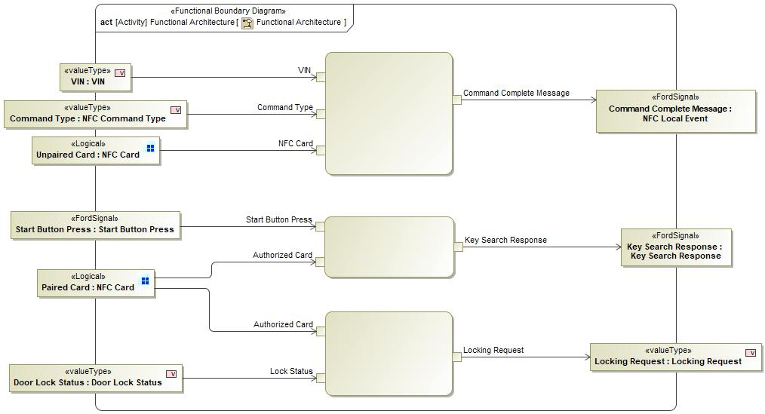

Figure 12: Functional Architecture

### List of Functions

**#Hint:** The functions shown in the Functional Architecture should be listed and described in the table below

| **Function Name** | Description | Comments |
| --- | --- | --- |
|  |  |  |
|  |  |  |
|  |  |  |

Table 23: List of Functions

## Logical Architecture

**#Classification:** Functional Safety Analysis only

**#Hint:** FS Analysis requires a description of the boundary of the feature and its elements. A simple block diagram or a SysML Internal Block Diagram could be used to depict the Logical Architecture

***#Link:*** [*Ford Functional Safety Sharepoint*](https://pd3.spt.ford.com/sites/GlobalFunctionalSafety/Pages/default.aspx)

Description of diagram and content on logical architecture in Documentation field of Structural Boundary Diagram.

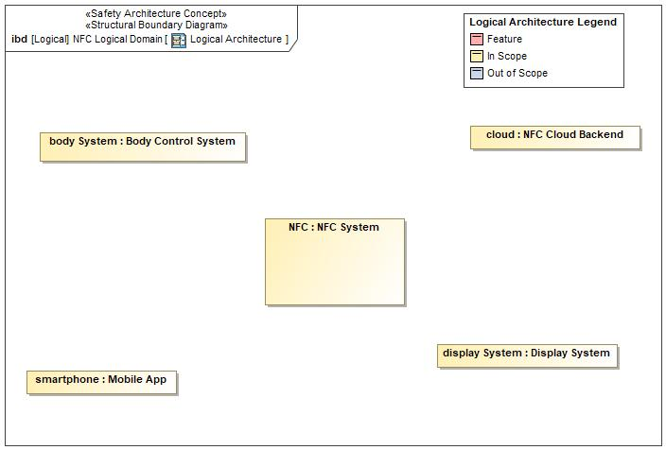

Figure 13: Logical Architecture

### Logical Elements

**#Hint:** Lists the elements of the Logical Architecture and the functions from the Functional Architecture, which are allocated to those elements.

|  |  |  |  |
| --- | --- | --- | --- |
| **Element Name** | **Description** | **Allocated Functions** | **Comments** |
| Body Control System |  |  |  |
| Display System |  |  |  |
| Mobile App |  |  |  |
| NFC Cloud Backend |  |  |  |
| NFC System | The NFC System consists of the components necessary for implementing the core of the NFC Entry and Starting feature behavior, including:   * Detecting and communicating with NFC key devices * Storing trusted NFC key credentials and authenticating presented NFC keys against these stored credentials * Updating stored credentials in response to secure commands from the backend * Interfacing with other vehicle systems that are impacted by the NFC Entry and Starting feature |  |  |

Table 24: Logical Elements

### Logical Interfaces

**#Hint:** Describe the interactions of the feature with other features or elements.

# Open Concerns

**#Hint:** The following list presents open concerns, which have to be discussed or clarified over the course of the on-going requirements engineering.

| ID | Concern Description | e-Tracker / Reference | Responsible | Status | Solution |
| --- | --- | --- | --- | --- | --- |
| 1 |  |  |  |  |  |

Table 25: Open Concerns *(Not supported by MagicDraw report generation)*

# Revision History

## Template Revisions

*#Important: Do not change this section*

|  |  |  |  |
| --- | --- | --- | --- |
| Revision | Date | Description | Responsible |
| 2020-05-22 | 5/22/2020 | Initial Functional Specification release for P708 UPV0 | abonnel1,  adelong2,  fehsan2, ekarpins |
| 2020-08-24 | 8/24/2020 | Updated release for P708 UPV1 | abonnel1,  adelong2,  fehsan2,  ekarpins |
|  |  |  |  |

|  |  |  |  |  |
| --- | --- | --- | --- | --- |
| Version | Rev. | Date | Description | Responsible |
| *0* | *6* | *2015-05-26* | * *Chapter “Feature Overview” and made a 2nd level heading.* * *Chapter “Feature Modeling” divided into 3 subchapter (“Scenarios”, “Use Cases”, “State Machines”) for different modeling methods* | *Jbaden1* |
| *0* | *7* | *2015-05-27* | * *Table of Content updated* * *Template Revision History chapter added* | *Jbaden1* |
| *0* | *8* | *2015-07-02* | * *Section “Unsettled Issues” added* | *Alevin7* |
| *0* | *9* | *2015-08-04* | * *Section “Feature Variants” added* * *Section “Feature Boundary Diagram” renamed to “Feature Context Diagram”* * *Document Properties adapted to match needs of VBA macros* | *Jbaden1, Awegman1* |
| *1* | *0* | *2015-09-11* | * *Section “Feature Variants” reworked* * *Feature Goals removed. Only “Safety Goals“ chapter remains.* * *Heading 2 formatting issues corrected.* * *Requirements / Use Cases Listing removed from traceability chapter.* * *Formatting of attribute table in Notation chapter corrected* * *Open Topics / Known Issues chapter moved to the end* | *Jbaden1* |
| *1* | *1* | *2015-11-16* | * *Table-Styles removed (for smooth VSEM import)* * *Some clean-up of sections “Purpose” and “Audience”* | *Awegman1, jbaden1* |
| *1* | *2* | *2016-02-26* | * *Minor corrections based on lessons learned from CC and PCL pilot (e.g. section market/regions) and discussion with Functional Safety Team (purpose of feature)* * *Footer corrected* * *Boundary diagram interface chapter renamed to influences.* | *Jbaden1* |
| *1* | *3* | *2016-02-26* | * *Minor corrections after review with Whitney Keith from Functional Safety team* | *Jbaden1* |
| *1* | *4* | *2016-03-10* | * *Some cleanup of meta-data in Word Properties* | *Jbaden1* |
| *1* | *5* | *2016-03-10* | * *Footer formatting corrected (Issue 19)* * *Results from review with Functional Safety Team incorporated (Issue 20).* | *jbaden1* |
| *1* | *6* | *2016-04-18* | * *Scenario Template added* | *Jbaden1* |
| *1* | *7* | *2016-04-18* | * *Chapter “Operation Modes and States” moved before “Use Case” section.* | *Jbaden1* |
| *1* | *8* | *2016-04-18* | * *Broken Wiki links repaired.* | *Jbaden1* |
| *2* | *0* | *2016-05-19* | * *Adapted to Specification_Macros.dotm V2.0* * *Requirements Templates chapter (ch. 1.7.1) no longer has an attribute table, but refers directly to the Wiki..* | *Jbaden1* |
| *2* | *1* | *2016-06-10* | * *Table for Context Diagram modified (lists external entities and Influence Description only)* | *Jbaden1* |
| *2* | *2* | *2016-07-08* | * *Template version added to footer* * *Several hints added to the various sections* * *Findings from Functional Safety Team incorporated.* * *RE_SafetyRequirement style added* | *Jbaden1* |
| *2* | *3* | *2016-09-21* | * *Update from Functional Safety Team incorporated (“Lessons Learned”, “System Behaviors for HARA”)* | *Jbaden1* |
| *2* | *4* | *2016-11-15* | * *Update from Functional Safety Team incorporated (“Lessons Learned”, “System Behaviors for HARA”)* * *Explanatory notes made more formal* | *Jbaden1* |
| *3* |  |  | *Skipped to synchronize with Specification_Macros.dotm* |  |
| *4* |  |
| *5* | *0* | *2017-01-13* | * *Meta data updated for specification macros, version 3.1* * *SW Unit chapter removed for the time being* * *Green boxes added for user hints* | *Jbaden1* |
| *5* | *1* | *2017-01-18* | * *Minor editorial changes* | *Jbaden1* |
| *6* | *0* | *2017-02-03* | * *CR48: Chapter 6 renamed from “Safety” to “Functional Safety”. New sub-chapter “Safety” introduced in Non-Functional Requirements section* | *Jbaden1* |
| *6* | *0* | *2017-04-28* | * *CR7: “RequirementsTraceability” chapter removed* | *Jbaden1* |
| *6* | *0* | *2017-11-15* | * *CR32/53: New Cover Sheet + Disclaimer replaces FAP-150 like ones.* * *CR75: Some rewording -> Terminology to Glossary, Notation -> Document Conventions* * *CR49: Rename “Assumptions & Constraints” to “Assumptions”* * *CR74: Safety Assumptions added to chapter 6.* * *CR58: Add function allocation column to Logical Architecture chapter* | *Jbaden1* |
| *6* | *0* | *2018-01-31* | * *CR63: Updated links to Functional Safety Sharepoint* | *Jbaden1* |
| *6* | *0* | *2018-07-24* | * *CR69: Add FSR to FeatureDoc* * *CR64: Add new section "Design Requirements" to Function Spec and Feature Spec* | *Jbaden1* |
| *6* | *0* | *2018-08-06* | * *CR53: some corrections for metada and formatting* | *Jbaden1* |
| *6* | *0* | *2018-09-28* | * *Broken links to RE Wiki repaired* | *Jbaden1* |
| *6* | *0* | *2018-10-31* | * *Cover sheet and footer more GIS like. Functional Safety team feedback incorporated:*   + *New subsections “Functional Safety Requirements, (Decomposed) FSRs and Parameters / Values*   + *Removal of “Logical Architecture”* | *Jbaden1* |
| *6* | *0* | *2018-12-12* | * *FSR template removed, now as a macro in the Specification_Macros.dotm* | *Jbaden1* |
| *N* |  | *2019-04-03* | * *Updated code for context diagrams, actors and use cases.* * *Updated code structure with all macros at the beginning.* * *Updated code to populate assumptions using element-assumption relationship or hazardous event.* | *snuesch* |
| *N* |  | *2019-04-18* | * *Added structural boundary diagram for FuSa based on TGB discussion.* * *Added operating modes to functional safety requirements.* | *snuesch* |
| *O* |  | *2019-04-25* | * *Improved export of actions and activities on functional boundary diagram.* | *snuesch* |
| *6* | *0b* | *2019-05-23* | * *Re-introduce “Logical Architecture” (for Functional Safety)* | *Jbaden1* |
| *O* |  | *2019-06-17* | * *Aligned “Architecture” section with RE template.* * *Made “Ford Documents” table more flexible.* * *Added template terms to glossary* | *snuesch* |
| *O* |  | *2019-06-25* | * *Improved use cases to handle Primary and Secondary actors.* * *Added Performance Requirements to Uncategorized.* | *snuesch* |
| *6* | *0b* | *2019-06-26* | * *Chapter “Logical Elements” in “Logical Architecture” section added (FuSa CR 15136240)* * *“References” and “Glossary” chapter moved from section “Feature Overview” to “Introduction”. References and Glossary should be available in the document as early as possible* | *Jbaden1* |
| *O* |  | *2019-07-25* | * *Added populated “Logical Elements” table and allocated functions.* * *Export documentation field of context diagram.* | *snuesch* |